# 2013 Observing Notes

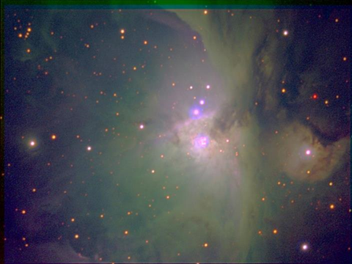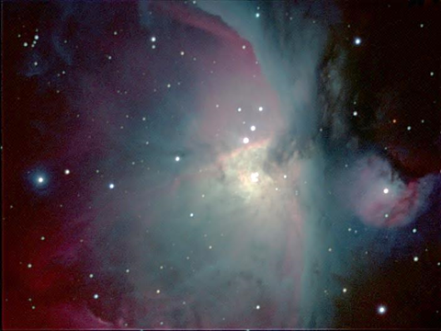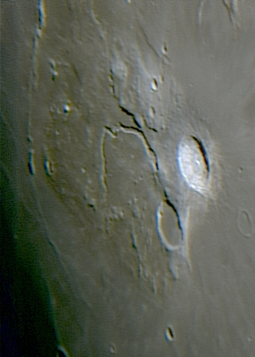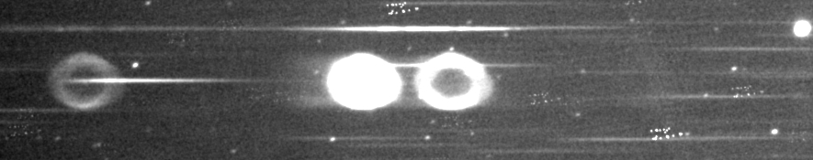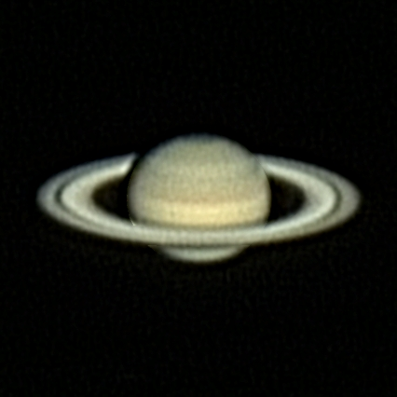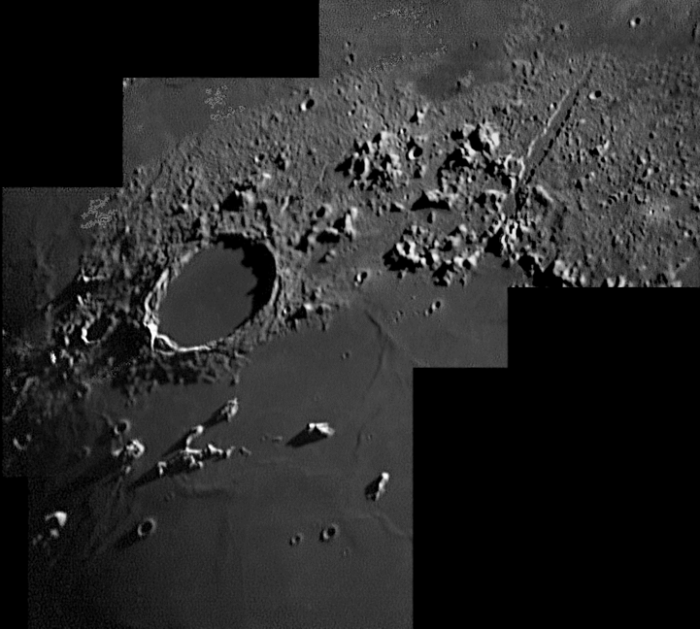

[2013 Observing Notes 1](#_Toc441408744)

[Year in Review 4](#_Toc441408745)

[January 5](#_Toc441408746)

[2013-Jan-01 (Jan-02 UT): M31 RGB 5](#_Toc441408747)

[2013-Jan-02 (Jan-03 UT): M31 Green and Blue 5](#_Toc441408748)

[2013-Jan-03 (Jan-04 UT): NGC1499 California Nebula 5](#_Toc441408749)

[2013-Jan-04 (Jan-04 UT): NGC1499 California Nebula 5](#_Toc441408750)

[2013-Jan-05 (Jan-06 UT): Jupiter 7](#_Toc441408751)

[2013-Jan-08 (Jan-09 UT): Spectra: Jupiter and Stars 9](#_Toc441408752)

[2013-Jan-16 (Jan-17 UT): Spectra: Jupiter and Stars 11](#_Toc441408753)

[2013-Jan-17 (Jan-18 UT): Jupiter Video 13](#_Toc441408754)

[2013-Jan-27 (Jan-28 UT): M42 – Red 15](#_Toc441408755)

[February 16](#_Toc441408756)

[2013-Feb-02 (Feb-03 UT): M42 – Green and Blue 16](#_Toc441408757)

[2013-Feb-03 (Feb-04 UT): M42 – NIR 16](#_Toc441408758)

[2013-Feb-04 (Feb-05 UT): M42 – NUV 17](#_Toc441408759)

[2013-Feb-07 (Feb-08 UT): M42 – H-alpha and Methane 17](#_Toc441408760)

[March 18](#_Toc441408761)

[2013-Mar-05 (Mar-06 UT): Stellar Spectra & YY Gem eclipse 18](#_Toc441408762)

[2013-Mar-06 (Mar-07 UT): Castor and YY Gem Broadband Photometry 23](#_Toc441408763)

[2013-Mar-31 (Apr-01 UT): Stellar Spectra 24](#_Toc441408764)

[June 28](#_Toc441408765)

[2013-Jun-09 (Jun-10 UT): Saturn Multi-spectral 28](#_Toc441408766)

[2013-Jun-11 (Jun-12 UT): Saturn and Titan Spectroscopy 31](#_Toc441408767)

[2013-Jun-19 (Jun-20 UT): Saturn Video 36](#_Toc441408768)

[2013-Jun-27 (Jun-28 UT): Saturn and Gam Vir (Porrima) Video 37](#_Toc441408769)

[Planning: Summer 2013 38](#_Toc441408770)

[2013-Jul-16 (Jul-17 UT): Moon and Double Star Video 39](#_Toc441408771)

[September 43](#_Toc441408772)

[2013-Sep-20 (Sep-21 UT): Spectroscopy of Vega, M57 and Nova Del 43](#_Toc441408773)

[2013-Sep-23 (Sep-24 UT): Spectroscopy 49](#_Toc441408774)

[2013-Sep-?? (Sep-24 UT): Deep Sky Constellations 49](#_Toc441408775)

[2013-Sep-27 (Sep-28 UT): Deep Sky Constellations 50](#_Toc441408776)

[October 51](#_Toc441408777)

[2013-Oct-16 (Oct-17 UT): Moon Video 51](#_Toc441408778)

[2013-Oct-22 (Oct-23 UT): Neptune Spectroscopy 52](#_Toc441408779)

[2013-Oct-23 (Oct-24 UT): Double Star Video 53](#_Toc441408780)

[2013-Oct-26 (Oct-27 UT): Double Star Video 54](#_Toc441408781)

[November 55](#_Toc441408782)

[2013-Nov-01 (Nov-01 UT): Cell Phone Dawn 55](#_Toc441408783)

[2013-Nov-02 (Nov-03 UT): Neptune and Triton Imaging 56](#_Toc441408784)

[2013-Nov-10 (Nov-11 UT): Uranus and Neptune 57](#_Toc441408785)

[2013-Nov-11 (Nov-11 UT): Sun 59](#_Toc441408786)

[2013-Nov-28 (Nov-28 UT): Sun (tried for ISON) 59](#_Toc441408787)

[2013-Nov-30 (Dec-01 UT): Uranus Spectroscopy 60](#_Toc441408788)

[December 62](#_Toc441408789)

[2013-Dec-12 (Dec-13 UT): Jupiter and Ganymede Video 62](#_Toc441408790)

[Analyses and Summaries 64](#_Toc441408791)

[Analysis: Jovian System 2012-13 Apparition 64](#_Toc441408792)

[Analysis: Saturn 69](#_Toc441408793)

[Analysis: Uranus 78](#_Toc441408794)

[Analysis: Neptune 82](#_Toc441408795)

[Analysis: Double Stars 96](#_Toc441408796)

[Analysis: Stellar Spectra 111](#_Toc441408797)

[Analysis: Planetary Nebulae Spectra 113](#_Toc441408798)

[Analysis: Nova Delphinus Spectra 115](#_Toc441408799)

[Analysis: Castor System (Including YY Gem) as a Place 120](#_Toc441408800)

[Analysis: M42 – Multispectral Imaging 132](#_Toc441408801)

[Analysis: M31 Wide Angle, Multispectral 136](#_Toc441408802)

## Year in Review

This year I worked a few special astronomical events along with quite a bit of quantitative astronomical imaging. It was also quite a lighter year with almost no summer or fall observations due to a convergence of business in the rest of my life.

The special events were indeed grand: An annular eclipse of the sun on the centerline in Albuquerque, New Mexico and the last transit of Venus for a century. Both were the first I’ve observed. And, the second is the only I will observe.

## January

### 2013-Jan-01 (Jan-02 UT): M31 RGB

Last Updated 1/4/2013

I took RGB images (80:50:56) min with the 135mm lens (f/2.5) and ST-2000. Tccd=-25C. Transparency 4/5. Images were not too well focused. I think this was due to how long it’s been since I’ve used these wavelengths with this lens system. Also, I did unguided imaging with 2 minute durations. I guess the focus was at least pretty good, because I could detect trailing in the E-W direction by a couple of pixels. I’m not totally sure whether or not I should use these images. Was there a transparency issue??? Seems like clouds were moving in…

### 2013-Jan-02 (Jan-03 UT): M31 Green and Blue

Last Updated 1/4/2013

I took green and blue images (44:30?) min with the 135mm lens (f/2.5) and ST-2000. Tccd=-25C. Transparency 2-4/5. Images were very well focused and I did use guiding for the 2 minute exposures, so stars are very sharp. There were occasional clouds moving through so there may be some images that need to be eliminated due to that fact.

### 2013-Jan-03 (Jan-04 UT): NGC1499 California Nebula

Last Updated 1/4/2013

I took 2h30m of 889nm Methane images with the 135mm lens (f/2.5) and ST-2000. Tccd=-25C. Transparency 4/5. Images were very well focused and I did use guiding for the 2 minute exposures. There was no nebulosity whatsoever visible in individual, uncalibrated images.

|  |  |  |  |  |  |  |  |  |  |  |  |  |  |
| --- | --- | --- | --- | --- | --- | --- | --- | --- | --- | --- | --- | --- | --- |
| **Date** | **NGC** | **Other ID** | **Type** | **Size1** | **Size2** | **Mag** | **mag/am2** | **MA\*** | **Const.** | **Obs** | **Photo** | **Comments** | **Update** |
| 2013 Jan 03 | 1499 | California Neb. | GN | 160.0 | 40.0 | 5.0 | 14.5 | 14.3 | Per | 0 | 1 | Imaging. Took 2h30m 889nm Methand image series with 135mm lens at f/2.5 and ST-2000. Tccd=-25C, no fan. Transparency 4/5. Imagers were very well focused and I dud use guiding for the 2 minutete exposures. There was no nebulocity whatsoever visible in individual, uncalibrated images. | 2013-Apr-26 |

### 2013-Jan-04 (Jan-04 UT): NGC1499 California Nebula

Last Updated 1/4/2013

I took 2h30m of 889nm Methane? images with the 135mm lens (f/2.5) and ST-2000. Tccd=-25C. Transparency 4/5. Images were very well focused and I did use guiding for the 2 minute exposures. There was no nebulosity whatsoever visible in individual, uncalibrated images.

|  |  |  |  |  |  |  |  |  |  |  |  |  |  |
| --- | --- | --- | --- | --- | --- | --- | --- | --- | --- | --- | --- | --- | --- |
| **Date** | **NGC** | **Other ID** | **Type** | **Size1** | **Size2** | **Mag** | **mag/am2** | **MA\*** | **Const.** | **Obs** | **Photo** | **Comments** | **Update** |
| 2013 Jan 04 | 1499 | California Neb. | GN | 160.0 | 40.0 | 5.0 | 14.5 | 14.3 | Per | 0 | 1 | Imaging. More 889 Methane? | 2013-Apr-26 |

### 2013-Jan-05 (Jan-06 UT): Jupiter

Last Updated 4/24/2014

Two videos of Jupiter at 5500mm followed by a set of multispectral (Meth,R,G,B,NUV) images at the same focal length. I then took three more videos of Jupiter at the same wavelength.

For plate scale determination, I took a video of the Trapezium at 5500mm I then added the f/6.3 focal reducer to the imaging train and took another Trapezium video and one of Jupiter.

Directory of F:\Astronomy\VideoAstronomyData\20130105

01/05/2013 09:13 PM 1,661,287,424 Jupiter-20130105-120sec-\_0000.avi

01/05/2013 09:16 PM 1,661,287,424 Jupiter-20130105-120sec-\_0001.avi

01/05/2013 09:17 PM 138,002,432 JupiterDark-20130105-10sec-\_0000.avi

01/05/2013 11:06 PM 1,646,525,952 Jupiter-20130105-120sec-\_0002.avi

01/05/2013 11:10 PM 1,661,287,424 Jupiter-20130105-120sec-\_0003.avi

01/05/2013 11:13 PM 1,653,445,120 Jupiter-20130105-120sec-\_0004.avi

01/05/2013 11:29 PM 1,651,138,560 Trapezium-20130105-120sec-\_0000.avi

01/05/2013 11:30 PM 136,618,496 TrapeziumDark-20130105-10sec-\_0000.avi

01/05/2013 11:39 PM 1,637,761,024 JupiterTest-20130105-120sec-\_0000.avi

01/05/2013 11:41 PM 1,633,609,216 JupiterTest-20130105-120sec-\_0001.avi

01/05/2013 11:46 PM 1,628,996,608 TrapBTest-20130105-120sec-\_0000.avi

01/05/2013 11:50 PM 1,615,618,560 TrapATest-20130105-120sec-\_0000.avi

01/05/2013 11:59 PM 134,773,248 TrapTestDark-20130105-10sec-\_0000.avi

13 File(s) 16,860,351,488 bytes

0 Dir(s) 117,449,523,200 bytes free

|  |  |
| --- | --- |
| E:\Astronomy\Jupiter Project 2012-13\Source Data\20130105Local\Video\2013-01-06-0415_5-Hill-Wavelets.jpg | E:\Astronomy\Jupiter Project 2012-13\Source Data\20130105Local\Video\2013-01-06-0610_3-Hill-Wavelets.jpg |
| 2013-01-06-0415\_5-Hill-Wavelets.jpg | 2013-01-06-0610\_3-Hill-Wavelets.jpg |
| E:\Astronomy\Jupiter Project 2012-13\Source Data\20130105Local\Video\2013-01-06-0622_6-Hill-Wavelets.jpg | E:\Astronomy\Jupiter Project 2012-13\Source Data\20130105Local\Video\2013-01-06-0641_0-Hill-Wavelets.jpg |
| 2013-01-06-0622\_6-Hill-Wavelets.jpg | 2013-01-06-0641\_0-Hill-Wavelets.jpg |

|  |  |  |
| --- | --- | --- |
| G:\Astronomy\Jupiter Project 2012-13\Source Data\20130105Local\CCD\2013-01-06-0508_1-Hill-Red-Wavelets.jpg | G:\Astronomy\Jupiter Project 2012-13\Source Data\20130105Local\CCD\2013-01-06-0516_9-Hill-Grn-Wavelets.jpg | G:\Astronomy\Jupiter Project 2012-13\Source Data\20130105Local\CCD\2013-01-06-0523_1-Hill-Blu-Wavelets.jpg |
| 2013-01-06-0508\_1-Hill-Red-Wavelets.jpg | 2013-01-06-0516\_9-Hill-Grn-Wavelets.jpg | 2013-01-06-0523\_1-Hill-Blu-Wavelets.jpg |
| G:\Astronomy\Jupiter Project 2012-13\Source Data\20130105Local\CCD\2013-01-06-0515_4-Hill-CH4-Wwavelets.jpg | G:\Astronomy\Jupiter Project 2012-13\Source Data\20130105Local\CCD\2013-01-06-0515_5-Hill-RGB-CH4GrnNUV.jpg | G:\Astronomy\Jupiter Project 2012-13\Source Data\20130105Local\CCD\2013-01-06-0514_2-Hill-NUV-Wavelets.jpg |
| 2013-01-06-0515\_4-Hill-CH4-Wwavelets.jpg | 2013-01-06-0515\_5-Hill-RGB-CH4GrnNUV.jpg | 2013-01-06-0514\_2-Hill-NUV-Wavelets.jpg |
| G:\Astronomy\Jupiter Project 2012-13\Source Data\20130105Local\CCD\2013-01-06-0513_5-Hill-RGB-CH4RedGrn.jpg | G:\Astronomy\Jupiter Project 2012-13\Source Data\20130105Local\CCD\2013-01-06-0516_0-Hill-RGB-RGB.jpg | G:\Astronomy\Jupiter Project 2012-13\Source Data\20130105Local\CCD\2013-01-06-0518_1-Hill-RGB-GrnBluNUV.jpg |
| 2013-01-06-0513\_5-Hill-RGB-CH4RedGrn.jpg | 2013-01-06-0516\_0-Hill-RGB-RGB.jpg | 2013-01-06-0518\_1-Hill-RGB-GrnBluNUV.jpg |

**Data Disposition:** Video images (all of them?) are in the images directory on the astronomy lap top and in the Jupiter Project 2012-13 folder. Presumably the raw data are archived on the 2TB archive drive. The CCD data have been fully processed as of 2014/04/25.

### 2013-Jan-08 (Jan-09 UT): Spectra: Jupiter and Stars

Last Updated 1/14/2013

I took spectra of Jupiter, Pleiades, Aldebaran, and Capella using the ST2000 and 135mm f/2.5 camera lens. The Star Analyzer 100 grating was placed in the CFW-8 filter wheel carousel. The grating does not fully secure in the carousel because it is not threaded along the entire barrel. It did seem to be pretty stable, however.

It was clear that the spherical chromatic aberration was causing significant problems in focusing, so I tried to make three exposures of each object with different focus settings: redfocus, redcentralfocus, and central focus. It was also clear that the spectral dispersion and plate scale varied at the different focus settings. The focus issue meant that only part of the spectrum was narrow and the rest fanned out like a butterfly with significant ‘smile.’

Finally, the sensitivity of the CCD from ~350nm to >800nm means that there is significant second order contamination in the far red to near infrared. In the future, this configuration should probably use the grating as an entrance grating (once the proper lens thread adaptor arrives) in combination with using the filter wheel to limit the spectral extent of individual exposures both to control focus and to control second order contamination. Especially for blue through NIR segments of the spectrum, the entrance aperture ‘fringe-killer’ filter should be used.

**Data Disposition:** Unsure where all the files are. I appear to have the output spectral files from R-Spec and the raw FITS image files. However, any of the rotated and cropped FITS files as well as the JPG files cannot be located as of 4/30/2014. Need to look on the 2TB Archive Drive.

|  |  |
| --- | --- |
| H:\Astronomy\08\Spectra\raw\Aldebran-redfocus-1sec-AlignedRotCrop-LogLog-8bit.jpg | Aldebran-redfocus-1sec-AlignedRotCrop-LogLog-8bit.jpg |
| H:\Astronomy\08\Spectra\raw\Aldebran-redcentralfocus-1sec-AlignedRotCrop-LogLog-8bit.jpg | Aldebran-redcentralfocus-1sec-AlignedRotCrop-LogLog-8bit.jpg |
| H:\Astronomy\08\Spectra\raw\Aldebran-centralfocus-1sec-AlignedRotCrop-LogLog-8bit.jpg | Aldebran-centralfocus-1sec-AlignedRotCrop-LogLog-8bit.jpg |
| H:\Astronomy\08\Spectra\raw\Capella-redfocus-1sec-AlignedRotCrop-LogLog-8bit.jpg | Capella-redfocus-1sec-AlignedRotCrop-LogLog-8bit.jpg |
| H:\Astronomy\08\Spectra\raw\Capella-redcentralfocus-1sec-AlignedRotCrop-LogLog-8bit.jpg | Capella-redcentralfocus-1sec-AlignedRotCrop-LogLog-8bit.jpg |
| H:\Astronomy\08\Spectra\raw\Capella-centralfocus-1sec-AlignedRotCrop-LogLog-8bit.jpg | Capella-centralfocus-1sec-AlignedRotCrop-LogLog-8bit.jpg |
| H:\Astronomy\08\Spectra\raw\Jupiter-redfocus-100ms-AlignedRotCrop-LogLog-8bit.jpg | Jupiter-redfocus-100ms-AlignedRotCrop-LogLog-8bit.jpg |
| H:\Astronomy\08\Spectra\raw\Jupiter-centralfocus-100ms-AlignedRotCrop-LogLog-8bit.jpg | Jupiter-redtocentralfocus-100ms-AlignedRotCrop-LogLog-8bit.jpg |
| H:\Astronomy\08\Spectra\raw\Jupiter-centralfocus-100ms-AlignedRotCrop-LogLog-8bit.jpg | Jupiter-centralfocus-100ms-AlignedRotCrop-LogLog-8bit.jpg |

### 2013-Jan-16 (Jan-17 UT): Spectra: Jupiter and Stars

Last Updated 9/04/2016

|  |  |  |  |  |  |  |  |  |  |  |  |  |  |
| --- | --- | --- | --- | --- | --- | --- | --- | --- | --- | --- | --- | --- | --- |
| **Date** | **NGC** | **Other ID** | **Type** | **Size1** | **Size2** | **Mag** | **mag/am2** | **MA\*** | **Const.** | **Obs** | **Photo** | **Comments** | **Update** |
| 2013 Jan 16 |  | Alpha Aurigae, Capella | ST |  |  | 0.1 |  |  | Aur | 0 | 1 | Spectra:Took spectrum of Capella with 135mm lens (f/2.5) and ST-2000 using StarAnalyzer 100 line/mm grating as an objective grating. The spectrum was taken through the NUV filter | 2016-Sep-04 |
| 2013 Jan 16 |  | Beta Orionis Rigel | DS | 0.3 | 6.8 | 9.6 | 2.72 | 0.94 | Ori | 0 | 1 | Spectra:Took spectra of Rigel with 135mm lens (f/2.5) and ST-2000 using StarAnalyzer 100 line/mm grating as an objective grating. The spectra were taken through IRGBU filters to avoid 2nd order contamination and the spherical chromatism aberrations of this particular lens. Refocusing was necessary between filters. | 2016-Sep-02 |
| 2013 Jan 16 |  | Aldebaran, Alpha Tauri | VS |  |  | 0.9 |  |  | Tau | 0 | 1 | Spectra:Took spectra of Rigel with 135mm lens (f/2.5) and ST-2000 using StarAnalyzer 100 line/mm grating as an objective grating. The spectra were taken through IRGB filters to avoid 2nd order contamination and the spherical chromatism aberrations of this particular lens. Refocusing was necessary between filters. No NUV data were taken because in test images no signal was evident. | 2016-Sep-02 |
| 2013-Jan-17 04:08 |  | Jupiter | PL |  | 44.7 | -2.6 | 5.7 |  |  | 0 | 11 | Spectra: I took eleven spectra of Jupiter using the ST2000 and 135mm f/2.5 camera lens. The Star Analyzer 100 grating was placed in front of the 135mm lens objective giving much higher dispersion than on 1/9/2013. Filters were used to isolate spectral regions and provide better focus. IRGBU images were taken. | 2014-May-01 |

Jupiter: NIR,R,G,B,NUV (NUV w/o fringe-killer)

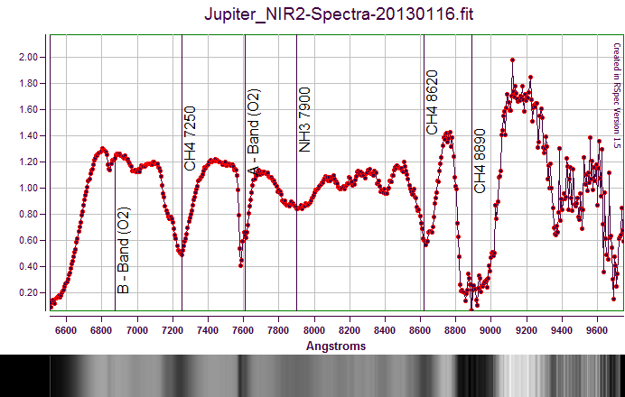

Place holder BMP: Jupiter-NIR-20130116-CalibratedCroppedNormalized.bmp

**Rigel:**

Rigel: IR,R,G,B,NUV (NUV w/o fringe-killer)

|  |  |
| --- | --- |
| F:\Astronomy\Projects\Stars\Rigel\Spectral Data\20130117UT\Rigel_NUV6-Spectra-20130116-RotCrop-Log-HalfSize.jpg | Rigel\_NUV6-Spectra-20130116-RotCrop-Log-HalfSize.jpg |
| F:\Astronomy\Projects\Stars\Rigel\Spectral Data\20130117UT\Rigel_BLU2-Spectra-20130116-RotCrop-Log-HalfSize.jpg | Rigel\_BLU2-Spectra-20130116-RotCrop-Log-HalfSize.jpg |
| F:\Astronomy\Projects\Stars\Rigel\Spectral Data\20130117UT\Rigel_GRN-Spectra-20130116-RotCrop-Log-HalfSize.jpg | Rigel\_GRN-Spectra-20130116-RotCrop-Log-HalfSize.jpg |
| F:\Astronomy\Projects\Stars\Rigel\Spectral Data\20130117UT\Rigel_RED-Spectra-20130116-RotCrop-Log-HalfSize.jpg | Rigel\_RED-Spectra-20130116-RotCrop-Log-HalfSize.jpg |
| F:\Astronomy\Projects\Stars\Rigel\Spectral Data\20130117UT\Rigel_NIR-Spectra-20130116-RotCrop-Log-HalfSize.jpg | Rigel\_NIR-Spectra-20130116-RotCrop-Log-HalfSize.jpg |

**Aldebaran:**

Aldebaran: NIR,R,G,B – couldn’t see signal for NUV so didn’t

|  |  |
| --- | --- |
| F:\Astronomy\Projects\Stars\Aldebaran\Spectral Data\20130117UT\Aldebaran_BLU-Spectra-20130116-RotCrop-Log-HalfSize.jpg | Aldebaran\_BLU-Spectra-20130116-RotCrop-Log-HalfSize.jpg |
| F:\Astronomy\Projects\Stars\Aldebaran\Spectral Data\20130117UT\Aldebaran_GRN-Spectra-20130116-RotCrop-Log-HalfSize.jpg | Aldebaran\_GRN-Spectra-20130116-RotCrop-Log-HalfSize.jpg |
| F:\Astronomy\Projects\Stars\Aldebaran\Spectral Data\20130117UT\Aldebaran_RED-Spectra-20130116-RotCrop-Log-HalfSize.jpg | Aldebaran\_RED-Spectra-20130116-RotCrop-Log-HalfSize.jpg |
| F:\Astronomy\Projects\Stars\Aldebaran\Spectral Data\20130117UT\Aldebaran_NIR1-Spectra-20130116-RotCrop-Log-HalfSize.jpg | Aldebaran\_NIR1-Spectra-20130116-RotCrop-Log-HalfSize.jpg |
| F:\Astronomy\Projects\Stars\Aldebaran\Spectral Data\20130117UT\Aldebaran_NIR2-Spectra-20130116-RotCrop-Log-HalfSize.jpg | Aldebaran\_NIR2-Spectra-20130116-RotCrop-Log-HalfSize.jpg |
| F:\Astronomy\Projects\Stars\Aldebaran\Spectral Data\20130117UT\Aldebaran_NIR3-Spectra-20130116-RotCrop-Log-HalfSize.jpg | Aldebaran\_NIR3-Spectra-20130116-RotCrop-Log-HalfSize.jpg |

**Capella:**

Capella: NUV (NUV w/o fringe-killer and binned 2x2)

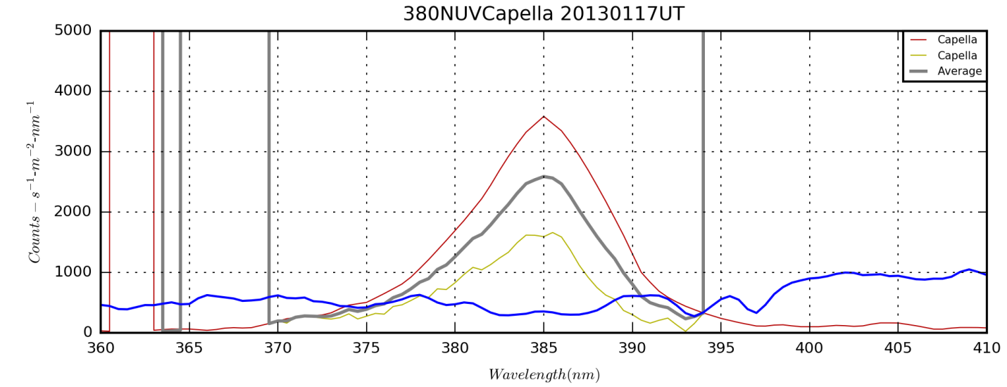

**Future Work:** Need to do basic processing and get spectra images created. Then need to see if each band can be calibrated to provide a composite spectrum from NUV to NIR. (SMH 5/1/14)

**Data Disposition:** Not even completely processed and analyzed yet. (SMH 5/1/14)

### 2013-Jan-17 (Jan-18 UT): Jupiter Video

Last Updated 8/19/2013

|  |  |
| --- | --- |
| H:\Astronomy\2013\01\17\Jupiter5500mm-20130117-120sec-_0000-DarkStack600-WaveletsJupiter1-Stack0thru3.bmp | H:\Astronomy\2013\01\17\Jupiter5500mm-20130117-120sec-_0000-DarkStack600-WaveletsJupiter1-Stack0thru3-Wavelets.bmp |
| Jupiter5500mm-20130117-120sec-\_0000-DarkStack600-WaveletsJupiter1-Stack0thru3 | Jupiter5500mm-20130117-120sec-\_0000-DarkStack600-WaveletsJupiter1-Stack0thru3-Wavelets |
| H:\Astronomy\2013\01\17\Jupiter5500mm-20130117-120sec-_0000-DarkStack600-WaveletsJupiter1-Stack0thru3-Wavelets-Gamma.bmp |  |
| Jupiter5500mm-20130117-120sec-\_0000-DarkStack600-WaveletsJupiter1-Stack0thru3-Wavelets-Gamma | Stacked with WinJUPOS |

Do WinJUPOS stack, then do map.

Volume in drive F is My Book

Volume Serial Number is 3D98-140F

Directory of F:\Astronomy\VideoAstronomyData\20130117

01/17/2013 09:30 PM 1,656,212,992 Jupiter5500mm-20130117-120sec-\_0000.avi

01/17/2013 09:33 PM 1,637,761,024 Jupiter5500mm-20130117-120sec-\_0001.avi

01/17/2013 09:35 PM 1,642,374,144 Jupiter5500mm-20130117-120sec-\_0002.avi

01/17/2013 09:37 PM 1,652,061,184 Jupiter5500mm-20130117-120sec-\_0003.avi

01/17/2013 09:38 PM 136,157,184 JupiterDark5500mm-20130117-10sec-\_0000.avi

5 File(s) 6,724,566,528 bytes

0 Dir(s) 108,163,072,000 bytes free

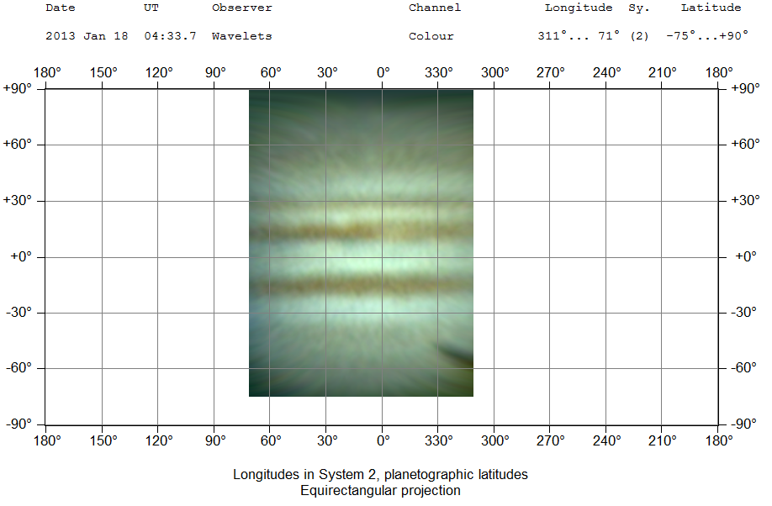

### 2013-Jan-27 (Jan-28 UT): M42 – Red

Last Updated 2/04/2013

I took a series of 37x120sec red images of M42 with the ST2000 and C8 at 1260mm (f/6.3). Tccd=-25C. Seeing was 3/5 and transparency 4/5.

|  |
| --- |
| H:\Astronomy\M42 Project 2013\M42-20130127-Red-sum1h15m-Log-HalfSize.jpg |
| M42-20130127-Red-sum1h15m-Log-HalfSize.jpg |

## February

### 2013-Feb-02 (Feb-03 UT): M42 – Green and Blue

Last Updated 2/04/2013

I took a series of 40x60sec green and blue images of M42 with the ST2000 and C8 at 1260mm (f/6.3). I forgot to turn on the coolers so the camera ran at ambient, probably around +5C! Fortunately, I took biases and darks. I also took flats for IRGB, but messed up and didn’t get NUV flats. There are darks for each of the flat durations. Seeing was 3/5 and transparency 4/5.

|  |  |
| --- | --- |
| H:\Astronomy\M42 Project 2013\M42-20130202-Green-sum0h40m-Log-HalfSize.jpg | H:\Astronomy\M42 Project 2013\M42-20130202-Blue-sum0h40m-Log-HalfSize.jpg |
| M42-20130202-Green-sum0h40m-Log-HalfSize.jpg | M42-20130202-Blue-sum0h40m-Log-HalfSize.jpg |

### 2013-Feb-03 (Feb-04 UT): M42 – NIR

Last Updated 2/04/2013

I took a series of 45x120sec NIR images of M42 with the ST2000 and C8 at 1260mm (f/6.3). Tccd=-25C. I also took biases and dark frames. Seeing was 2/5 with wind that sometimes upset the guiding. Transparency was 4/5.

|  |
| --- |
| H:\Astronomy\M42 Project 2013\M42-20130203-NIR-sum1h20m-Log-HalfSize.jpg |
| M42-20130203-NIR-sum1h20m-Log-HalfSize.jpg |

### 2013-Feb-04 (Feb-05 UT): M42 – NUV

Last Updated 2/04/2013

|  |
| --- |
| H:\Astronomy\M42 Project 2013\M42-20130204-NUV-sum1h10m-Log-HalfSize.jpg |
| M42-20130204-NUV-sum1h10m-Log-HalfSize.jpg |

### 2013-Feb-07 (Feb-08 UT): M42 – H-alpha and Methane

Last Updated 2/04/2013

TBD

|  |  |
| --- | --- |
| H:\Astronomy\M42 Project 2013\M42-20130207-Ha-sum0h50m-Log-HalfSize.jpg | H:\Astronomy\M42 Project 2013\M42-20130207-Methane-sum0h22m-Log-HalfSize.jpg |
| M42-20130207-Ha-sum0h50m-Log-HalfSize.jpg | M42-20130207-Methane-sum0h22m-Log-HalfSize.jpg |

## March

### 2013-Mar-05 (Mar-06 UT): Stellar Spectra & YY Gem eclipse

Last Updated 6/10/2013

|  |  |  |  |  |  |  |  |  |  |  |  |  |  |
| --- | --- | --- | --- | --- | --- | --- | --- | --- | --- | --- | --- | --- | --- |
| **Date** | **NGC** | **Other ID** | **Type** | **Size1** | **Size2** | **Mag** | **mag/am2** | **MA\*** | **Const.** | **Obs** | **Photo** | **Comments** | **Update** |
| 2013 Mar 05 |  | YY Gemorium Castor | DS/VS |  |  | 9.0 |  |  | Gem | 0 | 1 | Imaging: Took 130x5sec NIR images with ST-2000 and C8 at 1260mm (f/6.3) for eclipse photometry. Total exposure was 650 sec (10m50s). Tccd=-10C | 2013-Jun-10 |

|  |  |
| --- | --- |
| H:\Astronomy\2013\03\05\YY GEM\Castor-20130305-DarkStack130-HalfSize.jpg |  |
| Castor-20130305-DarkStack130-HalfSize.jpg | YY GEM NIR Light Curve 20130306UT.xlsx |

I could put some nice simple analysis of total depth, start and end times, etc…

Calculated at: <http://www.physics.sfasu.edu/astro/javascript/hjd.html>

3/6/2013 4:28:45

Sun -- RA: 23h 6m DEC: -5° 41'

Earth -- RA: 11h 6m DEC: 5° 41'

Object -- RA: 113.60833333333333° DEC: 31.869444444444443°

Earth -- X,Y,Z: -0.9685035103986751,0.22845294037019384,0.09904647586691792

Object -- X,Y,Z: -0.3401109539575258,0.7781746867629978,0.5279855072626635

Light Time: 4.653043886976317 minutes

Julian Date: 2456357.6866319445

Heliocentric Julian Date: 2456357.689863225

|  |  |
| --- | --- |
| **Latest Details** | **[http://www.aavso.org/vsx/_images/barhelp.gif](http://www.aavso.org/vsx/index.php?view=detail.top&oid=14346)** |
| Log in to retrieve additional aliases from SIMBAD. | |
|  | |
| |  |  |  |  | | --- | --- | --- | --- | | **Name** | |  |  | | --- | --- | | http://www.aavso.org/vsx/_images/0.gif   YY Gem |  | | | **AAVSO UID** | |  |  | | --- | --- | | 000-BCV-930 (794 observations) |  | | | **Const.** | Gemini | | **J2000.0** | |  |  | | --- | --- | | 07 34 37.41 +31 52 09.8  (113.65588 +31.86939) | http://www.aavso.org/vsx/_images/raquo.gif[**Search nearby**](http://www.aavso.org/vsx/index.php?view=results.nearby&oid=14346) | | | **B1950.0** | 07 31 25.66 +31 58 51.8 | | **Galactic coord.** | 187.462 +22.478 | | **Other names http://www.aavso.org/vsx/_images/spacer.gif** (Internal only) | |  |  |  | | --- | --- | --- | | 66 Gem C | alf Gem C | 1RXS J073437.2+315223 | | AAVSO 0728+32 | ADS 6175 C | BD+32 1582 | | GJ 278.0 C | SAO 60199 | X 07316+320 | |  |  |  |   (Not logged in)  http://www.aavso.org/vsx/_images/raquodim.gif**Add name** | | **Var. type** | |  |  | | --- | --- | | EA/DM+UV | **[http://www.aavso.org/vsx/_images/help.gif](javascript:varTypeHelp('EA/DM+UV'))** | | | **Spec. type** | M1Ve+M1Ve | | **Mag. range** | |  |  | | --- | --- | | 8.91 - 9.6 V | **[http://www.aavso.org/vsx/_images/help.gif](javascript:passbandHelp('V','',''))** | | | **Discoverer** | -- | | **Epoch** | |  |  | | --- | --- | | 21 Mar 1926 (HJD 2424595.8172) | http://www.aavso.org/vsx/_images/raquo.gif [**Ephemeris**](javascript:showEphemeris(14346)) | | | **Outburst** | -- | | **Period** | 0.81428254 | | **Rise/eclipse dur.** | 7% | | |
|  | |
| **Remarks** | **[http://www.aavso.org/vsx/_images/barhelp.gif](http://www.aavso.org/vsx/index.php?view=detail.top&oid=14346)** |
| Some references may be clicked to view in new window. Roll over index number to view submission details. | |
|  | |
| |  |  |  | | --- | --- | --- | | **1** | GCVS Team | VB C (A 1.99m, B 2.85m, a = 6.06", P = 306.3 y; C 73", 165deg, 1925); mu alpha = -0.0154s, mu delta = -0.108". Min II 9.59; Min II - Min I = 0.50P; D = 0.000P. X-ray source. P const [[**A.D.Mallama, PASP 92, 468, 1980.**](http://adsabs.harvard.edu/abs/1980PASP...92..468M)]. Both components are probably UV Cet type variables. Flare amplitude in the integrated light of the system reaches 0.3m V, or 1.8m U [[**T.J.Moffett, ApJ Suppl 29, 1, 1974.**](http://adsabs.harvard.edu/abs/1974ApJS...29....1M)]. | | |
|  | |
| (Not logged in)  http://www.aavso.org/vsx/_images/raquodim.gif**Add remark** | |
|  | |
| **References** | **[http://www.aavso.org/vsx/_images/barhelp.gif](http://www.aavso.org/vsx/index.php?view=detail.top&oid=14346)** |
| Click reference title/citation to view in new window. Roll over index number to view submission details. | |
|  | |
| |  |  |  | | --- | --- | --- | | **1** | [**M.Plavec, Z.Pekny, M.Smetanova, BAC 11, 180, 1960.**](http://adsabs.harvard.edu/abs/1960BAICz..11..180P) | 1960BAICz..11..180P | | **2** | [**H.van Gent, BAN 3, 121, 1926.**](http://adsabs.harvard.edu/abs/1926BAN.....3..121V) | 1926BAN.....3..121V | | **3** | [**Bob Nelson's O-C files, 2012**](http://www.aavso.org/sites/default/files/nelson.omc/2012/Gem_YY.xls) | -- | | **4** | [**CALEB - Catalog and AtLas of Eclipsing Binaries**](http://caleb.eastern.edu/star_summary.php?star_id=260) | -- | | |

From: <http://www.aavso.org/vsx/index.php?view=detail.top&oid=14346>

|  |  |  |  |  |  |  |  |  |  |  |  |  |  |
| --- | --- | --- | --- | --- | --- | --- | --- | --- | --- | --- | --- | --- | --- |
| **Date** | **NGC** | **Other ID** | **Type** | **Size1** | **Size2** | **Mag** | **mag/am2** | **MA\*** | **Const.** | **Obs** | **Photo** | **Comments** | **Update** |
| 2013 Mar 05 |  | Alpha CMa Sirius | DS | -1.0 | 8.0 | 8.4 | 2.11 | 0.89 | CMa | 0 | 1 | Spectra:Took spectra with C8 at 1260mm (f/6.3) and ST-2000. StarAnalyzer 100 line/mm grating was placed between the focal reducer and the filter wheel. The spectra were taken through NIR, NUV and Blue filters to avoid 2nd order contamination. | 2013-Jun-05 |
| 2013 Mar 05 |  | Alpha Orionis Betelgeuse | ST |  |  | 0.4 |  |  | Ori | 0 | 1 | Spectra:Took spectra with C8 at 1260mm (f/6.3) and ST-2000. StarAnalyzer 100 line/mm grating was placed between the focal reducer and the filter wheel. The spectra were taken through NIR, NUV and Blue filters to avoid 2nd order contamination. | 2013-Jun-05 |
| 2013 Mar 05 |  | Beta Orionis Rigel | DS | 0.3 | 6.8 | 9.6 | 2.72 | 0.94 | Ori | 0 | 1 | Spectra:Took spectra of Rigel with C8 at 1260mm (f/6.3) and ST-2000. StarAnalyzer 100 line/mm grating was placed between the focal reducer and the filter wheel. The spectra were taken through NIR and NUV filters to avoid 2nd order contamination. There was not time to get a spectrum through a blue filter. | 2013-Apr-26 |

**Betelgeuse Spectra:**

|  |  |
| --- | --- |
| H:\Astronomy\2013\03\SpectraProject2013\SourceFiles\Betelgeuse\BetelNUV-Rotated-30sec-Stacked-ExpNorm-Cropped.jpg | BetelNUV-Rotated-30sec-Stacked-ExpNorm-Cropped.jpg |
| H:\Astronomy\2013\03\SpectraProject2013\SourceFiles\Betelgeuse\BetelBlue-Rotated-1sec-Stacked-Cropped.jpg | BetelBlue-Rotated-1sec-Stacked-Cropped.jpg |
| H:\Astronomy\2013\03\SpectraProject2013\SourceFiles\Betelgeuse\BetelNIR-Rotated-1sec-Stacked-Cropped.jpg | BetelNIR-Rotated-1sec-Stacked-Cropped.jpg |
| H:\Astronomy\2013\03\SpectraProject2013\SourceFiles\Betelgeuse\BetelNIR-Rotated-6sec-Stacked-ExpNorm-Cropped.jpg | BetelNIR-Rotated-6sec-Stacked-ExpNorm-Cropped.jpg |

**Sirius Spectra**

|  |  |
| --- | --- |
| H:\Astronomy\2013\03\SpectraProject2013\SourceFiles\Sirius\SiriusNUV-Rotated-5sec-Stacked-ExpNorm-Cropped.jpg | SiriusNUV-Rotated-5sec-Stacked-ExpNorm-Cropped.jpg |
| H:\Astronomy\2013\03\SpectraProject2013\SourceFiles\Sirius\SiriusNUV-Rotated-30sec-Stacked-ExpNorm-Cropped.jpg | SiriusNUV-Rotated-30sec-Stacked-ExpNorm-Cropped.jpg |
| H:\Astronomy\2013\03\SpectraProject2013\SourceFiles\Sirius\SiriusBlue-Rotated-250ms-Stacked-ExpNorm-Cropped.jpg | SiriusBlue-Rotated-250ms-Stacked-ExpNorm-Cropped.jpg |
| H:\Astronomy\2013\03\SpectraProject2013\SourceFiles\Sirius\SiriusNIR-Rotated-500ms-Stacked-ExpNorm-Cropped.jpg | SiriusNIR-Rotated-500ms-Stacked-ExpNorm-Cropped.jpg |
| H:\Astronomy\2013\03\SpectraProject2013\SourceFiles\Sirius\SiriusNIR-Rotated-3sec-Stacked-ExpNorm-Cropped.jpg | SiriusNIR-Rotated-3sec-Stacked-ExpNorm-Cropped.jpg |
| H:\Astronomy\2013\03\SpectraProject2013\SourceFiles\Sirius\SiriusNIR01c-Rotated-10sec-ExpNorm-Cropped.jpg | SiriusNIR01c-Rotated-10sec-ExpNorm-Cropped.jpg |

**Rigel Spectra**

|  |  |
| --- | --- |
| H:\Astronomy\2013\03\SpectraProject2013\SourceFiles\Rigel\RigelNUV-Rotated-36secStacked-ExpNorm-Cropped.jpg | RigelNUV-Rotated-36secStacked-ExpNorm-Cropped.jpg |
| H:\Astronomy\2013\03\SpectraProject2013\SourceFiles\Rigel\RigelNIR-Rotated-7secStacked-ExpNorm-Cropped.jpg | RigelNIR-Rotated-7secStacked-ExpNorm-Cropped.jpg |

### 2013-Mar-06 (Mar-07 UT): Castor and YY Gem Broadband Photometry

Last Updated 7/12/2013

|  |  |  |
| --- | --- | --- |
| H:\Astronomy\2013\03\06\Castor\Castor-nuv-10000ms_30000ms_90000ms_easyHDR-PRO-2-Log-Cropped2-HalfSize.jpg | H:\Astronomy\2013\03\06\Castor\Castor-blu-10000ms_1000ms_100ms_30000ms_3000ms_300ms_easyHDR-PRO-2-Log-Cropped2-HalfSize.jpg | H:\Astronomy\2013\03\06\Castor\Castor-hlp-10000ms_1000ms_30000ms_3000ms_easyHDR-PRO-2-Log-Cropped2-HalfSize.jpg |
| Castor-nuv-10000ms\_30000ms\_90000ms\_easyHDR-PRO-2-Log-Cropped2-HalfSize.jpg | Castor-blu-10000ms\_1000ms\_100ms\_30000ms\_3000ms\_300ms\_easyHDR-PRO-2-Log-Cropped2-HalfSize.jpg | Castor-hlp-10000ms\_1000ms\_30000ms\_3000ms\_easyHDR-PRO-2-Log-Cropped2-HalfSize.jpg |
| H:\Astronomy\2013\03\06\Castor\Castor-NIR-10000ms_1000ms_100ms_30000ms_3000ms_300ms_easyHDR-PRO-2-Log-Cropped2-HalfSize.jpg | H:\Astronomy\2013\03\06\Castor\Castor-mth-sum60000ms-LogLog-Cropped2-HalfSize.jpg |  |
| Castor-NIR-10000ms\_1000ms\_100ms\_30000ms\_3000ms\_300ms\_easyHDR-PRO-2-Log-Cropped2-HalfSize.jpg | Castor-mth-sum60000ms-LogLog-Cropped2-HalfSize.jpg |  |

Need Excel spreadsheet database table in here.

### 2013-Mar-31 (Apr-01 UT): Stellar Spectra

Last Updated 4/4/2013

|  |  |  |  |  |  |  |  |  |  |  |  |  |  |
| --- | --- | --- | --- | --- | --- | --- | --- | --- | --- | --- | --- | --- | --- |
| **Date** | **NGC** | **Other ID** | **Type** | **Size1** | **Size2** | **Mag** | **mag/am2** | **MA\*** | **Const.** | **Obs** | **Photo** | **Comments** | **Update** |
| 2013 Mar 31 |  | Alpha CMa Sirius | DS | -1.0 | 8.0 | 8.4 | 2.11 | 0.89 | CMa | 0 | 1 | Spectra:Took spectra with C8 at 1260mm (f/6.3) and ST-2000. StarAnalyzer 100 line/mm grating was placed between the focal reducer and the filter wheel. The spectra were taken through clear, green, red filters to avoid 2nd order contamination. | 2013-Jul-05 |
| 2013 Mar 31 |  | Alpha Gemorium Castor | DS | 1.0 | 2.0 | 4.7 | 3.45 | 0.97 | CMa | 0 | 1 | Spectra:Took spectra with C8 at 1260mm (f/6.3) and ST-2000. StarAnalyzer 100 line/mm grating was placed between the focal reducer and the filter wheel. The spectra were taken through NUV, clear, green, red, and NIR filters to avoid 2nd order contamination. | 2013-Jul-05 |
| 2013 Mar 31 |  | YY Gemorium Castor | DS/VS |  |  | 9.0 |  |  | Gem | 0 | 1 | Spectra:Took spectra with C8 at 1260mm (f/6.3) and ST-2000. StarAnalyzer 100 line/mm grating was placed between the focal reducer and the filter wheel. The spectra were taken through NUV, clear, green, red, and NIR filters to avoid 2nd order contamination. | 2013-Jul-05 |
| 2013 Mar 31 |  | Alpha Orionis Betelgeuse | ST |  |  | 0.4 |  |  | Ori | 0 | 1 | Spectra:Took spectra with C8 at 1260mm (f/6.3) and ST-2000. StarAnalyzer 100 line/mm grating was placed between the focal reducer and the filter wheel. The spectra were taken through clear, green, red filters to avoid 2nd order contamination. | 2013-Jul-05 |

**Betelgeuse Spectra**

|  |  |
| --- | --- |
| H:\Astronomy\2013\03\SpectraProject2013\SourceFiles\Betelgeuse\Betel-100ms-Clr-Rotated-300ms-Stacked-ExpNorm-Cropped.jpg | Betel-100ms-Clr-Rotated-300ms-Stacked-ExpNorm-Cropped.jpg |
| H:\Astronomy\2013\03\SpectraProject2013\SourceFiles\Betelgeuse\Betel-100ms-Grn-Rotated-300ms-Stacked-ExpNorm-Cropped.jpg | Betel-100ms-Grn-Rotated-300ms-Stacked-ExpNorm-Cropped.jpg |
| H:\Astronomy\2013\03\SpectraProject2013\SourceFiles\Betelgeuse\Betel-100ms-Red-Rotated-300ms-Stacked-ExpNorm-Cropped.jpg | Betel-100ms-Red-Rotated-300ms-Stacked-ExpNorm-Cropped.jpg |

**Sirius Spectra**

|  |  |
| --- | --- |
| H:\Astronomy\2013\03\31\Spectra\SiriusClr-Rotated-90ms-Stacked-ExpNorm-Cropped.jpg | SiriusClr-Rotated-90ms-Stacked-ExpNorm-Cropped.jpg |
| H:\Astronomy\2013\03\31\Spectra\SiriusGrn-Rotated-120ms-Stacked-ExpNorm-Cropped.jpg | SiriusGrn-Rotated-120ms-Stacked-ExpNorm-Cropped.jpg |
| H:\Astronomy\2013\03\31\Spectra\SiriusGrn-Rotated-300ms-Stacked-ExpNorm-Cropped.jpg | SiriusGrn-Rotated-300ms-Stacked-ExpNorm-Cropped.jpg |
| H:\Astronomy\2013\03\31\Spectra\SiriusRed-Rotated-90ms-Stacked-ExpNorm-Cropped.jpg | SiriusRed-Rotated-90ms-Stacked-ExpNorm-Cropped.jpg |

**YY Geminorum Spectra**

|  |  |
| --- | --- |
| H:\Astronomy\2013\03\SpectraProject2013\SourceFiles\YY Gem\YYGemNUV-Rotated-150sec-Stacked-ExpNorm-Cropped.jpg | YYGemNUV-Rotated-150sec-Stacked-ExpNorm-Cropped.jpg |
| H:\Astronomy\2013\03\SpectraProject2013\SourceFiles\YY Gem\YYGemClr-Rotated-30sec-Stacked-ExpNorm-Cropped.jpg | YYGemClr-Rotated-30sec-Stacked-ExpNorm-Cropped.jpg |
| H:\Astronomy\2013\03\SpectraProject2013\SourceFiles\YY Gem\YYGemGrn-Rotated-30sec-Stacked-ExpNorm-Cropped.jpg | YYGemGrn-Rotated-30sec-Stacked-ExpNorm-Cropped.jpg |
| H:\Astronomy\2013\03\SpectraProject2013\SourceFiles\YY Gem\YYGemRed-Rotated-30sec-Stacked-ExpNorm-Cropped.jpg | YYGemRed-Rotated-30sec-Stacked-ExpNorm-Cropped.jpg |
| H:\Astronomy\2013\03\SpectraProject2013\SourceFiles\YY Gem\YYGemNIR-Rotated-30sec-Stacked-ExpNorm-Cropped.jpg | YYGemNIR-Rotated-30sec-Stacked-ExpNorm-Cropped.jpg |

**Castor Spectra**

|  |  |
| --- | --- |
| H:\Astronomy\2013\03\SpectraProject2013\SourceFiles\Castor\CastorNUV-Rotated-30sec-Stacked-ExpNorm-Cropped.jpg | CastorNUV-Rotated-30sec-Stacked-ExpNorm-Cropped.jpg |
| H:\Astronomy\2013\03\SpectraProject2013\SourceFiles\Castor\CastorNUV-Rotated-150sec-Stacked-ExpNorm-Cropped.jpg | CastorNUV-Rotated-150sec-Stacked-ExpNorm-Cropped.jpg |
| H:\Astronomy\2013\03\SpectraProject2013\SourceFiles\Castor\CastorClr-Rotated-300ms-Stacked-ExpNorm-Cropped.jpg | CastorClr-Rotated-300ms-Stacked-ExpNorm-Cropped.jpg |
| H:\Astronomy\2013\03\SpectraProject2013\SourceFiles\Castor\CastorClr-Rotated-30sec-Stacked-ExpNorm-Cropped.jpg | CastorClr-Rotated-30sec-Stacked-ExpNorm-Cropped.jpg |
| H:\Astronomy\2013\03\SpectraProject2013\SourceFiles\Castor\CastorGrn-Rotated-300ms-Stacked-ExpNorm-Cropped.jpg | CastorGrn-Rotated-300ms-Stacked-ExpNorm-Cropped.jpg |
| H:\Astronomy\2013\03\SpectraProject2013\SourceFiles\Castor\CastorGrn-Rotated-30sec-Stacked-ExpNorm-Cropped.jpg | CastorGrn-Rotated-30sec-Stacked-ExpNorm-Cropped.jpg |
| H:\Astronomy\2013\03\SpectraProject2013\SourceFiles\Castor\CastorRed-Rotated-300ms-Stacked-ExpNorm-Cropped.jpg | CastorRed-Rotated-300ms-Stacked-ExpNorm-Cropped.jpg |
| H:\Astronomy\2013\03\SpectraProject2013\SourceFiles\Castor\CastorRed-Rotated-30sec-Stacked-ExpNorm-Cropped.jpg | CastorRed-Rotated-30sec-Stacked-ExpNorm-Cropped.jpg |
| H:\Astronomy\2013\03\SpectraProject2013\SourceFiles\Castor\CastorNIR-Rotated-300ms-Stacked-ExpNorm-Cropped.jpg | CastorNIR-Rotated-300ms-Stacked-ExpNorm-Cropped.jpg |
| H:\Astronomy\2013\03\SpectraProject2013\SourceFiles\Castor\CastorNIR-Rotated-30sec-Stacked-ExpNorm-Cropped.jpg | CastorNIR-Rotated-30sec-Stacked-ExpNorm-Cropped.jpg |

|  |  |  |
| --- | --- | --- |
| H:\Astronomy\2013\03\31\Castor\Castor-NUV-10000ms_30000ms_avg9x90000ms-NUV_easyHDR-PRO-2-Log-Cropped2-HalfSize.jpg | H:\Astronomy\2013\03\31\Castor\Castor-Clr-10000ms_1000ms_100ms_30000ms_3000ms_300ms_easyHDR-PRO-2-Log-Cropped2-HalfSize.jpg | H:\Astronomy\2013\03\31\Castor\Castor-Grn-10000ms_1000ms_100ms_10ms_30000ms_3000ms_300ms_30ms_easyHDR-PRO-2-Log-Cropped2-HalfSize.jpg |
| Castor-NUV-10000ms\_30000ms\_avg9x90000ms-NUV\_easyHDR-PRO-2-Log-Cropped2-HalfSize.jpg | Castor-Clr-10000ms\_1000ms\_100ms\_30000ms\_3000ms\_300ms\_easyHDR-PRO-2-Log-Cropped2-HalfSize.jpg (Really Green) | Castor-Grn-10000ms\_1000ms\_100ms\_10ms\_30000ms\_3000ms\_300ms\_30ms\_easyHDR-PRO-2-Log-Cropped2-HalfSize.jpg (Really Clear) |
| H:\Astronomy\2013\03\31\Castor\Castor-Red-10000ms_1000ms_100ms_30000ms_3000ms_300ms_easyHDR-PRO-2-Log-Cropped2-HalfSize.jpg | H:\Astronomy\2013\03\31\Castor\Castor-NIR-HDR-Avg20130306+31-Cropped2-HalfSize.jpg |  |
| Castor-Red-10000ms\_1000ms\_100ms\_30000ms\_3000ms\_300ms\_easyHDR-PRO-2-Log-Cropped2-HalfSize.jpg | Castor-NIR-HDR-Avg20130306+31-Cropped2-HalfSize.jpg |  |

Need Excel spreadsheet database table in here.

## June

### 2013-Jun-09 (Jun-10 UT): Saturn Multi-spectral

Last Updated 6/10/2013

I took a series of images of Saturn in Methane, NIR, H-alpha, Green, and NUV with the ST-2000 at 5500mm (f/27.5). Tccd was -5C. Seeing was 3.5/5. Transparency was 4.5/5. Filter naming was messed up presumably from prior confusion.

Tonight when the filter in the FITS header says “Green” the filter was really methane. When the header says “Methane” the filter was really green. All others seem to be correct.

I SWAPPED THE LABELS IN THE FILTER SET UP IN MAXIMDL THE NEXT DAY

In the methane band, the rings show brightly but planet itself is essentially invisible.

Should create maps for each of these.

|  |  |  |  |  |  |
| --- | --- | --- | --- | --- | --- |
|  | **Time-Obs** | **Peak** | **Avg Bkg** | **RGB Scaling** | **Notes** |
| **NUV** | 05:35:45 | 43823 | 1905 | 0.81 |  |
| **Ha** | 05:55:01 | 55447 | 1914 | 0.64 |  |
| **NIR** | 05:21:27 | 46629 | 605 | 0.77 |  |
| **Meth** | 05:30:57 | 47843 | 1711 | 0.75 | Mislabeled Green |
| **Green** | 05:46:40 | 35678 | 115 | 1.00 | Mislabeled Methane |

|  |  |  |  |
| --- | --- | --- | --- |
| H:\Astronomy\2013\06\09\Saturn\TestStackNUVWavelets aligned-SmoothedBG-Cropped.jpg | H:\Astronomy\2013\06\09\Saturn\TestStackGreenWavelets aligned-SmoothedBG-Cropped.jpg | H:\Astronomy\2013\06\09\Saturn\TestStackHalphaWavelets aligned smoothedBG-Cropped.jpg | H:\Astronomy\2013\06\09\Saturn\TestStackNIRWavelets aligned-SmoothedBG-Cropped.jpg |
| TestStackNUVWavelets aligned-SmoothedBG-Cropped.jpg | TestStackGreenWavelets aligned-SmoothedBG-Cropped.jpg | TestStackHalphaWavelets aligned smoothedBG-Cropped.jpg | TestStackNIRWavelets aligned-SmoothedBG-Cropped.jpg |
| H:\Astronomy\2013\06\09\Saturn\TestStackMethaneWavelets aligned-SmoothedBG-Cropped.jpg | H:\Astronomy\2013\06\09\Saturn\TestStack-MIH-Cropped.jpg | H:\Astronomy\2013\06\09\Saturn\TestStack-MIG-Cropped.jpg | H:\Astronomy\2013\06\09\Saturn\TestStack-MHG-Cropped.jpg |
| TestStackMethaneWavelets aligned-SmoothedBG-Cropped.jpg | TestStack-MIH-Cropped.jpg | TestStack-MIG-Cropped.jpg | TestStack-MHG-Cropped.jpg |
| H:\Astronomy\2013\06\09\Saturn\Saturn-MGU-Cropped.jpg | H:\Astronomy\2013\06\09\Saturn\TestStack-IHG-Cropped.jpg | H:\Astronomy\2013\06\09\Saturn\Saturn-IGU-Cropped.jpg | H:\Astronomy\2013\06\09\Saturn\TestStack-HGU-Cropped.jpg |
| Saturn-MGU-Cropped.jpg | TestStack-IHG-Cropped.jpg | Saturn-IGU-Cropped.jpg | TestStack-HGU-Cropped.jpg |

|  |  |
| --- | --- |
| H:\Astronomy\2013\06\09\Saturn\TestStackGreenWavelets aligned-SmoothedBG-Cropped.jpg | H:\Astronomy\2013\06\09\Saturn\TestStackGreenWavelets aligned-SmoothedBG-Cropped-Annotated.jpg |
| TestStackGreenWavelets aligned-SmoothedBG-Cropped.jpg | TestStackGreenWavelets aligned-SmoothedBG-Cropped-Annotated.jpg |

**Is there any point in creating filter ratio images?**

|  |
| --- |
| **Manos Kardasis (280mm SCT )** |

here is a set under below average conditions.RGB is poor.IR is better where one tiny dark spot is visible at L3 126, B" 24. Also some dark spots at B"61 and some brighter areas around B" 30 as usual. The methane sets are very interesting especially around 20"-40". The hexagon seems darker near the corner-edges.  
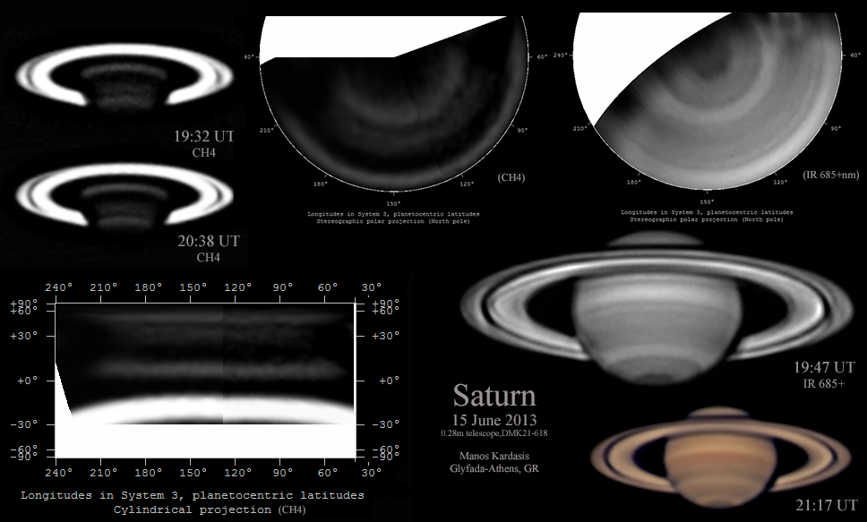

I need to do mapping here for the various bands and do a band analysis.

Table 1: Non-photometric ratio images of Saturn.

|  |  |  |  |
| --- | --- | --- | --- |
| H:\Astronomy\2013\06\09\Saturn\Saturn-Methane-over-NIR-20130610UT-Cropped.jpg |  | | |
| Saturn-Methane-over-NIR-20130610UT-Cropped.jpg |
| H:\Astronomy\2013\06\09\Saturn\Saturn-Methane-over-Ha-20130610UT-Cropped.jpg | H:\Astronomy\2013\06\09\Saturn\Saturn-NIR-over-Ha-20130610UT-Cropped.jpg |  |  |
| Saturn-Methane-over-Ha-20130610UT-Cropped.jpg | Saturn-NIR-over-Ha-20130610UT-Cropped.jpg |  |  |
| H:\Astronomy\2013\06\09\Saturn\Saturn-Methane-over-Green-20130610UT-Cropped.jpg | H:\Astronomy\2013\06\09\Saturn\Saturn-NIR-over-Green-20130610UT-Cropped.jpg | H:\Astronomy\2013\06\09\Saturn\Saturn-Ha-over-Green-20130610UT-Cropped.jpg |  |
| Saturn-Methane-over-Green-20130610UT-Cropped.jpg | Saturn-NIR-over-Green-20130610UT-Cropped.jpg | Saturn-Ha-over-Green-20130610UT-Cropped.jpg |  |
| H:\Astronomy\2013\06\09\Saturn\Saturn-Methane-over-NUV-20130610UT-Cropped.jpg | H:\Astronomy\2013\06\09\Saturn\Saturn-NIR-over-NUV-20130610UT-Cropped.jpg | H:\Astronomy\2013\06\09\Saturn\Saturn-Ha-over-NUV-20130610UT-Cropped.jpg | H:\Astronomy\2013\06\09\Saturn\Saturn-Green-over-NUV-20130610UT-Cropped.jpg |
| Saturn-Methane-over-NUV-20130610UT-Cropped.jpg | Saturn-NIR-over-NUV-20130610UT-Cropped.jpg | Saturn-Ha-over-NUV-20130610UT-Cropped.jpg | Saturn-Green-over-NUV-20130610UT-Cropped.jpg |

### 2013-Jun-11 (Jun-12 UT): Saturn and Titan Spectroscopy

Last Updated 1/15/2015

Observations were made using the ST2000 camera and C8 at 1260mm (f/6.3). The StarAnalyzer 100 line/mm grating was placed ahead of the CFW8 filter wheel and gives about 1.6nm/pixel dispersion. Multiple filters were used for order separation and multiple exposures were used to capture both the brightest and faintest parts of the spectrum.

**Saturn Spectra I**

|  |  |
| --- | --- |
| C:\Astronomy\IMAGES\2013\06\11\SaturnAlignedStacked\SaturnStacked-NUV-15sec-Cropped.jpg | SaturnStacked-NUV-15sec-Cropped.jpg |
| H:\Astronomy\2013\06\11\SaturnAlignedStacked\SaturnStacked-NUV-60sec-Cropped.jpg | SaturnStacked-NUV-60sec-Cropped.jpg |
| H:\Astronomy\2013\06\11\SaturnAlignedStacked\SaturnStacked-Clear-3sec-Cropped.jpg | SaturnStacked-Clear-3sec-Cropped.jpg |
| H:\Astronomy\2013\06\11\SaturnAlignedStacked\SaturnStacked-Clear-15sec-Cropped.jpg | SaturnStacked-Clear-15sec-Cropped.jpg |
| H:\Astronomy\2013\06\11\SaturnAlignedStacked\SaturnStacked-Clear-60sec-Cropped.jpg | SaturnStacked-Clear-60sec-Cropped.jpg |

**Saturn Spectra I**

|  |  |
| --- | --- |
| H:\Astronomy\2013\06\11\SaturnAlignedStacked\SaturnStacked-Open-3sec-Cropped.jpg | SaturnStacked-Open-3sec-Cropped.jpg |
| H:\Astronomy\2013\06\11\SaturnAlignedStacked\SaturnStacked-Open-15sec-Cropped.jpg | SaturnStacked-Open-15sec-Cropped.jpg |
| H:\Astronomy\2013\06\11\SaturnAlignedStacked\SaturnStacked-Open-60sec-Cropped.jpg | SaturnStacked-Open-60sec-Cropped.jpg |
| H:\Astronomy\2013\06\11\SaturnAlignedStacked\SaturnStacked-Ha-15sec-Cropped.jpg | SaturnStacked-Ha-15sec-Cropped.jpg |
| H:\Astronomy\2013\06\11\SaturnAlignedStacked\SaturnStacked-Ha-60sec-Cropped.jpg | SaturnStacked-Ha-60sec-Cropped.jpg |
| H:\Astronomy\2013\06\11\SaturnAlignedStacked\SaturnStacked-NIR-3sec-Cropped.jpg | SaturnStacked-NIR-3sec-Cropped.jpg |
| H:\Astronomy\2013\06\11\SaturnAlignedStacked\SaturnStacked-NIR-15sec-Cropped.jpg | SaturnStacked-NIR-15sec-Cropped.jpg |
| H:\Astronomy\2013\06\11\SaturnAlignedStacked\SaturnStacked-NIR-60sec-Cropped.jpg | SaturnStacked-NIR-60sec-Cropped.jpg |

**Titan Spectra**

|  |  |
| --- | --- |
| H:\Astronomy\2013\06\11\TitanAlignedStacked\TitanStacked-Clear-15sec-Cropped.jpg | TitanStacked-Clear-15sec-Cropped.jpg |
| H:\Astronomy\2013\06\11\TitanAlignedStacked\TitanStacked-Clear-60sec-Cropped.jpg | TitanStacked-Clear-60sec-Cropped.jpg |
| H:\Astronomy\2013\06\11\TitanAlignedStacked\TitanStacked-Ha-15sec-Cropped.jpg | TitanStacked-Ha-15sec-Cropped.jpg |
| H:\Astronomy\2013\06\11\TitanAlignedStacked\TitanStacked-Ha-60sec-Cropped.jpg | TitanStacked-Ha-60sec-Cropped.jpg |
| H:\Astronomy\2013\06\11\TitanAlignedStacked\TitanStacked-NIR-15sec-Cropped.jpg | TitanStacked-NIR-15sec-Cropped.jpg |
| H:\Astronomy\2013\06\11\TitanAlignedStacked\TitanStacked-NIR-60sec-Cropped.jpg | TitanStacked-NIR-60sec-Cropped.jpg |

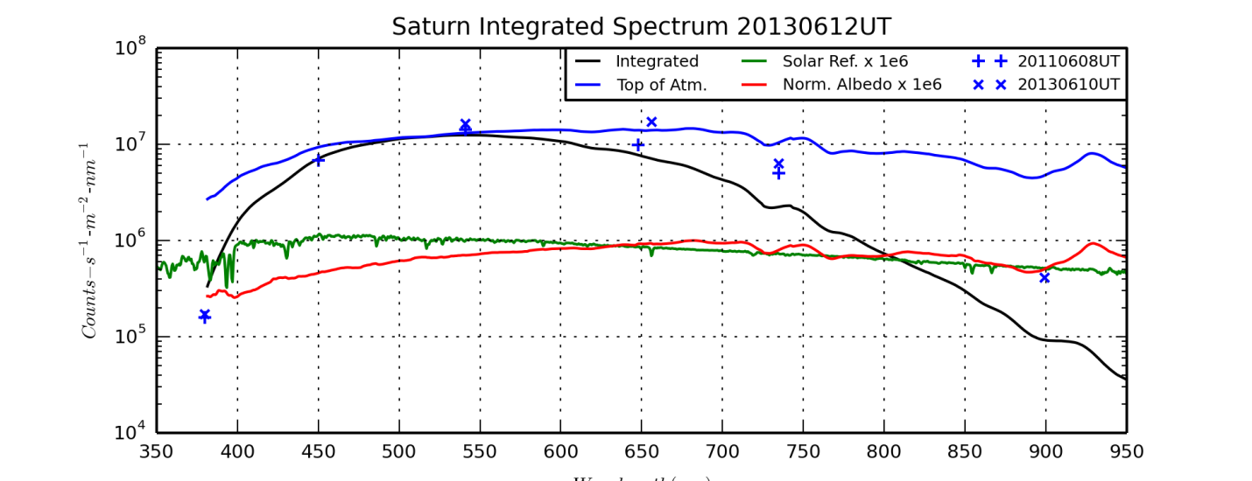

SaturnINTSpectrum20130612UT.png

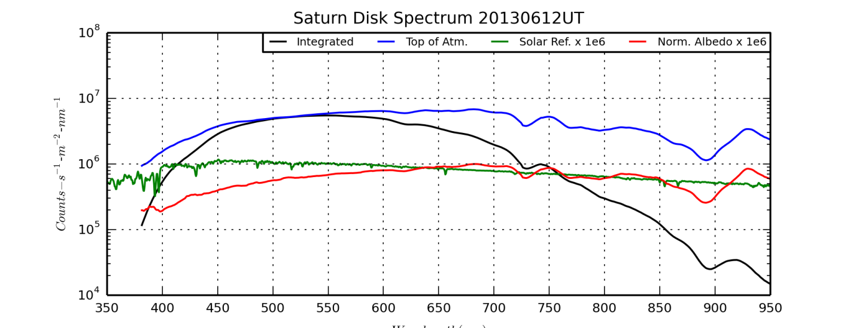

SaturnDSKSpectrum20130612UT.png

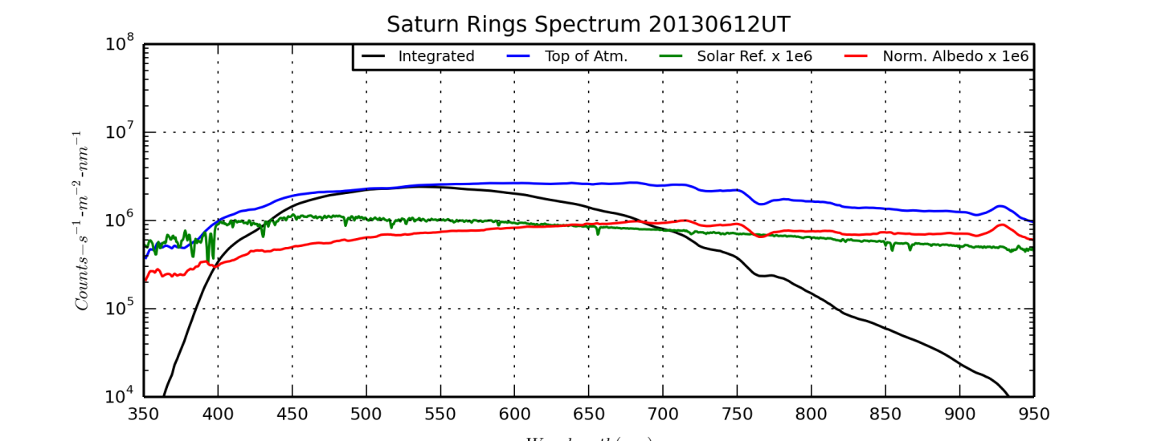

SaturnRNGSpectrum20130612UT.png

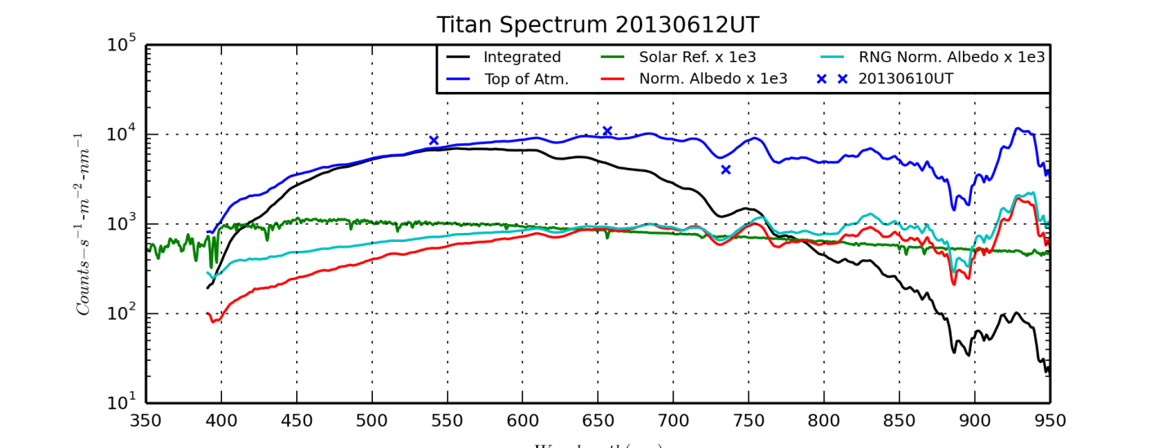

TitanSpectrum20130612UT.png

### 2013-Jun-19 (Jun-20 UT): Saturn Video

Last Updated 7/17/2013

|  |
| --- |
| C:\Astronomy\IMAGES\2013\06\19\Saturn5500mm-20130619-120sec-DarkStack600-WaveletsSaturn2-Stretch150-Stack012-Wavelets-ContBrt.jpg |
| FILE NAME? |

### 2013-Jun-27 (Jun-28 UT): Saturn and Gam Vir (Porrima) Video

Last Updated 8/22/2013

|  |  |
| --- | --- |
| H:\Astronomy\2013\06\27\Saturn-20130627-Stack00Thru11-MaximDL-Wave50-LRGB-Rotated5degCCW-Cropped.jpg | H:\Astronomy\2013\06\27\Aligned\2013-06-28-0430_3-Hill-Saturn-WinJUPOSStacked-Wavelets.jpg |
| Saturn-20130627-Stack00Thru11-MaximDL-Wave50-LRGB-Rotated5degCCW-Cropped.jpg | 2013-06-28-0430\_3-Hill-Saturn-WinJUPOSStacked-Wavelets.jpg |
| H:\Astronomy\2013\06\27\Saturn-20130627-Stack00Thru11-MaximDL-Wave50-LRGB-Rotated5degCCW-MoonsAnnotated.jpg | |
| Saturn-20130627-Stack00Thru11-MaximDL-Wave50-LRGB-Rotated5degCCW-MoonsAnnotated.jpg | |

I should enter the Excel spreadsheet log record here. Then need to archive data and put map files etc. in the correct permanent directories.

**06/27/2013 10:17 PM 1,600,395,776 Saturn5500mm-20130627-120sec-\_0000.avi**

**06/27/2013 10:20 PM 1,588,862,976 Saturn5500mm-20130627-120sec-\_0002.avi**

**06/27/2013 10:22 PM 1,588,401,664 Saturn5500mm-20130627-120sec-\_0003.avi**

**06/27/2013 10:25 PM 1,587,940,352 Saturn5500mm-20130627-120sec-\_0004.avi**

**06/27/2013 10:27 PM 1,598,089,216 Saturn5500mm-20130627-120sec-\_0005.avi**

**06/27/2013 10:29 PM 1,585,633,792 Saturn5500mm-20130627-120sec-\_0006.avi**

**06/27/2013 10:31 PM 1,592,092,160 Saturn5500mm-20130627-120sec-\_0007.avi**

**06/27/2013 10:33 PM 132,005,376 SaturnDark5500mm-20130627-10sec-\_0000.avi**

**06/27/2013 10:36 PM 1,586,556,416 Saturn5500mm-20130627-120sec-\_0008.avi**

**06/27/2013 10:39 PM 1,578,714,624 Saturn5500mm-20130627-120sec-\_0009.avi**

**06/27/2013 10:42 PM 1,564,414,464 Saturn5500mm-20130627-120sec-\_0010.avi**

**06/27/2013 10:45 PM 1,566,720,512 Saturn5500mm-20130627-120sec-\_0011.avi**

### Planning: Summer 2013

Last Updated 7/15/2013

* Double Stars
  + Eta CrB
  + Zet Her
  + Lam Oph
  + STF2173 11:00pm
  + Eta Oph 11:00pm
  + 70 Oph 11:30pm
  + BU648 12:30am
  + Eps Lyr 12:30am
  + Tau Oph 11:30pm
* Moon 9:00pm?
  + Plato
  + Copernicus Rim
  + Eratosthenes
  + Clavius
* Saturn 9:00pm?

### 2013-Jul-16 (Jul-17 UT): Moon and Double Star Video

Last Updated 7/16/2013

It was an exceptionally clear and steady night. The 300mb speeds shown by NAM and GFS were at the lowest levels on the scale. I chose to image really tough double stars and also got a bit of the Moon as well. I imaged Zet Her first since it is the one double star I may see make a complete orbit in my lifetime. Amazingly, the double was evident in the raw live video. Usually I need to process and stack the data to barely detect the secondary. I took two 120 second videos, with the camera PA rotated by about 90 degrees. I also took dark frames and drift files.

I also took video of Eta CrB, another close binary. I took two 120 second videos, with the camera PA rotated by about 90 degrees. I also took dark frames and drift files. Finally, I took a single 120 second video of Lam Oph.

Earlier, while testing my gear on the Moon, I took several videos around Plato, including the block mountain on Mare Imbrium and the Alpine Valley. I believe the images may be clear enough to see the central channel in the Alpine Valley. The tops of mountains and part of the rim of Plato were saturated, but I didn’t want to increase the gamma and decrease the contrast. I also took a video of just the outer crater wall of Copernicus in the rising sun. I took a defocused flat field and dark frame.

**(In order to get proper orientation, rotate by “rotation minus 90 degrees”, clockwise in MaximDL.)**

|  |  |  |  |  |  |  |  |  |  |  |  |  |  |
| --- | --- | --- | --- | --- | --- | --- | --- | --- | --- | --- | --- | --- | --- |
| **Date** | **NGC** | **Other ID** | **Type** | **Size1/Mag1** | **Size2/Mag2** | **Mag/Sep** | **mag/am2** | **MA\*** | **Const.** | **Obs** | **Photo** | **Comments** | **Update** |
| 2013 Jul 16 |  | Eta CrB  Struve 1937 | DS | 5.64 | 5.95 | 0.5 | -3.66 | 0.03 | CrB | 0 | 2 | Imaging: Took two 120 second videos - each in a different orientation - at 5500mm (f/27.5) with C8 and ToUcam 840. Seeing was extremely good ~4.5/5.0. | 2013-Aug-07 |
| 2013 Jul 16 |  | Zeta Her STF2084 ADS10157 | DS | 2 | 5 | 1.14 | -1.75 | 0.15 | Her | 0 | 2 | Imaging: Took two 120 second videos - each in a different orientation - at 5500mm (f/27.5) with C8 and ToUcam 840. Seeing was extremely good ~4.5/5.0. | 2013-Aug-07 |
| 2013 Jul 16 |  | Lambda Oph STF 2055 | DS | 4.15 | 5.15 | 1.55 | 1.25 | 0.78 | Oph | 0 | 1 | Imaging: Took one 120 second video (along with a 5 sec drift video) at 5500mm (f/27.5) with C8 and ToUcam 840. Seeing was extremely good, 4.5/5. | 2013-Aug-07 |

|  |  |  |  |
| --- | --- | --- | --- |
| **Zeta Hercules** | | **Eta Corona Borealis** | |
| H:\Astronomy\2013\07\16\ZetaHer5500mmRot1-20130716-120sec-_0000-DarkStack600-Wavelets-AlignedRotatedCropped.jpg | ZetaHer5500mmRot1-20130716-120sec-\_0000-DarkStack600-Wavelets-AlignedRotatedCropped.jpg | H:\Astronomy\2013\07\16\EtaCrB5500mmRot2-120sec-20130716-120sec-_0000-DarkStack600-Wavelets9-RotatedCropped.jpg | EtaCrB5500mmRot2-120sec-20130716-120sec-\_0000-DarkStack600-Wavelets9-RotatedCropped.jpg |
| H:\Astronomy\2013\07\16\ZetaHer5500mmRot2-120sec-20130716-120sec-_0000-DarkStack600-Wavelets-AlignedRotatedCropped.jpg | ZetaHer5500mmRot2-120sec-20130716-120sec-\_0000-DarkStack600-Wavelets-AlignedRotatedCropped.jpg | H:\Astronomy\2013\07\16\EtaCrB5500mmRot3-120sec-20130716-120sec-_0000-DarkStack600-Wavelets9-RotatedCropped.jpg | EtaCrB5500mmRot3-120sec-20130716-120sec-\_0000-DarkStack600-Wavelets9-RotatedCropped.jpg |
| H:\Astronomy\2013\07\16\ZetHer-20130717UT-StackedAlignedRotatedCropped.jpg | ZetHer-20130717UT-StackedAlignedRotatedCropped.jpg | H:\Astronomy\2013\07\16\EtaCrB-20130717UT-RotatedCroppedAlignedStacked.jpg | EtaCrB-20130717UT-RotatedCroppedAlignedStacked.jpg |
| H:\Astronomy\2013\07\16\ZetHer-20130717UT-StackedAlignedRotatedCropped-Wavelets-CurvesSat150pct.jpg | ZetHer-20130717UT-StackedAlignedRotatedCropped-Wavelets-CurvesSat150pct.jpg | H:\Astronomy\2013\07\16\EtaCrB-20130717UT-RotatedCroppedAlignedStacked-WaveletsContrast.jpg | EtaCrB-20130717UT-RotatedCroppedAlignedStacked-WaveletsContrast.jpg |
| **Lambda Ophiuchus** | |  |  |
| H:\Astronomy\2013\07\16\LamOph5500mmRot3-120sec-20130716-120sec-_0000-DarkStack600-Wavelets8-RotatedCropped.jpg | LamOph5500mmRot3-120sec-20130716-120sec-\_0000-DarkStack600-Wavelets8-RotatedCropped.jpg |  |  |

NOTES ON REGISTAX SIX FOR MOON IMAGES

Either need to estimate rotation in the align phase then include both “correct geometry” and “derotate images” in the stack phase, or deselect both “correct geometry” and “derotate images” in the stack phase. When both are deselected, image does appear sharper upon applying wavelets.

Dark frame and flat field issues – for some reason, DF and FF (created in Registax 5.x) are creating lots of pink and green artifacts when used in Registax 6. Looks like it may have something to do with swapping the red and blue channels. Playing with color swapping made no significant difference. May have to try to create the darks with Registax 6.x Running in B&W worked much better. Still had some ‘cracking/tiling’ effects due to the lack of feathering.

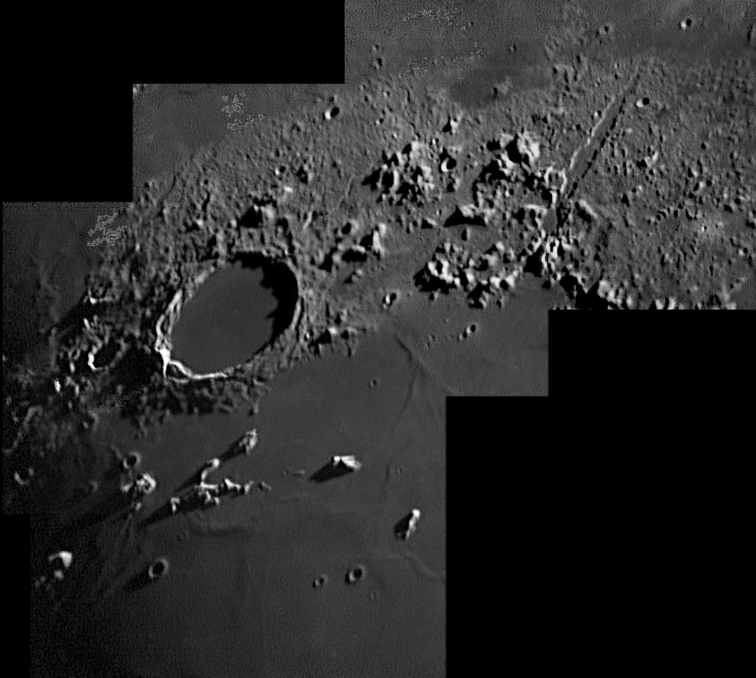

Volume in drive F is My Book

Volume Serial Number is 3D98-140F

Directory of F:\Astronomy\VideoAstronomyData\20130716

07/16/2013 09:56 PM 1,604,085,760 Plato5500mm-20130716-120sec-\_0000.avi

07/16/2013 09:58 PM 1,611,466,752 Plato5500mm-20130716-120sec-\_0001.avi

07/16/2013 10:01 PM 1,607,314,944 Plato5500mm-20130716-120sec-\_0002.avi

07/16/2013 10:03 PM 1,593,476,096 Plato5500mm-20130716-120sec-\_0003.avi

07/16/2013 10:09 PM 1,608,237,568 Plato5500mm-20130716-120sec-\_0004.avi

07/16/2013 10:10 PM 134,773,248 PlatoFlat5500mm-20130716-10sec-\_0000.avi

07/16/2013 10:12 PM 134,311,936 PlatoDark5500mm-20130716-10sec-\_0000.avi

07/16/2013 10:32 PM 1,636,838,400 ZetaHer5500mmRot1-20130716-120sec-\_0000.avi

07/16/2013 10:35 PM 68,803,072 ZetaHer5500mmRot1-5secDrift-20130716-120sec-\_0001.avi

07/16/2013 10:36 PM 67,880,448 ZetaHer5500mmRot1-5secDriftDark-20130716-120sec-\_0000.avi

07/16/2013 10:36 PM 68,803,072 ZetaHer5500mmRot1-5secDark-20130716-120sec-\_0001.avi

07/16/2013 10:40 PM 1,636,838,400 ZetaHer5500mmRot2-120sec-20130716-120sec-\_0000.avi

07/16/2013 10:42 PM 67,419,136 ZetaHer5500mmRot2-Drift5sec-20130716-120sec-\_0001.avi

07/16/2013 10:54 PM 1,595,782,656 EtaCrB5500mmRot2-120sec-20130716-120sec-\_0000.avi

07/16/2013 10:57 PM 1,589,324,288 EtaCrB5500mmRot3-120sec-20130716-120sec-\_0000.avi

07/16/2013 10:58 PM 65,573,888 EtaCrB5500mmRot3-Dark5sec-20130716-120sec-\_0000.avi

07/16/2013 11:00 PM 64,651,264 EtaCrB5500mmRot3-Drift5sec-20130716-120sec-\_0000.avi

07/16/2013 11:00 PM 63,728,640 EtaCrB5500mmRot3-DriftDark5sec-20130716-120sec-\_0000.avi

07/16/2013 11:22 PM 1,581,481,984 LamOph5500mmRot3-120sec-20130716-120sec-\_0000.avi

07/16/2013 11:23 PM 66,035,200 LamOph5500mmRot3-Dark5sec-20130716-120sec-\_0000.avi

20 File(s) 16,866,826,752 bytes

0 Dir(s) 86,633,775,104 bytes free

**Data Disposition (8/9/13):**

All video data has been zipped and moved to the 2TB backup drive.

All jpegs, etc. have been moved to the ~/images/ directory on the astronomy laptop.

## September

### 2013-Sep-20 (Sep-21 UT): Spectroscopy of Vega, M57 and Nova Del

Last Updated 1/6/2014

**Vega Spectra I**

|  |  |
| --- | --- |
| H:\Astronomy\2013\09\20\Vega\5ExpNorm\Vega-Spectrum-NUVFocus1-Stack6500ms-20130920-Rotated-Cropped.jpg | Vega-Spectrum-NUVFocus1-Stack6500ms-20130920-Rotated-Cropped.jpg |
| H:\Astronomy\2013\09\20\Vega\5ExpNorm\Vega-Spectrum-NUVFocus2-Stack21sec-20130920-Rotated-Cropped.jpg | Vega-Spectrum-NUVFocus2-Stack21sec-20130920-Rotated-Cropped.jpg |
| H:\Astronomy\2013\09\20\Vega\5ExpNorm\Vega-Spectrum-ClearFocus1-Stack200ms-20130920-Rotated-Cropped.jpg | Vega-Spectrum-ClearFocus1-Stack200ms-20130920-Rotated-Cropped.jpg |
| H:\Astronomy\2013\09\20\Vega\5ExpNorm\Vega-Spectrum-ClearFocus1-Stack600ms(sat)-20130920-Rotated-Cropped.jpg | Vega-Spectrum-ClearFocus1-Stack600ms-20130920-Rotated-Cropped.jpg |
| H:\Astronomy\2013\09\20\Vega\5ExpNorm\Vega-Spectrum-ClearFocus1-Stack1500ms(sat)-20130920-Rotated-Cropped.jpg | Vega-Spectrum-ClearFocus1-Stack1500ms-20130920-Rotated-Cropped.jpg |
| H:\Astronomy\2013\09\20\Vega\5ExpNorm\Vega-Spectrum-HaFocus2-Stack600ms-20130920-Rotated-Cropped.jpg | Vega-Spectrum-HaFocus2-Stack600ms-20130920-Rotated-Cropped.jpg |
| H:\Astronomy\2013\09\20\Vega\5ExpNorm\Vega-Spectrum-HaFocus1-Stack1500ms-20130920-Rotated-Cropped.jpg | Vega-Spectrum-HaFocus1-Stack1500ms-20130920-Rotated-Cropped.jpg |
| H:\Astronomy\2013\09\20\Vega\5ExpNorm\Vega-Spectrum-NIR-Stack2100ms-20130920-Rotated-Cropped.jpg | Vega-Spectrum-NIR-Stack2100ms-20130920-Rotated-Cropped.jpg |
| H:\Astronomy\2013\09\20\Vega\5ExpNorm\Vega-Spectrum-NIR-Stack6sec(sat)-20130920-Rotated-Cropped.jpg | Vega-Spectrum-NIR-Stack6sec(sat)-20130920-Rotated-Cropped.jpg |

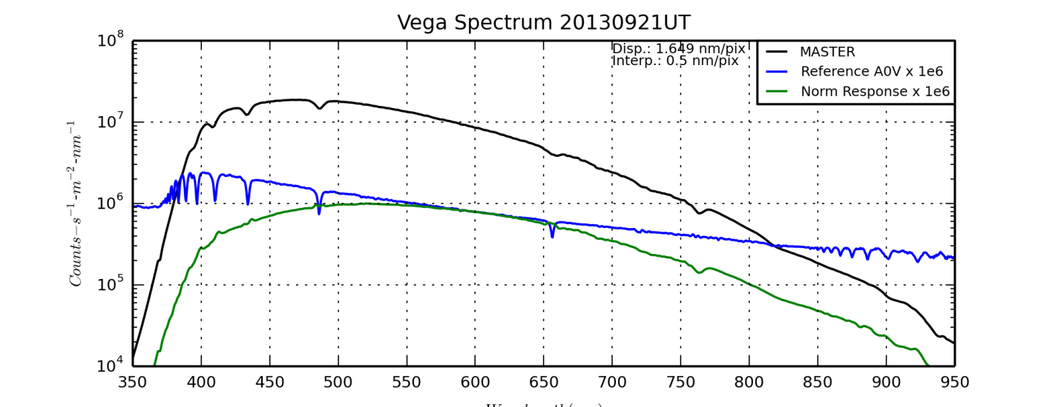

VegaSpectrum20130921UT.png (produced by VegaSpectrum20130921UT.py)

**Nova Del Spectra**

|  |  |
| --- | --- |
| H:\Astronomy\2013\09\20\Nova Del\5ExpNorm\NovaDel-20130920-NUV-200sec-Rotated-Cropped.jpg | NovaDel-20130920-NUV-200sec-Rotated-Cropped.jpg |
| H:\Astronomy\2013\09\20\Nova Del\5ExpNorm\NovaDel-20130920-Clear-215sec-Rotated-Cropped.jpg | NovaDel-20130920-Clear-215sec-Rotated-Cropped.jpg |
| H:\Astronomy\2013\09\20\Nova Del\5ExpNorm\NovaDel-20130920-Ha-100sec-Rotated-Cropped.jpg | NovaDel-20130920-Ha-100sec-Rotated-Cropped.jpg |
| H:\Astronomy\2013\09\20\Nova Del\5ExpNorm\NovaDel-20130920-NIR-200sec-Rotated-Cropped.jpg | NovaDel-20130920-NIR-200sec-Rotated-Cropped.jpg |

**M57 Spectra**

|  |  |
| --- | --- |
| H:\Astronomy\2013\09\20\M57\5ExpNorm\M57-20130920-Clear-630sec--Rotated-Cropped.jpg | M57-20130920-Clear-630sec--Rotated-Cropped.jpg |
| H:\Astronomy\2013\09\20\M57\5ExpNorm\M57-20130920-Ha-300sec-Rotated-Cropped.jpg | M57-20130920-Ha-300sec-Rotated-Cropped.jpg |
| H:\Astronomy\2013\09\20\M57\5ExpNorm\M57-20130920-NIR-600sec-Rotated-Cropped.jpg | M57-20130920-NIR-600sec-Rotated-Cropped.jpg |

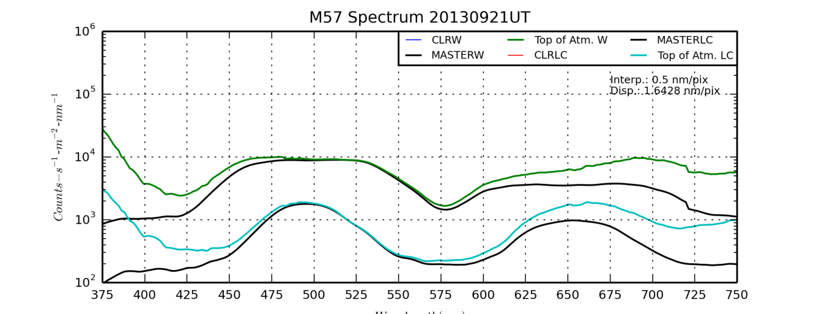

M57SpectrumBot20130921UT.png (produced by M57SpectrumBot20130921UT.py)

Crop Parameters:

Width: 885 X Offset: 178

Height: 176 Y Offset: 654

I think I can see TBD lines/groups:

* 435nm: O III + H-gamma
* 500nm: O III + H-beta
* 620nm: He I (587.6) and/or O I 630.0
* 656.3nm: H-alpha + N II
* 710.0nm: Ar III
* 950.0nm: S III

I’ll need to do some differencing work along with background flattening to bring out the fainter lines.

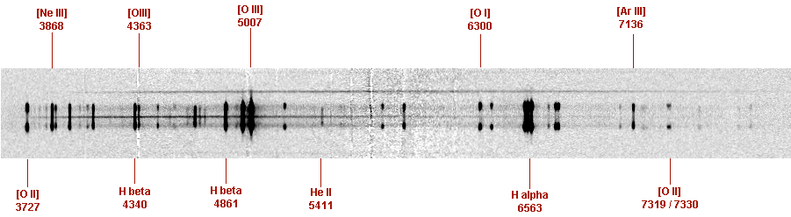

<http://www.astrosurf.com/buil/alpy600/data4/m57_3.png>

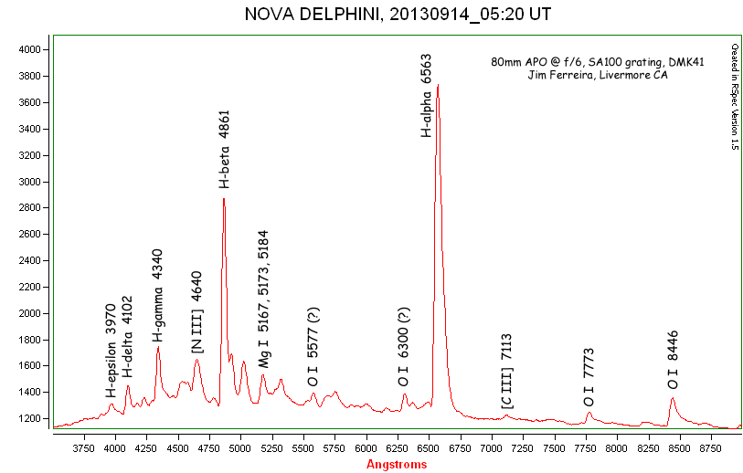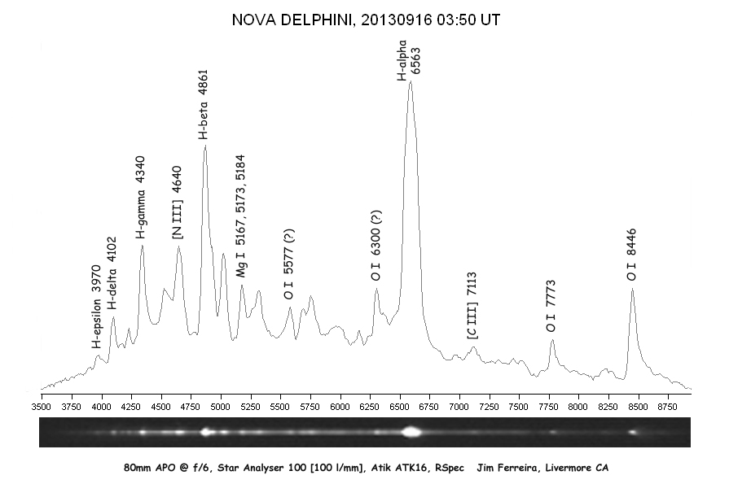

<http://www.lafterhall.com/astro.html>

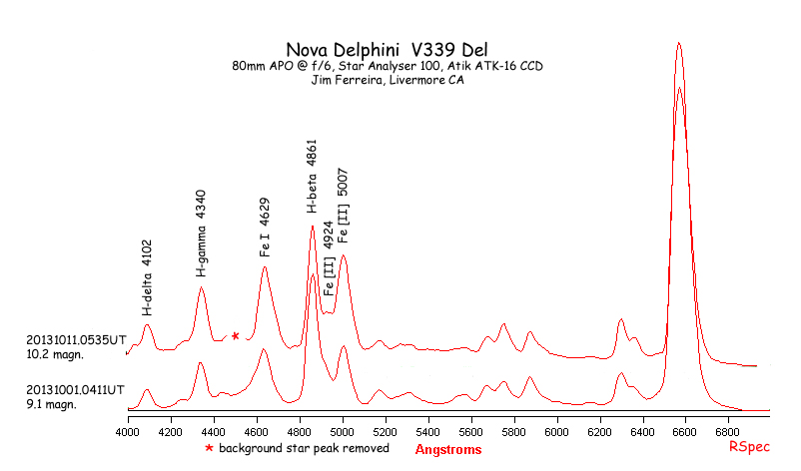

**NOTE: BE CAREFUL WITH FERRERIA LINE IDENTIFICATIONS!!!**

**Data Disposition:**

Images in the /images directory on Astronomy Laptop

Data is zipped and on 2TB archive drive

### 2013-Sep-23 (Sep-24 UT): Spectroscopy

Last Updated 9/24/2013

NGC6884

|  |  |
| --- | --- |
| D:\Astronomy\Spectra-NovaPNCarbonStars\NGC6884\5ExpNorm\NGC6884-Spectrums-20130923-Stack2110sec-Clear-Rotated-Cropped.jpg | NGC6884-Spectrums-20130923-Stack2110sec-Clear-Rotated-Cropped.jpg |
| D:\Astronomy\Spectra-NovaPNCarbonStars\NGC6884\5ExpNorm\NGC6884-Spectrums-20130923-Stack230sec-Ha-Rotated-Cropped.jpg | NGC6884-Spectrums-20130923-Stack230sec-Ha-Rotated-Cropped.jpg |
| D:\Astronomy\Spectra-NovaPNCarbonStars\NGC6884\5ExpNorm\NGC6884-Spectrums-20130923-Stack1800sec-NIR-Rotated-Cropped.jpg | NGC6884-Spectrums-20130923-Stack1800sec-NIR-Rotated-Cropped.jpg |

### 2013-Sep-?? (Sep-24 UT): Deep Sky Constellations

Last Updated 9/24/2013

Deepsky stuff with Canon camera...

### 2013-Sep-27 (Sep-28 UT): Deep Sky Constellations

Last Updated 9/24/2013

Deepsky stuff with Canon camera...

|  |  |
| --- | --- |
| F:\117CANON\Stack1792-1796-WhiteBal-FilterSat150pct-Cropped-HalfSize.jpg | F:\117CANON\Stack1792-1796-UnCal-Stretched-Cropped-ColSmooth-HalfSize.jpg |
| Stack1792-1796-Log-WhiteBal-FilterSat150pct-Cropped-HalfSize.jpg | Stack1792-1796-UnCal-Stretched-Cropped-ColSmooth-HalfSize.jpg |
|  |  |
| Gassendi-20131016-120sec-\_00thru02-DarkStack600-Wavelets50-Drizzle2x-Wavelets-HalfSize.jpg | Schroter-20131016-120sec-\_00thru01-DarkStack600-Wavelets50-Drizzle2x-Wavelets-HalfSize.jpg |

## October

### 2013-Oct-16 (Oct-17 UT): Moon Video

Last Updated 11/8/2013

|  |  |  |
| --- | --- | --- |
| H:\Astronomy\2013\10\16\Gassendi-20131016-120sec-_00thru02-DarkStack600-Wavelets50-Drizzle2x-Wavelets-HalfSize.jpg | H:\Astronomy\2013\10\16\Schroter-20131016-120sec-_00thru01-DarkStack600-Wavelets50-Drizzle2x-Wavelets-HalfSize.jpg | H:\Astronomy\2013\10\16\Plato-20131016-120sec-_00thru02-DarkStack600-Wavelets50-Drizzle2x-Wavelets-HalfSize.jpg |
| Gassendi-20131016-120sec-\_00thru02-DarkStack600-Wavelets50-Drizzle2x-Wavelets-HalfSize.jpg | Schroter-20131016-120sec-\_00thru01-DarkStack600-Wavelets50-Drizzle2x-Wavelets-HalfSize.jpg | Plato-20131016-120sec-\_00thru02-DarkStack600-Wavelets50-Drizzle2x-Wavelets-HalfSize.jpg |

Volume in drive F is My Book

Volume Serial Number is 3D98-140F

Directory of F:\Astronomy\VideoAstronomyData\20131016

10/16/2013 09:41 PM 1,661,287,424 Gassendi-20131016-120sec-\_0000.avi

10/16/2013 09:43 PM 1,660,826,112 Gassendi-20131016-120sec-\_0001.avi

10/16/2013 09:45 PM 1,660,826,112 Gassendi-20131016-120sec-\_0002.avi

10/16/2013 09:50 PM 1,616,078,848 Schroter-20131016-120sec-\_0000.avi

10/16/2013 09:52 PM 1,555,189,248 Schroter-20131016-120sec-\_0001.avi

10/16/2013 10:00 PM 1,660,364,800 Plato-20131016-120sec-\_0000.avi

10/16/2013 10:02 PM 1,660,364,800 Plato-20131016-120sec-\_0001.avi

10/16/2013 10:04 PM 1,659,442,176 Plato-20131016-120sec-\_0002.avi

10/16/2013 10:07 PM 69,725,696 Dark-20131016-5sec-\_0000.avi

10/16/2013 10:08 PM 69,264,384 Flat-20131016-5sec-\_0000.avi

10 File(s) 13,273,369,600 bytes

0 Dir(s) 116,846,362,624 bytes free

### 2013-Oct-22 (Oct-23 UT): Neptune Spectroscopy

Last Updated 9/24/2013

Sig Aqr – A0IVs – subgiant – 4.82mV – calibration star (should be nearly identical to Vega spectrum) at similar airmass

**Neptune**

|  |  |
| --- | --- |
| F:\Astronomy\Neptune Project 2013\Spectroscopy\NeptuneSpectrum-Clear-930sec-Calibrated-Rotated-Aligned-Cropped-ExpNorm.jpg | NeptuneSpectrum-Clear-930sec-Calibrated-Rotated-Aligned-Cropped-ExpNorm.jpg |
| F:\Astronomy\Neptune Project 2013\Spectroscopy\NeptuneSpectrum-Ha-300sec-Calibrated-Rotated-Aligned-Cropped-ExpNorm.jpg | NeptuneSpectrum-Ha-300sec-Calibrated-Rotated-Aligned-Cropped-ExpNorm.jpg |
| F:\Astronomy\Neptune Project 2013\Spectroscopy\NeptuneSpectrum-NIR-2740sec-Calibrated-Rotated-Aligned-Cropped-ExpNorm.jpg | NeptuneSpectrum-NIR-2740sec-Calibrated-Rotated-Aligned-Cropped-ExpNorm.jpg |

**Sig Aqr**

|  |  |
| --- | --- |
| F:\Astronomy\Neptune Project 2013\Spectroscopy\SigAqrSpectrum-Clr-298sec-Calibrated-Rotated-Aligned-Cropped-ExpNorm.jpg | SigAqrSpectrum-Clr-298sec-Calibrated-Rotated-Aligned-Cropped-ExpNorm.jpg |
| F:\Astronomy\Neptune Project 2013\Spectroscopy\SigAqrSpectrum-Ha-300sec-Calibrated-Rotated-Aligned-Cropped-ExpNorm.jpg | SigAqrSpectrum-Ha-300sec-Calibrated-Rotated-Aligned-Cropped-ExpNorm.jpg |
| F:\Astronomy\Neptune Project 2013\Spectroscopy\SigAqrSpectrum-NIR-330sec-Calibrated-Rotated-Aligned-Cropped-ExpNorm.jpg | SigAqrSpectrum-NIR-330sec-Calibrated-Rotated-Aligned-Cropped-ExpNorm.jpg |

5760A and 5430 bands are Methane!! – see Owen and Cess, 1975

See also, Lutz, Owen, and Cess, 1976

Lutz, Owen, Cess, 1982

Lutz and Owen, 1980 for NH3

**Data Disposition:** Raw data are zipped on the Astronomy thumb drive and ready to be moved to the 2TB archive drive. Processed data are located in the “Neptune Project 2013” directory.

### 2013-Oct-23 (Oct-24 UT): Double Star Video

Last Updated 9/24/2013

Worked a long time to align finder and focus scope for video. Ended up only recording Epsilon Lyrae. Seeing was supposed to be pretty good (3/5), but looked more like a “Boulder” 3/5 than the great seeing I had at Oneida on Oct 16 that was perhaps only slightly better rated by looking at GFS and ClearDarkSky.

Eps Lyr

|  |  |  |  |
| --- | --- | --- | --- |
| **Eps 1 Lyr** | | **Eps 2 Lyr** | |
| D:\Astronomy\2013\10\23\EpsLyrA-20131023-120sec-_0001-DarkStack600-WaveletsStack600-RotCrop.jpg | EpsLyrA-20131023-120sec-\_0001-DarkStack600-WaveletsStack600-RotCrop.jpg | D:\Astronomy\2013\10\23\EpsLyrB-20131023-120sec-_0001-DarkStack600-WaveletsStack600-RotCrop.jpg | EpsLyrB-20131023-120sec-\_0001-DarkStack600-WaveletsStack600-RotCrop.jpg |

### 2013-Oct-26 (Oct-27 UT): Double Star Video

Last Updated 10/27/2013

**Yet to do:**

**Mu Dra**

**Mu Cyg**

**61 Cyg**

|  |  |  |  |
| --- | --- | --- | --- |
| **Eps 1 Lyr** | | **BU 648** | |
| H:\Astronomy\20131026\EpsLyrB1-20131026-120sec-_0000-DarkStack600-Wavelets7-RotCrop.jpg | EpsLyrB1-20131026-120sec-\_0000-DarkStack600-Wavelets7-RotCrop.jpg | H:\Astronomy\20131026\BU648-20131026-120sec-Rot1-_0000-DarkStack600-Wavelets7-RotCrop.jpg | BU648-20131026-120sec-Rot1-\_0000-DarkStack600-Wavelets7-RotCrop.jpg |
| **Eps 2 Lyr** | | H:\Astronomy\20131026\BU648-20131026-120sec-Rot2-_0001-DarkStack600-Wavelets7-RotCrop.jpg | BU648-20131026-120sec-Rot2-\_0001-DarkStack600-Wavelets7-RotCrop.jpg |
| H:\Astronomy\20131026\EpsLyr2A-20131026-120sec-_0000-DarkStack600-Wavelets7-RotCrop.jpg | EpsLyr2A-20131026-120sec-\_0000-DarkStack600-Wavelets7-RotCrop.jpg |
| **70 Oph** | | H:\Astronomy\20131026\BU648-20131026-Wavelets7-RotCrop-Stack2.jpg | BU648-20131026-Wavelets7-RotCrop-Stack2.jpg |
| H:\Astronomy\20131026\70Oph-20131026-120sec-_0001-DarkStack600-RotCrop.jpg | 70Oph-20131026-120sec-\_0001-DarkStack600-RotCrop.jpg |
| **Eta Cas** | | **TBD** | |
| G:\Astronomy\Data\2013\10\26\EtaCas-20131026-120sec-Rot2-_0000-DarkStack600-Wavelets7-RotCrop.jpg | EtaCas-20131026-120sec-Rot2-\_0000-DarkStack600-Wavelets7-RotCrop.jpg |  |  |

## November

### 2013-Nov-01 (Nov-01 UT): Cell Phone Dawn

Last Updated 12/13/2013

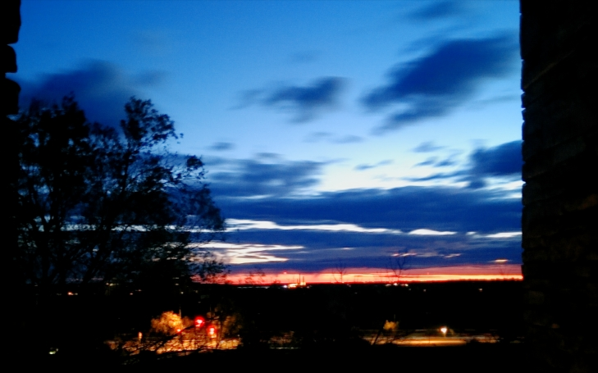

SunriseStackedWavelets\_RGB-Log-Sat150pct-Cropped2-HalfSize.jpg

The above image is a stack of about 20 image using normal settings on my HTC One taken from the window of DSRC.

### 2013-Nov-02 (Nov-03 UT): Neptune and Triton Imaging

Last Updated 11/5/2013

The conditions were very non-photometric. High cirro-cumulous (is that a cloud type?) came in during the exposure series. I’m not sure precisely when. I’d rate transparency as starting at 3/5 declining to 1/5.

|  |  |  |
| --- | --- | --- |
| H:\Astronomy\20131102\Neptune-20131102-RGB-FilteredBalancedScaled.jpg | H:\Astronomy\20131102\Neptune-20131102-RGB-Sharpened.jpg | H:\Astronomy\20131102\Neptune-20131102-Green-210sec-Aligned-Wavelets-LogFiltered-Cropped.jpg |
| Neptune-20131102-RGB-FilteredBalancedScaled.jpg | Neptune-20131102-RGB-Sharpened-Cropped.jpg | Neptune-20131102-Green-210sec-Aligned-Wavelets-LogFiltered-Cropped.jpg |

### 2013-Nov-10 (Nov-11 UT): Uranus and Neptune

Last Updated 1/1/2014

|  |  |  |  |  |
| --- | --- | --- | --- | --- |
| D:\Astronomy\2013\11\10\Neptune\Neptune-Blue-MXDLStack-123sec-20131110-Aligned-AlignedExpNormBkg-Cropped.jpg | D:\Astronomy\2013\11\10\Neptune\Neptune-Green-MXDLStack-234sec-20131110-Aligned-AlignedExpNormBkg-Cropped.jpg | D:\Astronomy\2013\11\10\Neptune\Neptune-Clear-MXDLStack-48sec-20131110-Aligned-AlignedExpNormBkg-Cropped.jpg | D:\Astronomy\2013\11\10\Neptune\Neptune-Red-MXDLStack-180sec-20131110-Aligned-AlignedExpNormBkg-Cropped.jpg | D:\Astronomy\2013\11\10\Neptune\Neptune-NIR-MXDLStack-60sec-20131110-Aligned-AlignedExpNormBkg-Cropped.jpg |
| Neptune-Blue-MXDLStack-123sec-20131110-Aligned-AlignedExpNormBkg-Cropped.jpg | Neptune-Green-MXDLStack-234sec-20131110-Aligned-AlignedExpNormBkg-Cropped.jpg | Neptune-Clear-MXDLStack-48sec-20131110-Aligned-AlignedExpNormBkg-Cropped.jpg | Neptune-Red-MXDLStack-180sec-20131110-Aligned-AlignedExpNormBkg-Cropped.jpg | Neptune-NIR-MXDLStack-60sec-20131110-Aligned-AlignedExpNormBkg-Cropped.jpg |
| D:\Astronomy\2013\11\10\Neptune\Neptune-RGB-RGB-Cropped.jpg | D:\Astronomy\2013\11\10\Neptune\Neptune-RGB-IRG-Cropped.jpg | D:\Astronomy\2013\11\10\Neptune\Neptune-RGB-IGB-Cropped.jpg | D:\Astronomy\2013\11\10\Neptune\Neptune-RGB-RGB-Log-Cropped.jpg | D:\Astronomy\2013\11\10\Neptune\Neptune-StackAllSynthLum-20131110-Cropped.jpg |
| Neptune-RGB-RGB-Cropped.jpg | Neptune-RGB-IRG-Cropped.jpg | Neptune-RGB-IGB-Cropped.jpg | Neptune-RGB-RGB-Log-Cropped.jpg | Neptune-StackAllSynthLum-20131110-Cropped.jpg |

|  |  |  |  |  |
| --- | --- | --- | --- | --- |
| D:\Astronomy\2013\11\10\Uranus\Uranus-Blue-MXDLStack-231sec-20131110-Aligned-AlignedExpNormBkg-Cropped.jpg | D:\Astronomy\2013\11\10\Uranus\Uranus-Green-MXDLStack-192sec-20131110-Aligned-AlignedExpNormBkg-Cropped.jpg | D:\Astronomy\2013\11\10\Uranus\Uranus-Clear-MXDLStack-69sec-20131110-Aligned-AlignedExpNormBkg-Cropped.jpg | D:\Astronomy\2013\11\10\Uranus\Uranus-Red-MXDLStack-207sec-20131110-Aligned-AlignedExpNormBkg-Cropped.jpg | D:\Astronomy\2013\11\10\Uranus\Uranus-NIR-MXDLStack-186sec-20131110-Aligned-AlignedExpNormBkg-Cropped.jpg |
| Uranus-Blue-MXDLStack-231sec-20131110-Aligned-AlignedExpNormBkg-Cropped.jpg | Uranus-Green-MXDLStack-192sec-20131110-Aligned-AlignedExpNormBkg-Cropped.jpg | Uranus-Clear-MXDLStack-69sec-20131110-Aligned-AlignedExpNormBkg-Cropped.jpg | Uranus-Red-MXDLStack-207sec-20131110-Aligned-AlignedExpNormBkg-Cropped.jpg | Uranus-NIR-MXDLStack-186sec-20131110-Aligned-AlignedExpNormBkg-Cropped.jpg |
| D:\Astronomy\2013\11\10\Uranus\Uranus-RGB-RGB-Cropped.jpg | D:\Astronomy\2013\11\10\Uranus\Uranus-RGB-IRG-Cropped.jpg | D:\Astronomy\2013\11\10\Uranus\Uranus-RGB-IGB-Cropped.jpg | D:\Astronomy\2013\11\10\Uranus\Uranus-RGB-RGB-Cropped-PedistalSmooth-Log.jpg | D:\Astronomy\2013\11\10\Uranus\Uranus-StackAllSynthLum-20131110-Cropped-Smoothed.jpg |
| Uranus-RGB-RGB-Cropped.jpg | Uranus-RGB-IRG-Cropped.jpg | Uranus-RGB-IGB-Cropped.jpg | Uranus-RGB-RGB-Cropped-PedistalSmooth-Log.jpg | Uranus-StackAllSynthLum-20131110-Cropped-Smoothed.jpg |

|  |
| --- |
| G:\Astronomy\2013\11\10\Uranus\Uranus-StackAllSynthLum-20131110-Cropped-Stretched-Annotated.jpg |
| Uranus-StackAllSynthLum-20131110-Cropped-Stretched-Annotated.jpg |

### 2013-Nov-11 (Nov-11 UT): Sun

Last Updated 12/23/2013

In preparation for trying to see comet ISON at its perihelion, I took a series of images of the Sun and near the Sun.

|  |  |  |
| --- | --- | --- |
| F:\Astronomy\2013\11\11\Sun\SunMethaneMosaic-20131111a-Aligned-Resized-Stretched-Quartersize.jpg | F:\Astronomy\2013\11\11\Sun\SunNUVMosaic-20131111a-Aligned-Stretched-Quartersize.jpg | F:\Astronomy\2013\11\11\Sun\Sun-RGB-Wavelets-Quartersize.jpg |
| SunMethaneMosaic-20131111a-Aligned-Resized-Stretched-Quartersize.jpg | SunNUVMosaic-20131111a-Aligned-Stretched-Quartersize.jpg | Sun-RGB-Wavelets-Quartersize.jpg |

I NEED TO REDO MOSAICS TO INCLUDE MISSING QUADRANT WHICH WAS MISNAMED “BLUE” FOR NUV AND “CLEAR” FOR METHANE.

### 2013-Nov-28 (Nov-28 UT): Sun (tried for ISON)

Last Updated 12/13/2013

### 2013-Nov-30 (Dec-01 UT): Uranus Spectroscopy

Last Updated 3/4/2014

**Uranus**

|  |  |
| --- | --- |
| D:\Astronomy\UranusProject2013\Spectroscopy\Uranus-1260mm-20131130-Spectrum-Clear-sum600s-RotatedCroppedExpNorm.jpg | Uranus-1260mm-20131130-Spectrum-Clear-sum600s-RotatedCroppedExpNorm.jpg |
| D:\Astronomy\UranusProject2013\Spectroscopy\Uranus-1260mm-20131130-Spectrum-NIR-sum2080s-RotatedCroppedExpNorm.jpg | Uranus-1260mm-20131130-Spectrum-NIR-sum2080s-RotatedCroppedExpNorm.jpg |

**29 Psc (B7 III-IV)**

|  |  |
| --- | --- |
| D:\Astronomy\UranusProject2013\Spectroscopy\29Psc-1260mm-20131130-Spectrum-Clear-sum100s-RotatedCroppedExpNorm.jpg | 29Psc-1260mm-20131130-Spectrum-Clear-sum100s-RotatedCroppedExpNorm.jpg |
| D:\Astronomy\UranusProject2013\Spectroscopy\29Psc-1260mm-20131130-Spectrum-NIR-sum100s-RotatedCroppedExpNorm.jpg | 29Psc-1260mm-20131130-Spectrum-NIR-sum100s-RotatedCroppedExpNorm.jpg |

**44 Psc (G5 III)**

|  |  |
| --- | --- |
| D:\Astronomy\UranusProject2013\Spectroscopy\44Psc-1260mm-20131130-Spectrum-Clear-sum100s-RotatedCroppedExpNorm.jpg | 44Psc-1260mm-20131130-Spectrum-Clear-sum100s-RotatedCroppedExpNorm.jpg |
| D:\Astronomy\UranusProject2013\Spectroscopy\44Psc-1260mm-20131130-Spectrum-NIR-sum100s-RotatedCroppedExpNorm.jpg | 44Psc-1260mm-20131130-Spectrum-NIR-sum100s-RotatedCroppedExpNorm.jpg |

29 Psc analysis of resolution using RSpec

FWHM un-normalized:

59.0 at 4861 (H-bet)

49.2 at 4341 (H-gam)

FWHM normalized:

54.3 at 6563 (H-alp)

54.0 at 4861 (H-bet)

48.7 at 4341 (H-gam)

49.4 at 4105 (H-del)

36.5 at 39?? (H-eps)

## December

### 2013-Dec-12 (Dec-13 UT): Jupiter and Ganymede Video

Last Updated 1/2/2014

Volume in drive F is My Book

Volume Serial Number is 3D98-140F

Directory of F:\Astronomy\VideoAstronomyData\20131212

12/12/2013 09:47 PM 1,661,287,424 Jupiter-20131212-120sec\_0000.avi

12/12/2013 09:49 PM 1,657,596,928 Jupiter-20131212-120sec\_0001.avi

12/12/2013 09:52 PM 1,607,314,944 Jupiter-20131212-120sec\_0002.avi

12/12/2013 09:56 PM 1,596,243,968 Gany-20131212-120sec\_0000.avi

12/12/2013 09:58 PM 1,583,789,056 Gany-20131212-120sec\_0001.avi

12/12/2013 10:00 PM 1,572,256,256 Gany-20131212-120sec\_0002.avi

12/12/2013 10:03 PM 1,571,794,944 Gany-20131212-120sec\_0003.avi

12/12/2013 10:26 PM 65,573,888 GanyDark-20131212-120sec\_0000.avi

12/12/2013 10:27 PM 66,035,200 JupiterDark-20131212-5sec\_0000.avi

12/12/2013 10:43 PM 3,285,600,768 Jupiter-20131212-120sec\_0003.avi

10 File(s) 14,667,493,376 bytes

0 Dir(s) 110,368,292,864 bytes free

|  |  |  |  |  |
| --- | --- | --- | --- | --- |
|  |  |  |  |  |
| Gany-20131212-120sec\_0000thru0003-DarkStack400-WaveletsGany1-2xCropped-Stack4-Wavelets1-Rotated22.5deg-RGBAligned.bmp | Gany-20131212-120sec\_0000thru0003-DarkStack400-WaveletsGany1-2xCropped-Stack4-Wavelets2-Rotated22.5deg-RGBAligned.bmp | Gany-20131212-120sec\_0000thru0003-DarkStack400-WaveletsGany1-2xCropped-Stack4-Wavelets2-Rotated22.5deg-RGBAligned-More.bmp | Gany-20131212-WinJUPOS-2pixBlur.bmp | Gany-20131212-WinJUPOS.bmp |

Ganymede reduction:

1. Stacked four individual video sums roughly in MaximDL after doubling in size.
2. Did precise stack in Registax. Saw some RGB offset, but couldn’t do sub-pixel changes so it didn’t work.
3. Did some wavelets sharpening in Registax (two versions)
4. Loaded into MaximDL and rotated 22.5 deg CW so that Jovian *south* was up then rotated 180 deg to put north up.
5. Did some final sprucing on the 2nd wavelets version in MaximDL
6. Created a snapshot of Ganymede at 2013-12-13 0500UT in WinJUPOS 10.0.16 (with north up), loaded it into MaximDL and performed a Gaussian blur of 2 pixels that visually approximated observational data.

I believe that the hemispheric brightness difference is evident in my images, e.g., the southern hemisphere is brighter than the northern hemisphere.

|  |  |  |
| --- | --- | --- |
| G:\Astronomy\2013\12\12\2013-12-13-0449_3-Wavelets-Wavelets.bmp | G:\Astronomy\2013\12\12\Jupiter-20131212-240sec_0003-DarkStack1200-WaveletsJupiter1-RGBAligned2-WaveletsRotated.bmp | G:\Astronomy\2013\12\12\2013-12-13-0502_8-Wavelets-Wavelets.bmp |
| 2013-12-13-0449\_3-Wavelets-Wavelets.bmp | Jupiter-20131212-240sec\_0003-DarkStack1200-WaveletsJupiter1-RGBAligned2-WaveletsRotated.bmp | 2013-12-13-0502\_8-Wavelets-Wavelets.bmp |

Stuff to do: Maps and associated analysis. FWHM analysis on Ganymede and maybe Io.

Data Disposition: ZIPped and ready to move to 2TB archive drive.

## Analyses and Summaries

### Analysis: Jovian System 2012-13 Apparition

Last Updated 1/12/2012

LAST FULL ANALYSIS FOR JUPITER, INCLUDING MAPS, WAS 2009! NEED TO DO all of 2010, part of 2011-12 AND all of 2012-13

2012-13 Apparition Observation Journal

| **Date (UT)** | **Size** | **Mag.** | **mag/as2** | **CM I** | **CM II** | **CM III** | **Jupiter** | **Io** | **Europa** | **Ganymede** | **Callisto** | **Himalia** | **Elevation** | **Seeing** | **Visual** | **Photo** | **Comments** | **Update** |
| --- | --- | --- | --- | --- | --- | --- | --- | --- | --- | --- | --- | --- | --- | --- | --- | --- | --- | --- |
| 2012-Dec-22 05:57 |  |  |  |  |  |  | X | X | X |  | X |  |  | 3/5 | 0 | 1 | Imaging: I took a set of 50 5sec 889nm Methane images using the ST2000 and C8 at 5500mm (f/27.5). Seeing was 3/5 and transparency 4/5. Tccd=-25C without the fan. Imaging duration spanned 10 minutes. | 2014-Apr-18 |
| 2012-Dec-22 06:09 |  |  |  |  |  |  | X | X | X |  | X |  |  | 3/5 | 0 | 1 | Imaging: I took a set of 50 400msec NIR images using the ST2000 and C8 at 5500mm (f/27.5). Seeing was 3/5 and transparency 4/5. Tccd=-25C without the fan. Imaging duration spanned 10 minutes. | 2014-Apr-18 |
| 2012-Dec-22 06:22 |  |  |  |  |  |  | X | X | X |  | X |  |  | 3/5 | 0 | 1 | Imaging: I took a set of 50 5sec Halpha images using the ST2000 and C8 at 5500mm (f/27.5). Seeing was 3/5 and transparency 4/5. Tccd=-25C without the fan. Imaging duration spanned 10 minutes. | 2014-Apr-18 |
| 2012-Dec-22 06:34 |  |  |  |  |  |  | X | X | X |  | X |  |  | 3/5 | 0 | 1 | Imaging: I took a set of 50 400msec Blue images using the ST2000 and C8 at 5500mm (f/27.5). Seeing was 3/5 and transparency 4/5. Tccd=-25C without the fan. Imaging duration spanned 10 minutes. | 2014-Apr-18 |
| 2012-Dec-22 06:46 |  |  |  |  |  |  | X | X | X |  | X |  |  | 3/5 | 0 | 1 | Imaging: I took a set of 50 5sec NUV images using the ST2000 and C8 at 5500mm (f/27.5). Seeing was 3/5 and transparency 4/5. Tccd=-25C without the fan. Imaging duration spanned 10 minutes. | 2014-Apr-18 |
| 2012-Dec-22 07:14 |  |  |  |  |  |  | X | X |  |  | X |  |  | 3/5 | 0 | 1 | Imaging: I took 2x120sec videos with ToUcam and C8 at 5500mm (f/27.5). Seeing was 3/5 and transparency 4/5. | 2014-Apr-18 |
| 2012-Dec-23 07:14 |  |  |  |  |  |  | X | X |  |  | X |  |  | 2/5 | 0 | 1 | Imaging: I took 2x120sec videos with ToUcam and C8 at 5500mm (f/27.5). Seeing was quite bad at 2/5 and transparency 4/5. | 2014-Apr-18 |
| 2012-Dec-23 07:50 |  |  |  |  |  |  | X |  | X | X | X |  |  | 2/5 | 0 | 1 | Imaging: I took a set of 25x200msec Blue images using the ST2000 and C8 at 5500mm (f/27.5). Seeing was quite bad at 2/5 and transparency 4/5. Tccd=-25C without the fan. Imaging spanned 4 minutes. | 2014-Apr-18 |
| 2012-Dec-23 07:57 |  |  |  |  |  |  | X |  | X | X | X |  |  | 2/5 | 0 | 1 | Imaging: I took a set of 5x5sec NUV images using the ST2000 and C8 at 5500mm (f/27.5). Seeing was quite bad at 2/5 and transparency 4/5. Tccd=-25C without the fan. | 2014-Apr-18 |
| 2012-Dec-23 08:03 |  |  |  |  |  |  | X |  | X | X | X |  |  | 2/5 | 0 | 1 | Imaging: I took a set of 50x200msec 889nm Methane images using the ST2000 and C8 at 5500mm (f/27.5). Seeing was quite bad at 2/5 and transparency 4/5. Tccd=-25C without the fan. Imaging spanned 11 minutes. | 2014-Apr-18 |
| 2013-Jan-06 04:15 |  |  |  |  |  |  | X |  |  |  |  |  |  |  | 0 | 1 | Imaging: Took 2x120s videos of Jupiter with ToUcam 840 and ST2000 at 5500mm (f/27.5). | 2014-Apr-25 |
| 2013-Jan-06 04:15 |  |  |  |  |  |  | X |  |  |  |  |  |  |  | 0 | 1 | Imaging: Took 2x120s videos of Jupiter with ToUcam 840 and ST2000 at 5500mm (f/27.5). | 2014-Apr-25 |
| 2013-Jan-06 05:08 |  |  |  |  |  |  | X |  |  |  |  |  |  |  | 0 | 1 | Imaging: Took series of 25 RED images with ST2000 and C8 at 5500mm (f/27.5) centered on the time given. | 2014-Apr-25 |
| 2013-Jan-06 05:14 |  |  |  |  |  |  | X |  |  |  |  |  |  |  | 0 | 1 | Imaging: Took series of 100 NUV images with ST2000 and C8 at 5500mm (f/27.5) centered on the time given. | 2014-Apr-25 |
| 2013-Jan-06 05:15 |  |  |  |  |  |  | X |  |  |  |  |  |  |  | 0 | 1 | Imaging: Took series of 100 CH4 images with ST2000 and C8 at 5500mm (f/27.5) centered on the time given. | 2014-Apr-25 |
| 2013-Jan-06 05:16 |  |  |  |  |  |  | X |  |  |  |  |  |  |  | 0 | 1 | Imaging: Took series of 50 GREEN images with ST2000 and C8 at 5500mm (f/27.5) centered on the time given. | 2014-Apr-25 |
| 2013-Jan-06 05:23 |  |  |  |  |  |  | X |  |  |  |  |  |  |  | 0 | 1 | Imaging: Took series of 50 BLU images with ST2000 and C8 at 5500mm (f/27.5) centered on the time given. | 2014-Apr-25 |
| 2013-Jan-06 06:10 |  |  |  |  |  |  | X |  |  |  |  |  |  |  | 0 | 1 | Imaging: Took 3x120s videos of Jupiter with ToUcam 840 and ST2000 at 5500mm (f/27.5). | 2014-Apr-25 |
| 2013-Jan-06 06:22 |  |  |  |  |  |  | X |  |  |  |  |  |  |  | 0 | 1 | Imaging: Image created in WinJUPOS from the 06:10 and 06:41 videos. | 2014-Apr-25 |
| 2013-Jan-06 06:41 |  |  |  |  |  |  | X |  |  |  |  |  |  |  | 0 | 1 | Imaging: Took 2x120s videos of Jupiter with ToUcam 840 and ST2000. Inserted f/6.3 focal reducer in imaging train but appears that focal length remained exactly at 5500mm (f/27.5). | 2014-Apr-25 |
| 2013-Jan-09 03:53 |  |  |  |  |  |  | X |  |  |  |  |  |  |  | 0 | 3 | Spectra: I took three spectra of Jupiter using the ST2000 and 135mm f/2.5 camera lens. The Star Analyzer 100 grating was placed in the CFW-8 filter wheel carousel. I made three exposures with different focuses to try to counteract the smile and defocus due to chromatic aberation. | 2014-May-01 |
| 2013-Jan-17 04:08 |  |  |  |  |  |  | X |  |  |  |  |  |  |  | 0 | 11 | Spectra: I took elevent spectra of Jupiter using the ST2000 and 135mm f/2.5 camera lens. The Star Analyzer 100 grating was placed in front of the 135mm lens objective giving much higher dispersion than on 1/9/2013. Filters were used to isolate spectral regions and provide better focus. IRGBU images were taken. | 2014-May-01 |
| 2013-Jan-18 04:35 | 44.5 | -2.6 |  | 37.1 | 11.2 | 83.6 | X |  |  | X |  |  | 66.0 |  | 0 | 1 | Imaging: Took video (4x120sec) with ToUcam 840 and C8 at 5500mm (f/27.5). Nice shadow transit by Ganymede visible. | 2014-May-01 |

****

**Make sure the “Group” is selected when computing and saving aligned files in the stacking dialog!!!!**



### Analysis: Saturn

Last Updated 9/11/2013

1. ***Mapping***
   1. ***Create new image files (ToUcam and multispectral)***
   2. ***Aggregate source images and .ics files***
   3. ***Create map files and associated macro, both for individual maps and for apparition map***

This section is intended for creation of a context map of the overall apparition. It should selectively incorporate as many images – of consistent type, e.g., spectral band, spatial resolution, as is reasonable to achieve the greatest longitudinal coverage.

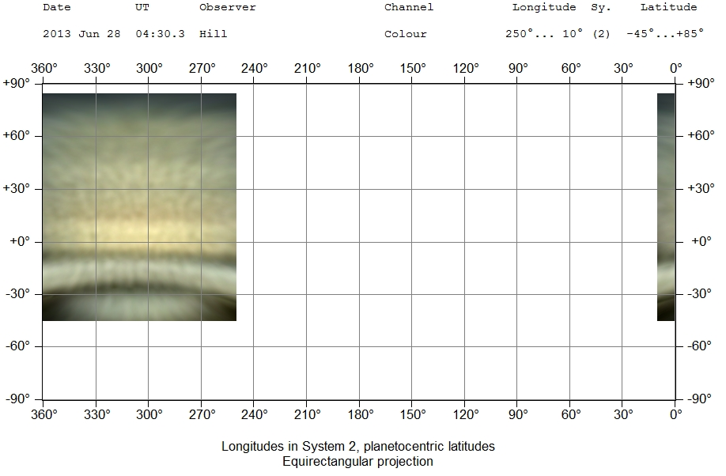

2013-06-28-0430.3-Hill-Saturn-WinJUPOSStacked-Wavelets.jpg

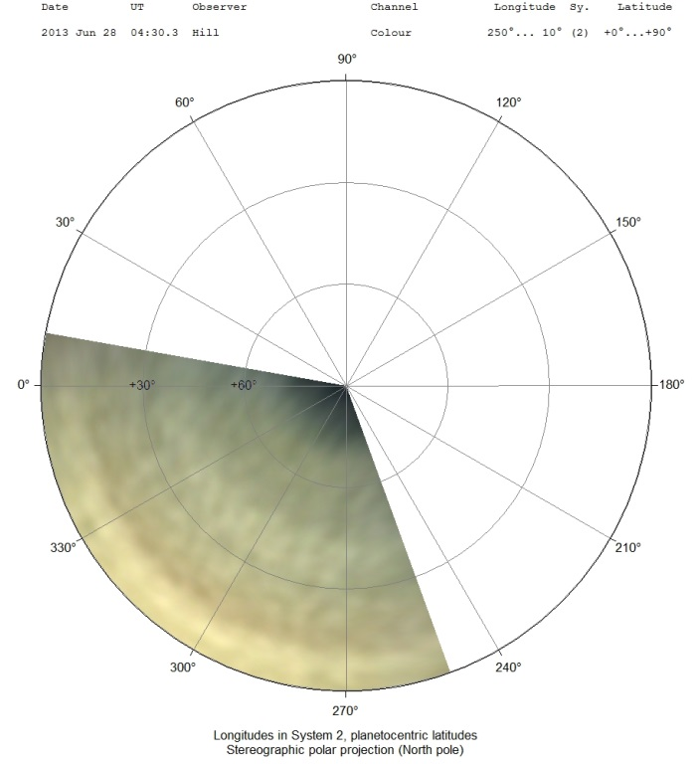

2013-06-28-0430.3-Hill-Saturn-WinJUPOSStacked-Wavelets-PolarMap.jpg

1. ***Zonal Measurement and Analysis***
   1. ***Measure belts and zones in ToUcam and multispectral images (need a means to identify non-RGB bands)***
   2. ***Create a macro for selections and creation of zonal drift charts (may one two to three here, e.g., one only for ToUcam, one integrated ToUcam and multispectral, and one just comparing multispectral and RGB over the apparition)***

|  |  |  |  |  |  |  |
| --- | --- | --- | --- | --- | --- | --- |
| H:\Notes\Planets\Saturn\Mapping\2013-06-28-0430.3-Hill-Saturn-WinJUPOSStacked-Wavelets-a-Cropped.jpg | H:\Notes\Planets\Saturn\Mapping\2013-06-10-0535.8-Hill-Saturn-MIH-Wavelets4x6.7-Cropped.jpg | H:\Notes\Planets\Saturn\Mapping\2013-06-10-0535.8-Hill-Saturn-CH4-Wavelets4x6.7-Cropped.jpg | H:\Notes\Planets\Saturn\Mapping\2013-06-10-0535.8-Hill-Saturn-NIR-Wavelets4x6.7-Cropped.jpg | H:\Notes\Planets\Saturn\Mapping\2013-06-10-0535.8-Hill-Saturn-Ha-Wavelets4x6.7-Cropped.jpg | H:\Notes\Planets\Saturn\Mapping\2013-06-10-0535.8-Hill-Saturn-Green-Wavelets4x6.7-Cropped.jpg | H:\Notes\Planets\Saturn\Mapping\2013-06-10-0535.8-Hill-Saturn-NUV-Wavelets4x6.7-Cropped.jpg |
| 2013-06-28-0430.3-Hill-Saturn-WinJUPOSStacked-Wavelets-a-Cropped.jpg | 2013-06-10-0535.8-Hill-Saturn-MIH-Wavelets4x6.7-Cropped.jpg | 2013-06-10-0535.8-Hill-Saturn-CH4-Wavelets4x6.7-Cropped.jpg | 2013-06-10-0535.8-Hill-Saturn-NIR-Wavelets4x6.7-Cropped.jpg | 2013-06-10-0535.8-Hill-Saturn-Ha-Wavelets4x6.7-Cropped.jpg | 2013-06-10-0535.8-Hill-Saturn-Green-Wavelets4x6.7-Cropped.jpg | 2013-06-10-0535.8-Hill-Saturn-NUV-Wavelets4x6.7-Cropped.jpg |

1. ***Meridional Measurement and Analysis***
2. ***Identify and measure phenomena in ToUcam and multispectral images***
3. ***Multi-band Photometric Analysis - Global (Maxim DL)***
4. ***Subtract backgrounds***
5. ***Determine total signal***
6. ***Create ratio image matrix***
7. ***Calibrate against Vega photometry to get absolutes?***

Process for image masking to get average signal rate:

* Start with stacked IEEE floating point image
* Set minimum threshold (use average background as a starting point) – enable and zero checked and ‘okay’
* Set maximum threshold to 1 DN above the minimum threshold (enabled, but uncheck ‘zero’)
* Set screen stretch to ‘range’ and use aperture photometry to verify the pixels all have the value used for the maximum threshold
* Do pixel math scaling the brightness by 1/max threshold
* Use aperture photometry to verify pixels of interest have a value of 1.0
* Change photometry type to ‘area’ and draw a box around the pixels of interest – the total signal is the number of contributing pixels

Computed plate scale from green image (TestStackGreen(wasHalphaMaybe)-IEEE-Flattened.fit) at 5500mm focal length. Equatorial diameter was given by WinJUPOS as 18.3 arcsec. Measured equatorial diameter on blue image was 60.42 pixels. This gives a plate scale of **0.3029 arcsec/pixel**. This is important for computing surface brightness for future comparisons.

Charts below are from: Saturn Broadband Spectrum 2013.xlsx

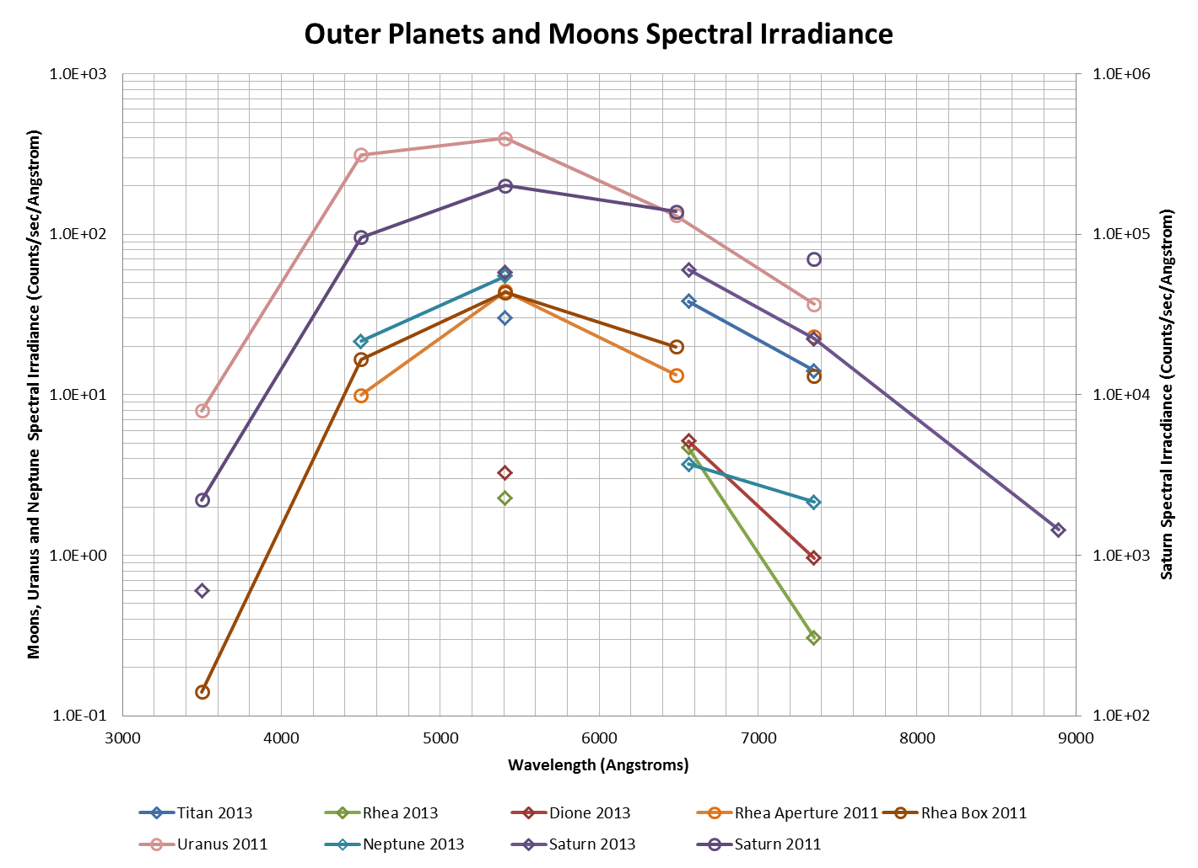

Saturn Broadband Spectrum 2013.xlsx

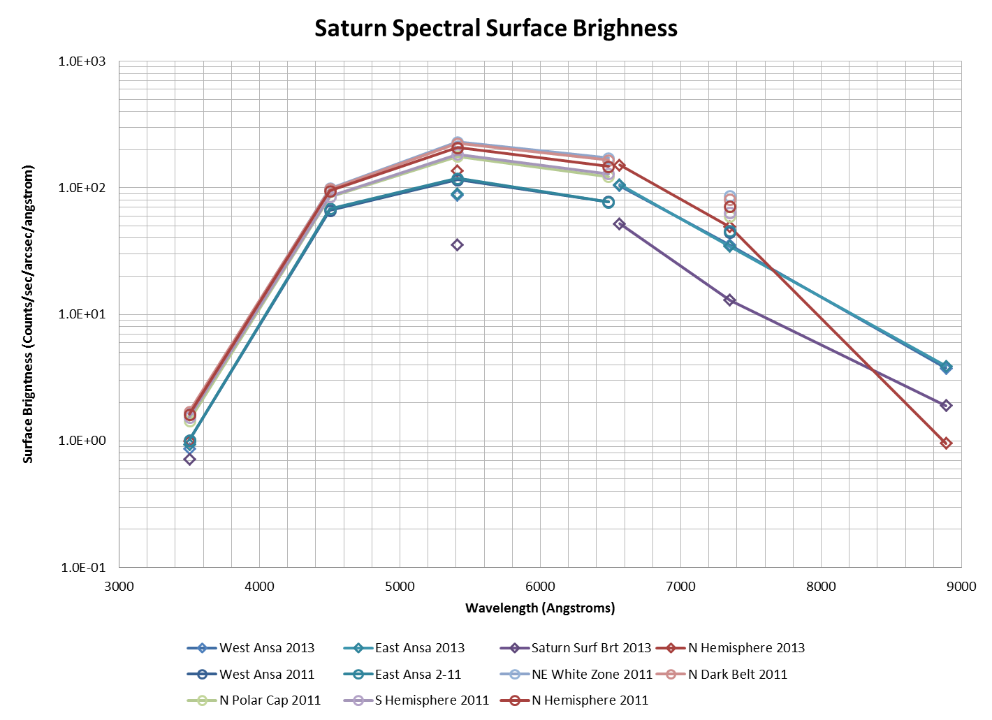

Saturn Broadband Spectrum 2013.xlsx

1. ***Multi-band Photometric - Regions of Interest (Maxim DL)***
   1. ***Zones***
   2. ***Belts***
2. ***Longitudinally Integrated Zonal Analysis (Maxim DL)***
   1. ***A test of more ‘sophisticated’ analysis to try to pull out finer zonal structure***

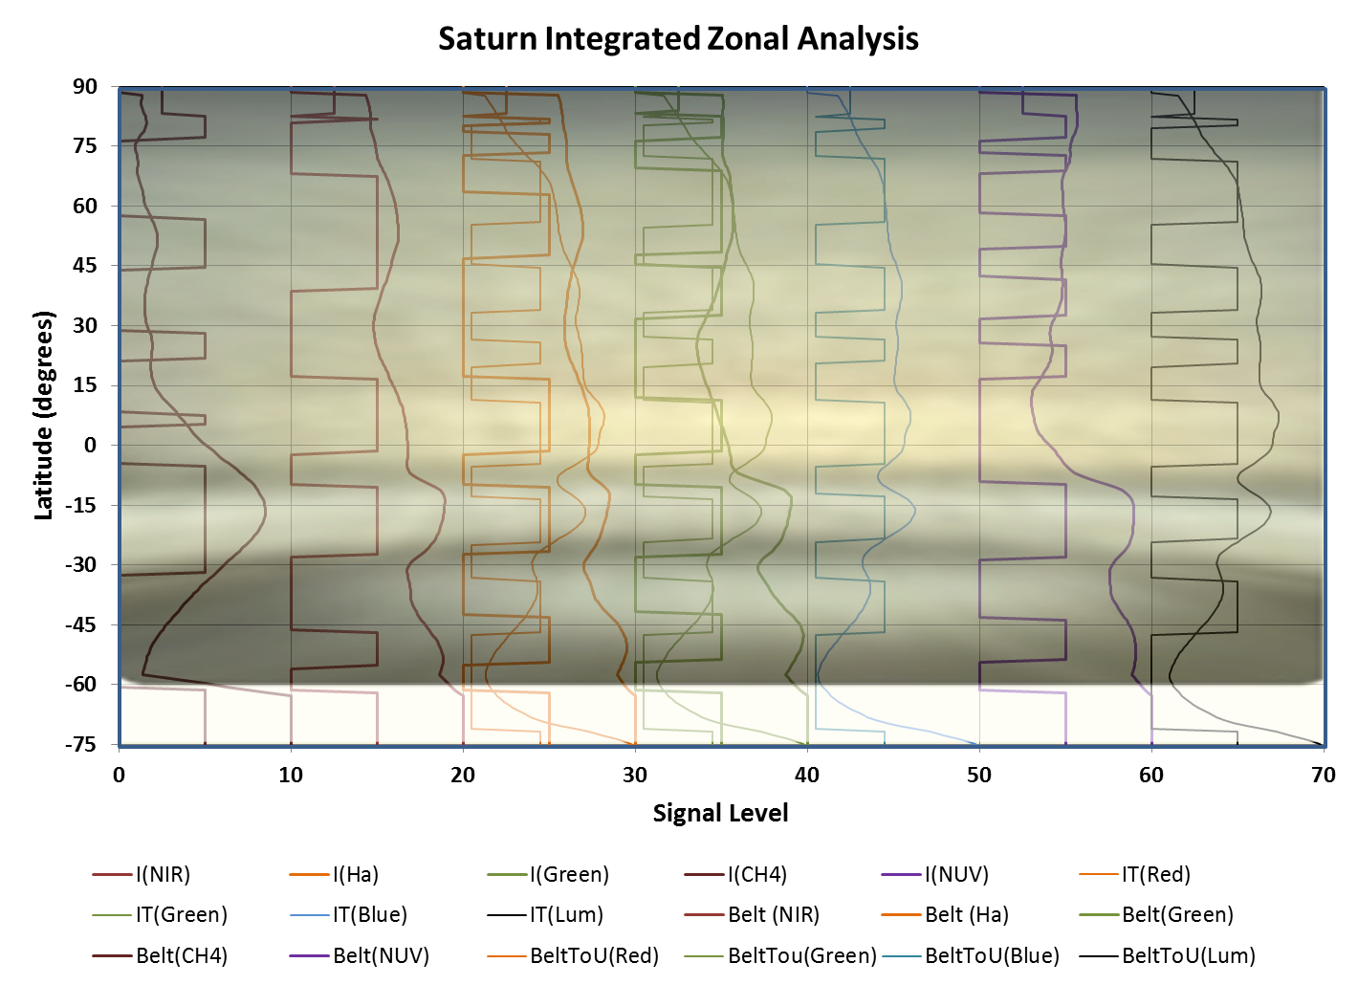

Saturn Band-Zone Analysis 2013.xlsx

* 1. ***Good to compare to WinJUPOS zonal measurements***

1. ***Multi-band Photometry of Saturnian Moons***
   1. ***Variation by central meridian?***
   2. ***Comparison to other solar system moons***
   3. ***Baseline from literature***
2. ***Spectroscopy***

NOTE: I may not have slanted all images in the baseline Saturn spectra in RSPEC. I originally thought the slant value 0.2 pix/pix applied to all images loaded once it was set. When I was doing rings and disk separately, I realized it needed to be reset for each image. It’s also not clear where the slant “center” is. If it moves vertically with the selected spectral window, there will be wavelength offsets compared to disk center.

Measured Dispersions based on linear H-alpha fits:

Saturn Integrated: 16.4034 A/pix

Saturn Disk: 16.4116 A/pix

Saturn Rings Avg: 16.4157 A/pix

Titan: 16.4034 A/pix

Saturn Disk (SaturnStacked-Clear-3sec-Cropped.fit) FWHM: 13 pixels (using horizontal box)

Saturn Rings (SaturnStacked-Clear-3sec-Cropped.fit) FWHM: 10 pixels (using horizontal box)

Titan (TitanStacked-Clear-15sec-Cropped.fit) FWHM: 5 pixels (using horizontal box)

Titan (TitanStacked-Clear-15sec-Cropped.fit) FWHM: 6.35 pixels (using aperture)

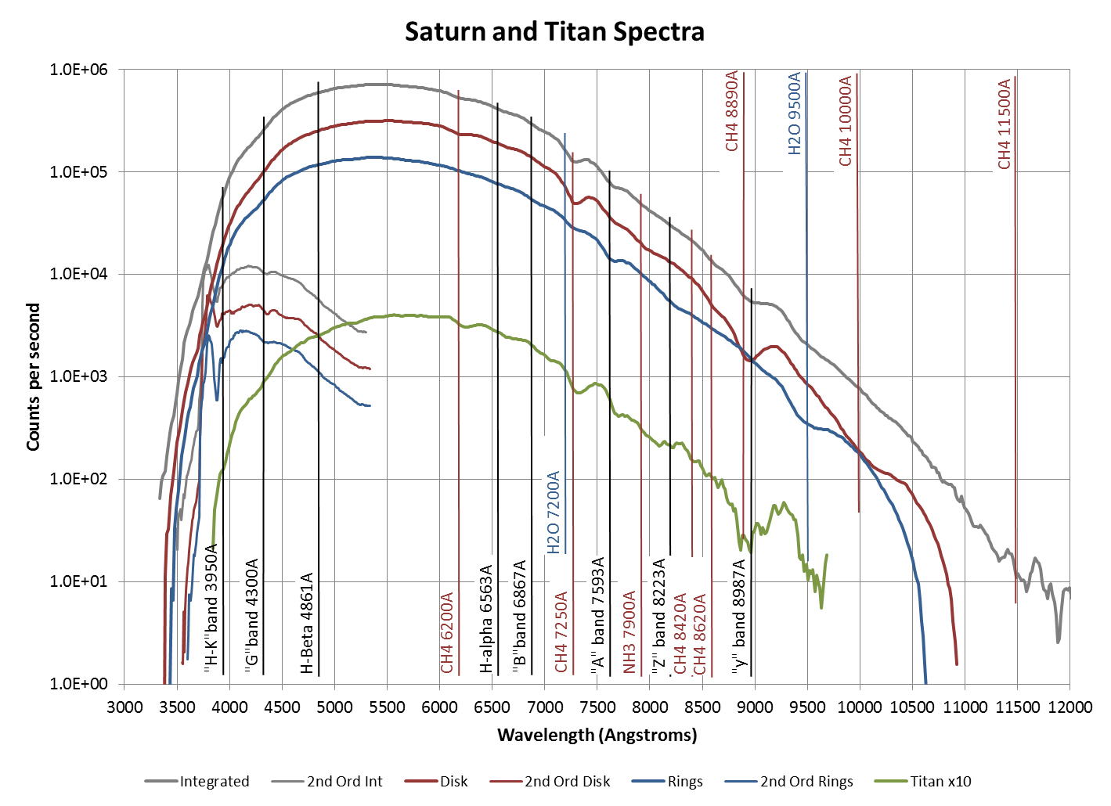

Saturn Spectrum - UHIOpnClrRev2.xlsx

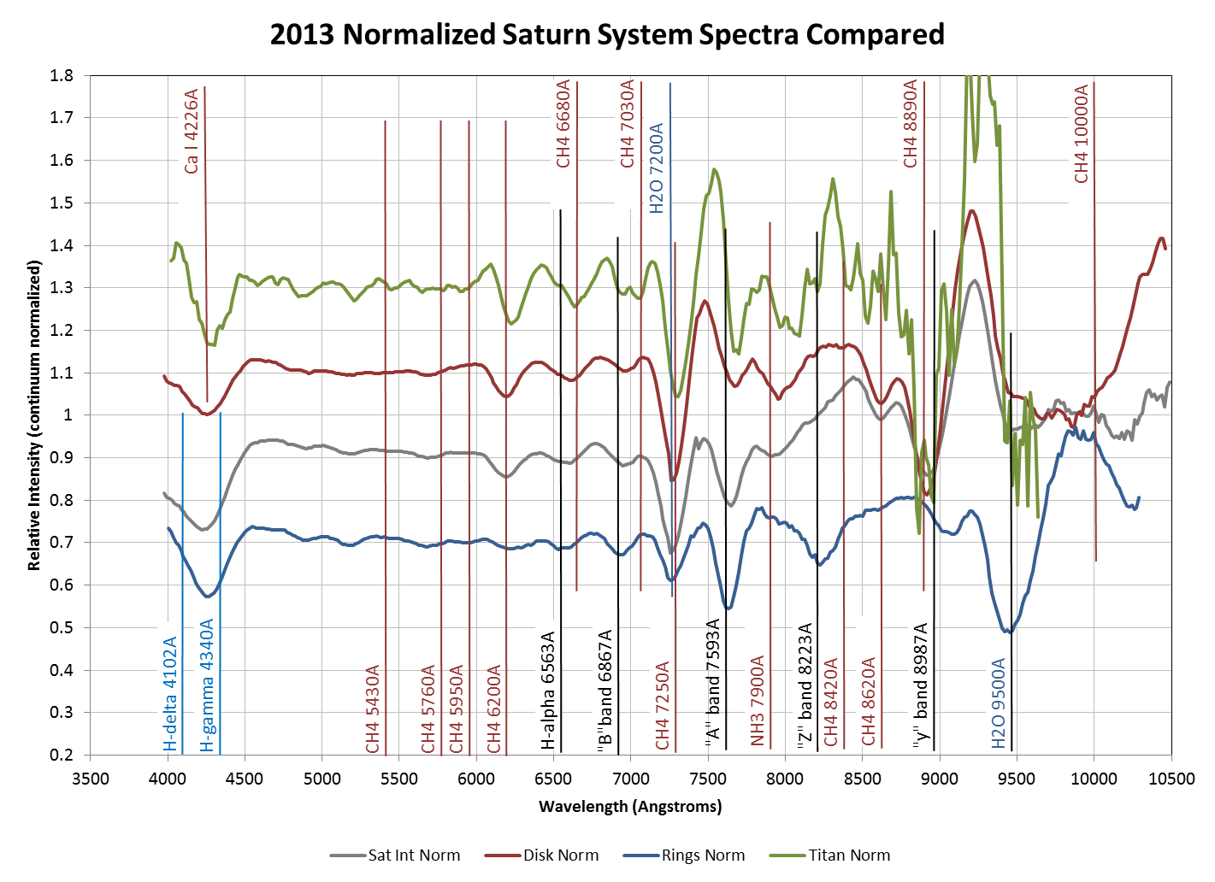

Saturn-Titan Profiles Stacked Charts.xlsx

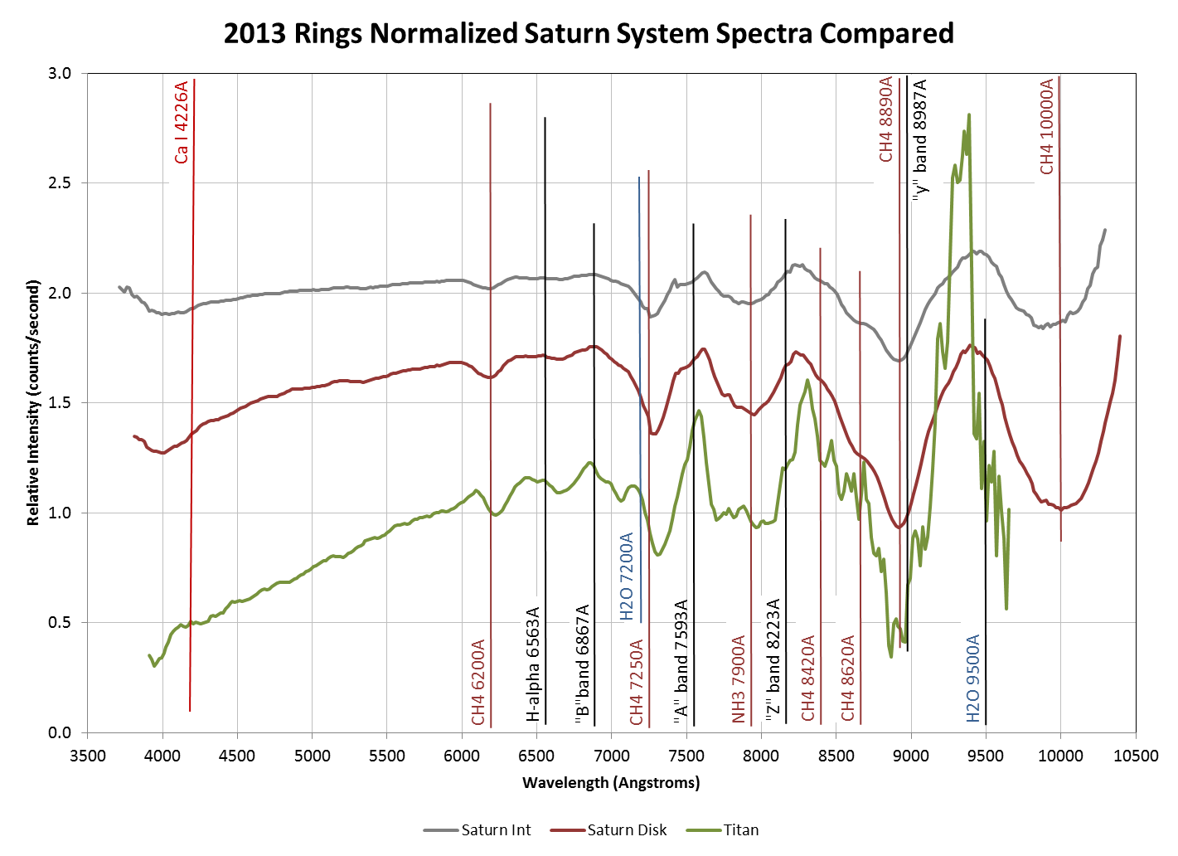

Saturn-Titan Profiles Stacked Charts.xlsx

d sin θn = nλ

d=0.01 mm = 10-5m

λ= 6563 A = 656.3x10-9 m

pix = 7.4x10-6 m/pix

n=1

θn=arcsin(nλ/d) = arcsin(656.3x10-9 m / 10-5m) = arcsin(656.3x10-4) = arcsin(0.06563) = 3.763 deg

Ha location = pix \* λ/dispersion = (7.4x10-6 m/pix) \* (656.3x10-9 m) / (1.64x10-9 m/pix) = 2.961x10-3 m = 2.961 mm

2.961mm = optical distance \* sin θn

Optical Distance = 2.961mm / sin θn =2.961 mm / 0.06563 = 45.12 mm

Chip size = 1200x1600. Long dimension = (7.4x10-6 m/pix) x 1800 pix = 8.88x11.84 mm

Chip diagonal = 14.80mm

Say we want the zero-order image and 1200nm on diagonally in first order. Allowing for a bit of slop, let’s use 10mm for the full dispersion. If rotated horizontally, that would correspond to (10x10-3 m) / (7.4x10-6 m/pix) = 1351 pixels. This would be a dispersion of 12000A/1351 pixels of 8.88 A/pix

**Challenges with Equivalent Widths**

**In R-spec, the options for spline fitting along with setting the continuum in for equiv widths are limited.**

**Need to be very careful on selecting band min and max wavelengths, especially on un-normalized data.**

* 1. ***Saturn***
  2. ***Ring Ansae***
  3. ***Titan***
  4. ***Other moons?***
  5. ***Equivalent Widths and Atmospheric Analysis***

|  |  |  |  |  |  |  |  |  |
| --- | --- | --- | --- | --- | --- | --- | --- | --- |
| **Equivalent Widths (Å)** | | | | | | | | |
|  | **Saturn** | | | | **Titan** | | | |
| **Band Center (Å)** | **This Work** |  | **Other Work** |  | **This Work** |  | **Other Work** |  |
| 5430 | 1.26 | 1 | 3.01 | b | 1.46 | 1 | 2.83 | b |
|  |  |  | 3.23 | c |  |  | 4.2 | d |
|  |  |  |  |  |  |  |  |  |
| 5510 | 0.92 | 1 |  |  | 0.48 | 1 |  |  |
|  |  |  |  |  |  |  |  |  |
| 5760 | 1.50 | 1 | 1.49 | b | 2.15 | 1 | 1.49 | b |
|  |  |  |  |  |  |  |  |  |
| 5970 | 0.83 | 1 |  |  | 1.24 | 1 |  |  |
|  |  |  |  |  |  |  |  |  |
| 6190 | 19.30 | 1 | 23.4-24.9 | d | 18.36 | 1 | 18.4-24.1 | d |
|  | 4.9-5.6 | 2 |  |  | 4.0-7.1 | 2 | 21 | e |
|  |  |  |  |  |  |  |  |  |
| 7250 | 81.89 | 1 | 106.8 | d | 69.94 | 1 | 82.6 | d |
|  | 31.5-48.7 | 2 |  |  | 33.1-58.3 | 2 |  |  |
|  |  |  |  |  |  |  |  |  |
| 7840 |  |  |  |  |  |  |  |  |
|  |  |  |  |  |  |  |  |  |
| 7924-30 |  |  |  |  |  |  |  |  |
|  |  |  |  |  |  |  |  |  |
| 8890 | 42.7-123.8 | 2 |  |  | 133.3-228.1 | 2 |  |  |
| (a) Orton |  |  |  |  | (1) 1996 |  |  |  |
| (b) Lutz et al, 1976 | |  |  |  | (2) 2013 Integrated | |  |  |
| (c) Cochran, 1982 | |  |  |  |  |  |  |  |
| (d) Lutz et al, 1982 | |  |  |  |  |  |  |  |
| (e) Moreno et al., 1991 | | |  |  |  |  |  |  |

* Broadband photometry
  + Spectra
    - All Saturn
    - Rings (each ansa)
    - Disk
    - Titan
    - Other moons where possible
    - Compare to 2011 (including converting 2011 to counts/Ang)
  + Mapping – does this make sense given the low spatial resolution?
  + Profiles
* Video
  + Mapping
  + Belt measurement
  + Moons?
* Spectroscopy
  + Saturn
    - Rings (each ansa)
    - Disk (disk minus rings?)
    - Titan

### Analysis: Uranus

Last Updated 9/11/2013

1. ***Mapping***
   1. ***Create new image files (ToUcam and multispectral)***
   2. ***Aggregate source images and .ics files***
   3. ***Create map files and associated macro, both for individual maps and for apparition map***
2. ***Zonal Measurement and Analysis***
3. ***Measure belts and zones in ToUcam and multispectral images (need a means to identify non-RGB bands)***
4. ***Create a macro for selections and creation of zonal drift charts (may one two to three here, e.g., one only for ToUcam, one integrated ToUcam and multispectral, and one just comparing multispectral and RGB over the apparition)***
5. ***Multi-band Photometric Analysis - Global (Maxim DL)***
6. ***Subtract backgrounds***
7. ***Determine total signal***
8. ***Create ratio image matrix***
9. ***Calibrate against Vega photometry to get absolutes?***
10. ***Multi-band Photometry of Uranian Moons***
11. ***Variation by central meridian?***
12. ***Comparison to other solar system moons***
13. ***Baseline from literature***
14. ***Spectroscopy***
    1. ***Uranus***

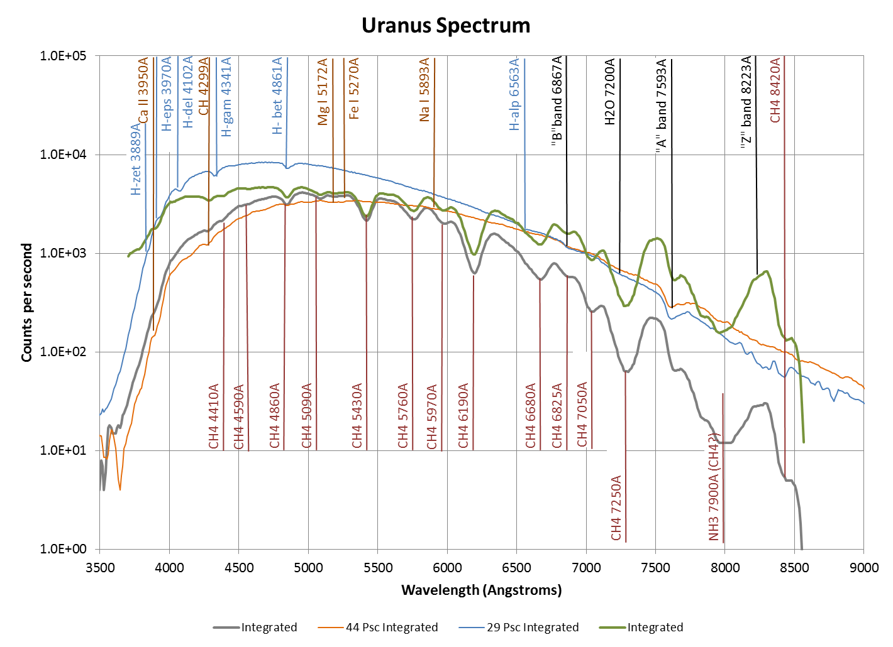

Uranus Spectrum 2013.xlsx

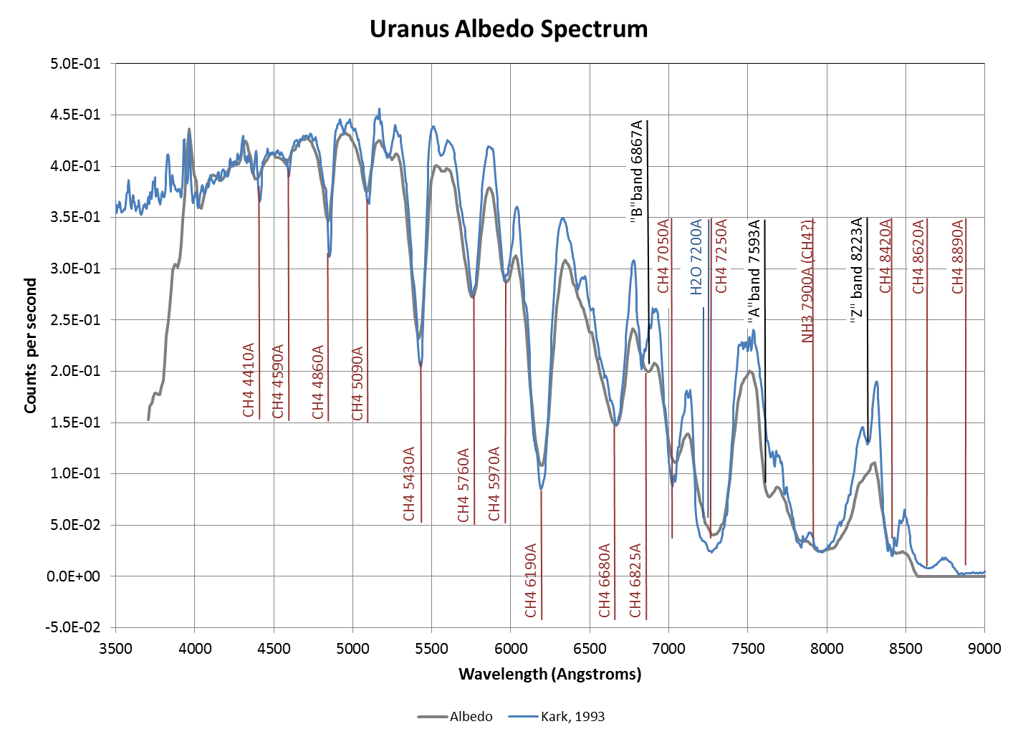

Uranus Spectrum 2013.xlsx

Uranus Spectrum 2013.xlsx

|  |  |  |  |  |  |
| --- | --- | --- | --- | --- | --- |
| **Band Center (Å)** | **LOI Obs EW** | **Mean Obs EW (Å)** | **Std Err of Mean (Å)** | **Std Err of Mean (%)** | **Ratio (Obs/LOI Obs)** |
| 4410 | 14 | 19.32 | 2.30 | 12% | 1.38\* |
| 4590 | 0 | 8.18 | 1.20 | 15% |  |
| 4860 | 69 | 64.75 | 1.45 | 2% | 0.94 |
| 5090 |  | 27.73 | 2.26 | 8% |  |
| 5430 | 171 | 149.65 | 1.63 | 1% | 0.88 |
| 5760 | 122 | 109.92 | 4.11 | 4% | 0.90 |
| 5970 |  | 32.96 | 0.54 | 2% |  |
| 6190 | 306 | 248.02 | 4.13 | 2% | 0.81 |
| 6680 |  | 196.19 | 3.96 | 2% |  |
| 6825 | 51 | 13.83 | 0.42 | 3% | 0.27\* |
| 7250 | 576 | 281.94 | 9.08 | 3% |  |
| 7250+7050 | 576 | 456.61 | 25.77 | 6% | 0.79 |
| 7593 |  | 73.84 | 5.64 | 8% |  |
| 8990 |  | 1123.79 | 31.62 | 3% |  |
| Average EW versus LOI | | | | | 0.86 |
| Standard Error of the Mean | | | | | 0.03 |

\*Outliers not used in computing average EW ratio (Obs/LOI Obs).

* 1. ***Moons– too much glare to do spectroscopy on moons***

### Analysis: Neptune

Last Updated 12/13/2013

My observations of Neptune were quite comprehensive this year in quantity, quality and diversity. I recorded Neptune on three nights:

SS\_obs\_2015.xlsx

|  |  |  |  |  |  |  |  |  |  |  |  |  |  |  |  |
| --- | --- | --- | --- | --- | --- | --- | --- | --- | --- | --- | --- | --- | --- | --- | --- |
| **Date (UT)** | **Size2** | **Mag** | **mag/as2** | **CM** | **LS** | **Triton** | **Mag** | **Sep** | **PA** | **Elevation** | **Seeing** | **Visual** | **Photo** | **Comments** | **Update** |
| 2013-Oct-23 04:11 | 2.3 | 7.9 | 9.4 | 340 | 334 |  |  |  |  | 35.0 |  | 0 | 1 | Spectra: Took CLR, HAL and NIR(685) spectra using the C8 at 1260mm FL (f/6.3), the ST-2000XM and the 100 line/mm grating. Used spacer in imaging train to get a bit more dispersion (~10A/pix - TBC). Also captured faint spectrum of Triton. UT time is midpoint of CLR and NIR exposures, which spanned more than an hour. Spectra of SigAqr were taken to use as instrumental/atmospheric calibration. | 2015-Nov-13 |
| 2013-Nov-03 03:21 | 2.3 | 7.9 | 9.4 | 101 | 334 | X | 13.5 |  |  | 35.0 | 2/5 | 0 | 1 | Imaging: Took broadband filtered images (685, HAL, GRN, BLU) using the C8 at 1260mm FL (f/6.3) and the ST-2000XM. UT time is midpoint of GRN exposure. The conditions were very non-photometric. High cirro-cumulous (is that a cloud type?) came in during the exposure series. I’m not sure precisely when. I’d rate transparency as starting at 3/5 declining to 1/5. Had wide enough field for relative photometry. NOTE: CDC and WinJUPOS do not agree on Sep and PA. I need to find what is authoritative. | 2015-Nov-13 |
| 2013-Nov-11 03:10 | 2.3 | 7.9 | 9.4 | 67 | 334 | X | 13.8 |  |  | 34.0 |  | 0 | 1 | Imaging: Took broadband filtered images (CLR, 685, RED, GRN, BLU) using the C8 at 5500mm FL (f/27.5) and the ST-2000XM. UT time is midpoint of CLR exposure. Very good seeing. Attempt to clearly resolve the disk. | 2015-Nov-13 |

1. ***Spatial Analysis***
   1. ***Astrometry***

Mag should be 7.9mV with a diameter of 2.3” from WinJUPOS (7.9 & 2.5” from CDC).

Plate scale was measured between TYC 5807-1418-1 and TYC 5806-646-1 to be 980.557 pixels and 998.700 arcsec (CDC measurement) to give 1.019 arcsec/pixel. Determining the centroids of Neptune and Triton by visual inspection gives a separation of 14.32 pixels or 14.58 arcseconds. Predicted separation (from SkySafari on my phone) was 13.3 arcsec. Measuring the centroid of Neptune using an aperture in MaximDL with a gap that excludes Triton results in a separation of 13.47 arcsec. There is too much contamination to measure Triton’s centroid by anything other than visual estimation. Only after wavelets processing in Registax (for the green channel) can we use the centroid method on both bodies. The result is 14.06 pixels or 14.33 arcseconds. The range of errors (0.17 to 1.28 arcsec) is generally worse than separation accuracies for double stars measure with much longer focal lengths and the ToUcam.

* 1. ***Image resolution***

Both tables are taken from NeptunePhotometry.txt. While the data from Nov. 3 appear to return a pretty good (<15% error) diameter for Neptune, the supposedly higher quality Nov. 12 data have much higher errors. My suspicion is that retrieving the unresolved FWHM from Triton is very problematic due to low signal and to scattering from Neptune. On the Nov. 3 data, there are a number of stars well away from scatter light and of significant brightness. It may be that combining the FWHM data from Uranus on Nov. 12, which had several good stars visible, my improve the diameter retrieval. The two planets would be at different airmasses, however. Note two additional problems:

1. The Triton separation data from SkySafari on my phone differs substantially (15.3” vs 15.8”) on the PDS rings node
2. Using only the Triton separation to determine plate scale is probably not a good idea. Better to combine with Uranus field data also.

|  |  |  |  |  |  |
| --- | --- | --- | --- | --- | --- |
| **FWHM Analysis (arcsec) for 2013-Nov-03 UT** | | | | | |
| **Object** | **B** | **G** | **H** | **I** | **Avg.** |
| TYC 5807-1418-1 | 4.51 | 4.60 | 5.11 | 5.08 | 4.83 |
| TYC 5807-1471-1 | 4.60 | 4.79 | 5.26 | 5.34 | 5.00 |
| TYC 5807-1138-1 | 4.33 | 4.65 | 5.69 | 5.04 | 4.93 |
| TYC 5806-646-1 | 4.43 | 4.78 | 5.66 | 5.24 | 5.02 |
| Avg. Star Obs. | 4.47 | 4.70 | 5.43 | 5.17 | 4.94 |
| **Neptune Obs.** | 4.72 | 4.73 | 6.58 | 5.30 | **5.33** |
| **Avg. Star Nept. RSS** | 5.05 | 5.25 | 5.91 | 5.68 | **5.47** |
| **Neptune Deconv.** | 1.53 | 0.49 | 3.72 | 1.13 | **2.00** |
| **Neptune Pred.** | 2.30 | 2.30 | 2.30 | 2.30 | **2.30** |
| **Error** | -0.77 | -1.81 | 1.42 | -1.17 | **-0.30** |
| **Error Pct.** | -33% | -79% | 62% | -51% | **-13%** |

|  |  |  |  |  |  |  |
| --- | --- | --- | --- | --- | --- | --- |
| **FWHM Analysis (arcsec) for 2013-Nov-12 UT** | | | |  |  |  |
| **Object** | **C** | **B** | **G** | **R** | **I** | **Avg.** |
| Triton X | 738.66 | 740.86 | 741.41 | 743.00 | 745.61 | 742.72 |
| Triton Y | 671.40 | 668.79 | 670.11 | 672.00 | 670.95 | 670.46 |
| Neptune X | 771.32 | 772.81 | 771.49 | 771.46 | 771.41 | 771.79 |
| Neptune Y | 646.82 | 643.85 | 646.46 | 647.07 | 646.05 | 645.86 |
| Separation (pix) | 40.88 | 40.54 | 38.27 | 37.84 | 35.86 | 38.13 |
| Separation Pred. (asec) | 15.30 | 15.30 | 15.30 | 15.30 | 15.30 | 15.30 |
| Plate Scale (as/pix) | 0.37 | 0.38 | 0.40 | 0.40 | 0.43 | 0.40 |
| Triton | - | 10.13 | 5.61 | - | - | 7.87 |
| Neptune Obs. (pix) | 13.20 | 13.53 | 11.40 | 11.42 | 11.31 | 11.91 |
| Neptune Obs. (asec) | **4.94** | **5.11** | **4.56** | **4.62** | **4.83** | **4.78** |
| Neptune Pred. | 2.30 | 2.30 | 2.30 | 2.30 | 2.30 | 2.30 |
| Error | 2.64 | 2.81 | 2.26 | 2.32 | 2.53 | 2.48 |
| Error Pct. | 115% | 122% | 98% | 101% | 110% | 108% |
| **Neptune Obs. Decon** |  | 8.97 | 9.93 |  |  | 8.95 |
| Neptune Obs. Decon(asec) |  | **3.39** | **3.97** |  |  | **3.59** |
| Neptune Pred. |  | 2.30 | 2.30 |  |  | 2.30 |
| Error |  | 1.09 | 1.67 |  |  | 1.29 |
| Error Pct. |  | 47% | 73% |  |  | 56% |

1. ***Multi-band Photometric Analysis of Neptune and Triton***

Photometric analysis of Neptune and Triton takes two forms. First a ‘bottom-up’ approach (hence called forward photometry) that works from counts per second and second a ‘top-down’ approach that uses comparison stars for relative photometry.

* 1. ***Forward Photometry***

To get the total raw signal, MaximDL aperture photometry was used. The data were entered in a spreadsheet[[1]](#footnote-1) and normalized for exposure time. In an effort to produce a raw, broadband spectrum, the data were then divided by the approximate band-pass (in terms of equivalent width) of the filters used for each image (giving signal in counts-s-1-Å-1).

A subsequent step that could be taken is calibrating the spectrum in flux units by dividing by instrumental sensitivity, including atmospheric absorption. No sensitivity measurements were made, e.g., by looking at comparison stars at similar elevation. However, an average response functions exists from other data, e.g., prior measurements of Vega, etc. This would give signal in terms of ergs-s-1-Å-1.

Finally, dividing by the measured flux by the spectrum of the Sun or other G2V star in each broadband bin would give the broadband albedo of Neptune and Triton. Of course, the spectrum would need to be computed in the first place and scaled to the incident solar flux at the top of Neptune’s atmosphere.

For the two days (2013-11-03 and 2013-11-12 UT) when photometric measurements were made, the first day had very poor and variable transparency. Thus, the data from that day have little value, but are displayed for completeness. The data for Neptune and Triton are shown in Figure 1 and Figure 2. Note that the flux is lower by a factor of 1.5 to 5.0 depending on wavelength. A substantial portion of the apparent wavelength dependence is likely due to temporal variations of the terrestrial cloud opacity on 2013-11-03.

One can also look at the ratio of flux from Triton and Neptune. In doing this, some of the temporal effects of cloud opacity may be reduced for 2013-11-03. Overall the flux ratio shows Triton to be 6.5 to 7.5 magnitudes dimmer than Neptune in the visible portion of the spectrum, with Triton brightening in the red. In the near IR, the ratio is 4.8 to 5.1 magnitudes showing the dramatic difference due to deep atmospheric methane absorption on Neptune versus relatively minor absorption on Triton due to methane ice.

Sky Safari shows Neptune’s magnitude to be 7.9 (presumably visual magnitude) and Triton’s to be 13.8 on 2013-11-12. This predicted difference of 5.9 magnitudes is less than that observed and may be due to systematic errors involving scattered light from Neptune. Because of Neptune’s color, blue scattered light would be emphasized. Using aperture photometry, any enhancement of Triton’s signal could be disproportionately reduced due to the annulus used for background subtraction approaching close to Neptune. This might be particularly true if the scattering gradient along the Neptune-Trition line were non-linear.

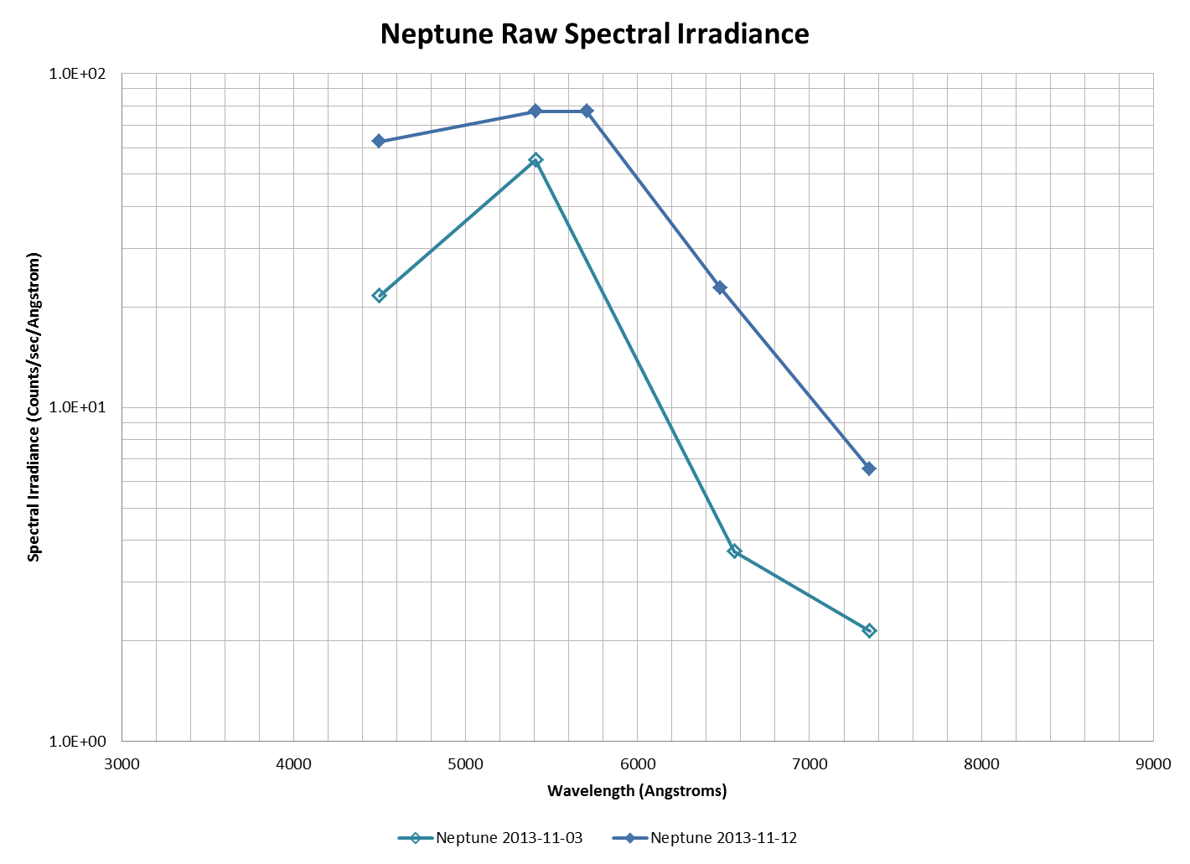

Figure 1: Neptune Spectral Irradiance[[2]](#footnote-2)

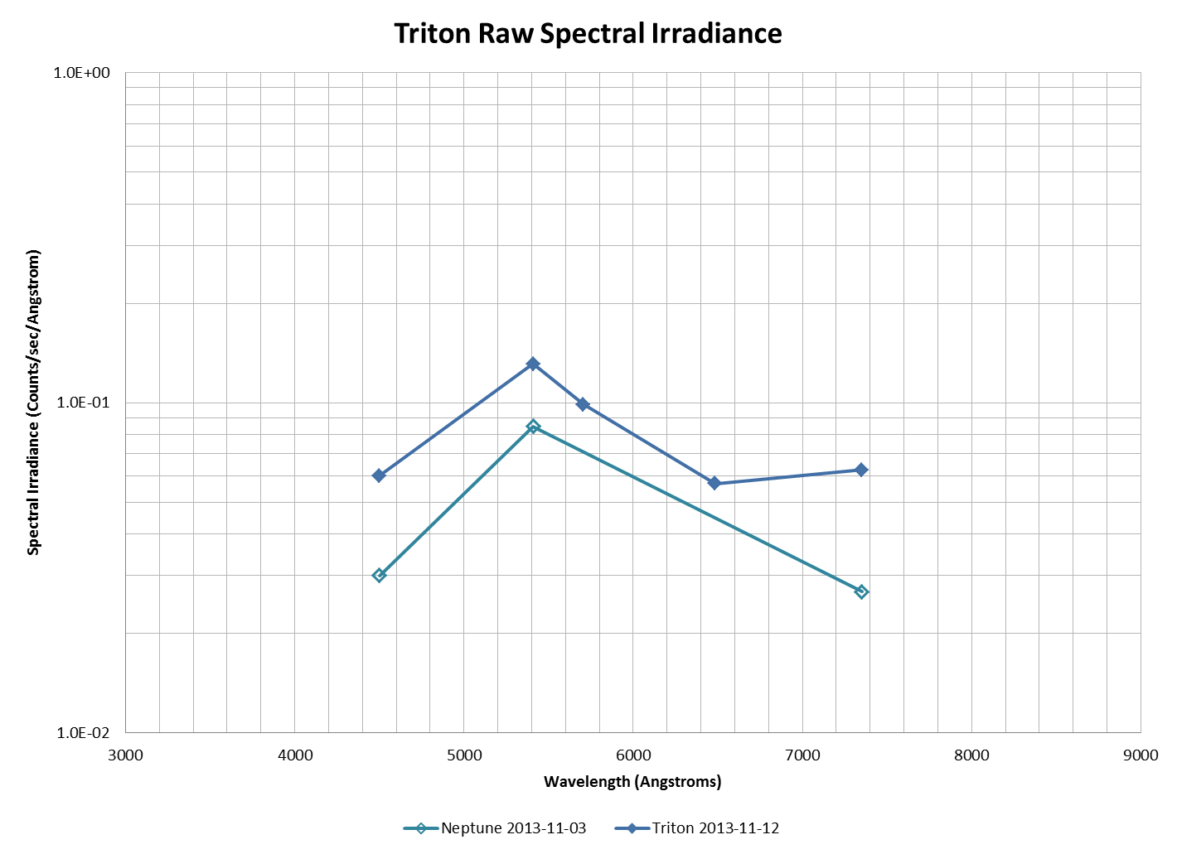

Figure 2: Triton Spectral Irradiance[[3]](#footnote-3)

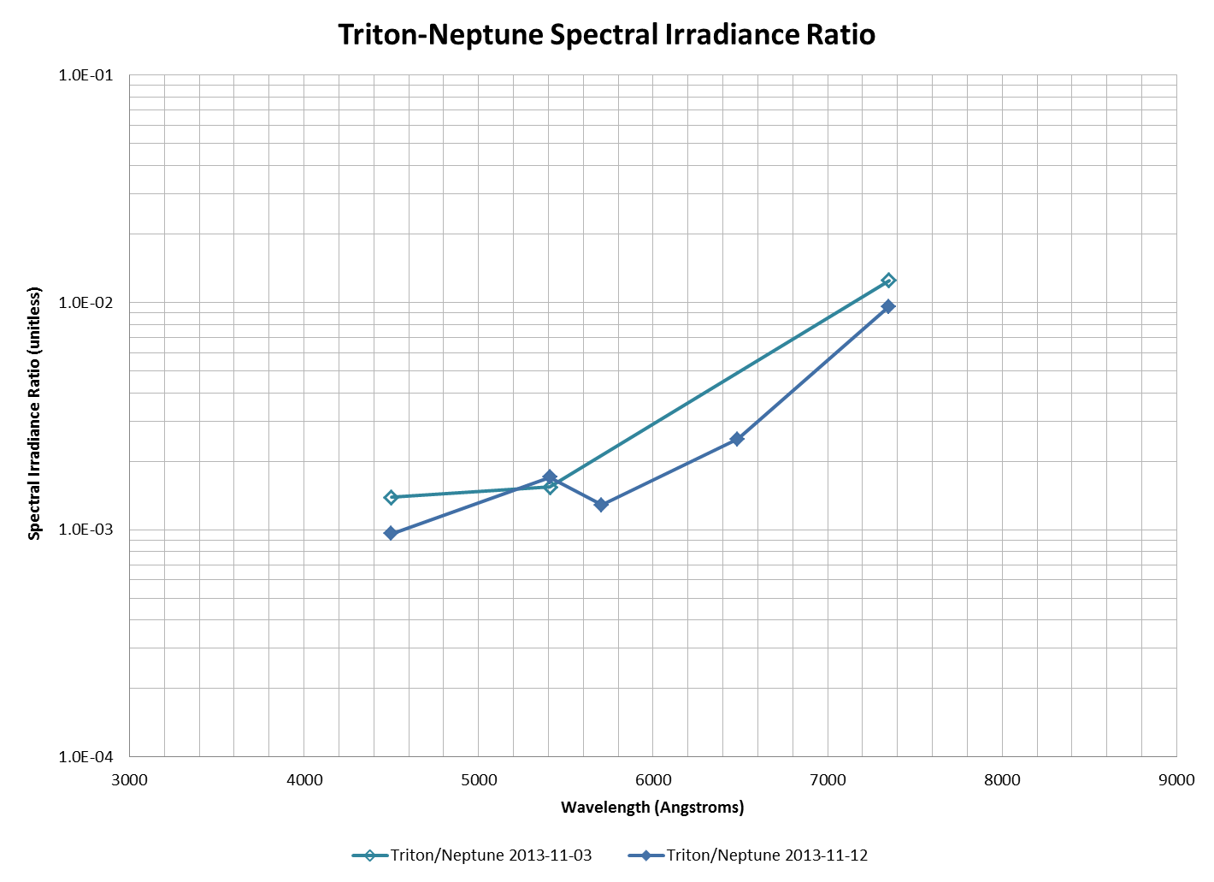

Figure 3: Triton/Neptune Spectral Irradiance Ratio[[4]](#footnote-4)

* 1. ***Relative Photometry***

Relative photometry was carried out on Neptune and Triton for the observations of 2013‑11‑03UT. Four comparison stars were available for the B and V bands and only one was available for the R and I bands. The comparison stars and their magnitudes are shown in Figure 4 and Table 2.

|  |  |
| --- | --- |
| H:\Astronomy\20131102\Neptune-20131102-RGB-FilteredBalancedScaled-HalfSize.jpg | H:\Astronomy\20131102\Neptune-20131102-RGB-FilteredBalancedScaled-Annotated-HalfSize.jpg |
| Neptune-20131102-RGB-FilteredBalancedScaled-HalfSize.jpg | Neptune-20131102-RGB-FilteredBalancedScaled-Annotated-HalfSize.jpg |

Figure 4: Neptune, Triton and reference stars

Table 2: Comparison Stars[[5]](#footnote-5)

|  |  |  |  |  |
| --- | --- | --- | --- | --- |
| **Star** | **B** | **V** | **R** | **I** |
| TYC 5807-1418-1 | 11.48 | 10.57 |  |  |
| TYC 5807-1471-1 | 10.93 | 10.39 |  |  |
| TYC 5807-1138-1 | 12.05 | 10.82 |  |  |
| TYC 5806-646-1 | 11.54 | 10.87 | 10.45 | 10.45 |
| Reference stars and brightnesses from SIMBAD | | | | |

Three different attempts were made at measuring the magnitude of Neptune and Triton, essentially varying the aperture parameters and the photometric band used for the comparison stars. Of the three attempts, the final one was the most controlled. The first two tries only worked with Neptune, assuming nothing could be done with Triton due to scattered light. Those two analyses used relatively large apertures and gaps (labelled Larger Aperture and Smaller Aperture in the Notes column of Table 3). The final attempt used a very narrow aperture with a radius of 4 pixels. The gap and annulus were each one pixel. The radius is tight enough to allow use on Triton and seems consistent with a FWHM that ranges from 4.25 to 6.46 pixels.

Table 3: Neptune Photometric Analysis

|  |  |  |  |  |  |  |  |  |
| --- | --- | --- | --- | --- | --- | --- | --- | --- |
| **T (JD)** | **B** | **V** | **R** | **I** | **Filter** | **N\*** | **Notes** | **Image File** |
| 2456599.664 | 8.138 | - | - | - | Blue | 4 | Smaller aperture | Neptune-20131102-Blue-180sec-Aligned.fit |
| 2456599.664 | 8.135 | - | - | - | Blue | 4 | Larger aperture | Neptune-20131102-Blue-180sec-Aligned.fit |
| 2456599.664 | 8.131 | - | - | - | Blue | 4 | 4,1,1 | Neptune-20131102-Blue-180sec.fit |
| 2456599.640 | - | 9.256 | - | - | Green | 4 | Smaller aperture | Neptune-20131102-Green-210sec-Aligned.fit |
| 2456599.640 | - | 9.171 | - | - | Green | 4 | Larger aperture | Neptune-20131102-Green-210sec-Aligned.fit |
| 2456599.640 | - | 7.617 | - | - | Green | 4 | 4,1,1 | Neptune-20131102-Green-210sec.fit |
| 2456599.648 | - | 8.412 | - | - | Ha | 3 | Larger aperture | Neptune-20131102-Ha-290sec-Aligned.fit |
| 2456599.648 | - | - | 6.497 | - | Ha | 1 | Larger aperture | Neptune-20131102-Ha-290sec-Aligned.fit |
| 2456599.648 | - | 8.700 | - | - | Ha | 4 | 4,1,1 | Neptune-20131102-Ha-290sec.fit |
| 2456599.648 | - | - | 7.931 | - | Ha | 1 | 4,1,1 | Neptune-20131102-Ha-290sec.fit |
| 2456599.656 | - | 9.470 | - | - | NIR | 4 | Larger aperture | Neptune-20131102-NIR-170sec-Aligned.fit |
| 2456599.656 | - | - | 8.554 | - | NIR | 1 | Larger aperture | Neptune-20131102-NIR-170sec-Aligned.fit |
| 2456599.656 | - | 9.139 | - | - | NIR | 1 | 4,1,1 | Neptune-20131102-NIR-170sec.fit |
| 2456599.656 | - | - | 8.530 | - | NIR | 1 | 4,1,1 | Neptune-20131102-NIR-170sec.fit |
| 2456599.656 | - | - | - | 8.430 | NIR | 1 | 4,1,1 | Neptune-20131102-NIR-170sec.fit |

Table 4: Triton Photometric Analysis

|  |  |  |  |  |  |  |  |  |
| --- | --- | --- | --- | --- | --- | --- | --- | --- |
| **T (JD)** | **B** | **V** | **R** | **I** | **Filter** | **N\*** | **Notes** | **Image File** |
| 2456599.664 | 14.407 | - | - |  | Blue | 4 | 4,1,1 | Neptune-20131102-Blue-180sec.fit |
| 2456599.640 | - | 14.647 | - |  | Green | 4 | 4,1,1 | Neptune-20131102-Green-210sec.fit |
| 2456599.656 | - | 13.463 | - | - | NIR | 1 | 4,1,1 | Neptune-20131102-NIR-170sec.fit |
| 2456599.656 | - | - | 12.854 | - | NIR | 1 | 4,1,1 | Neptune-20131102-NIR-170sec.fit |
| 2456599.656 | - | - | - | 12.754 | NIR | 1 | 4,1,1 | Neptune-20131102-NIR-170sec.fit |

The magnitudes above are approximate because they have not been converted to the actual bandpasses from the standard B-V system. However, if converted to top-of-atmosphere fluxes, they should be fairly accurate since all

<http://en.wikipedia.org/wiki/Photometric_system> - for effective band centers of standard photometric systems.

I need to plot the Triton magnitudes against the journal papers showing the magnitudes. I also need to set up a bibliography here.

1. ***Spectroscopy***
   1. ***Neptune***

Spectra of Neptune were taken through clear and NIR filters for order separation. Additionally, spectra were taken using a 7nm H-alpha filter to establish a baseline linear wavelength calibration. Additionally, spectra of the A0IV s star Sig Aqr were made to provide a flux calibration reference at similar air mass.

<<<Standard calibration was performed (bias and dark subtraction, flat fielding)?>>> All spectra were rotated horizontal in MaximDL, co-aligned with the zero-order image, and cropped for reduced file size. The 1-D spectral files (\*.dat) were then extracted using RSpec, including background subtraction to each side of the target spectrum. Linear calibration was established by the centroids of zero-order image and the H-alpha image and applied to all extracted spectra.

Data were then loaded into MS Excel for further analysis. The order-separated data were combined using their average in the overlapping wavelength range. Some boxcar smoothing was applied both at very short and very long wavelengths to partially mitigate the effects of lower signal-to-noise ratios.

The full range spectra were exported as MS DOS text files (extension changed to \*.dat) for further manipulation in RSpec. First, the reference library spectrum of an A0IV star was smoothed to approximately match the FWHM of the Sig Aqr data. The Siq Aqr data were then divided by the smoothed reference data to establish a response curve particular to the equipment configuration, atmospheric conditions, and air mass that night. That reference curve was then smoothed to remove artifacts remaining from small mismatches in wavelength calibration and FWHM. The Neptune spectrum was divided by the response curve to obtain a top-of-atmosphere flux spectrum.

Finally, the reference spectrum for a G2V star (solar type) was smoothed to the approximate FWHM of the flux calibrated Neptune spectrum. The Neptune spectrum was divided by the G2V spectrum to produce an albedo spectrum of Neptune. <<<Adjustment by multiplier?>>>

Albedo data from Karkoshka were downloaded for comparison to the observed albedo spectra.

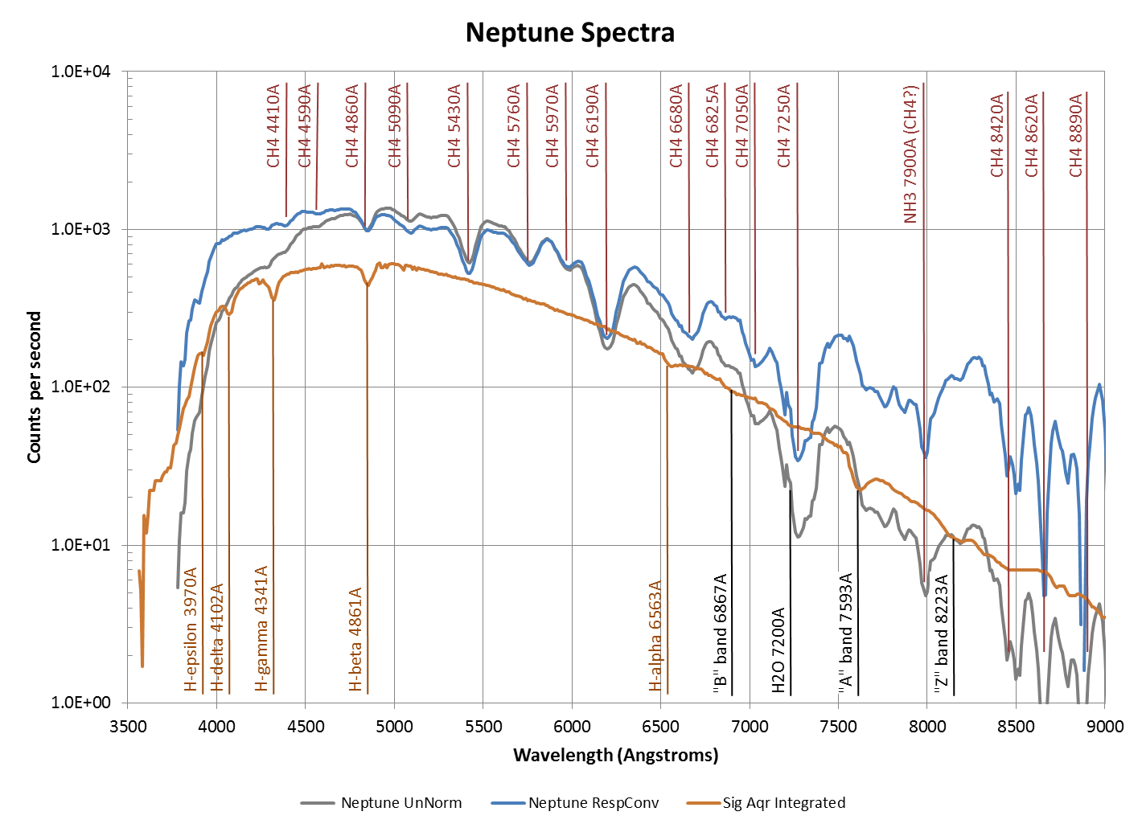

Neptune Spectrum 2013.xlsx



Response with Smoothed30+Smoothed1 Analysis.xlsx

NOTE: Should I show the G2V smoothed spectrum here as well? Perhaps show up front, prior to actual target spectra? Maybe I should also have other prior response curves, e.g., the Vega-based on from September 2013 for comparison purposes.

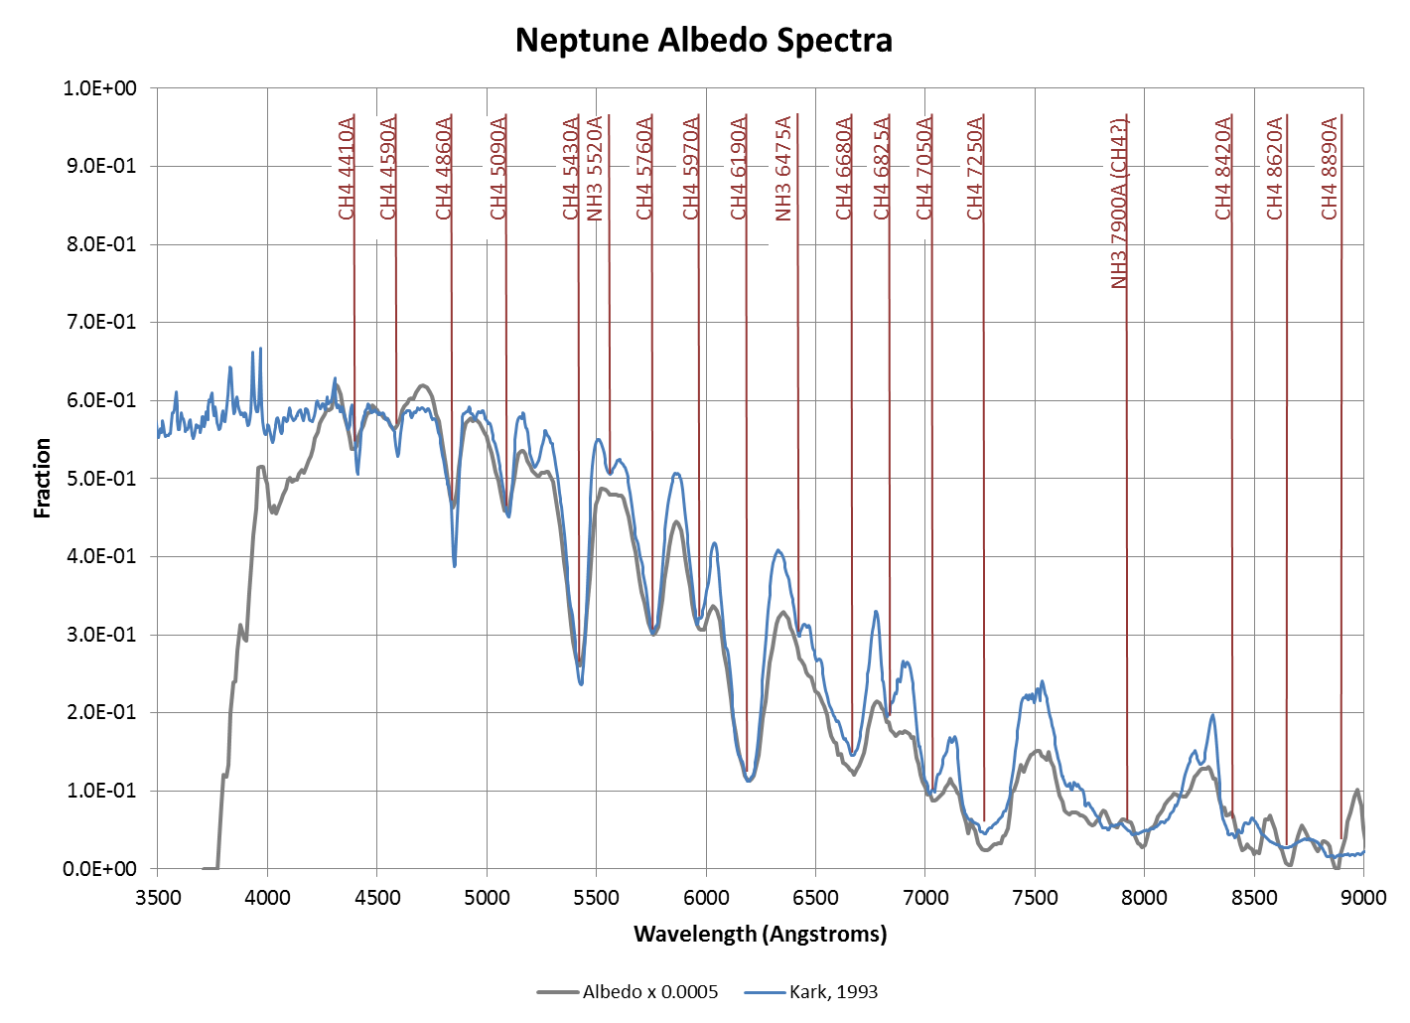

Neptune Spectrum 2013.xlsx

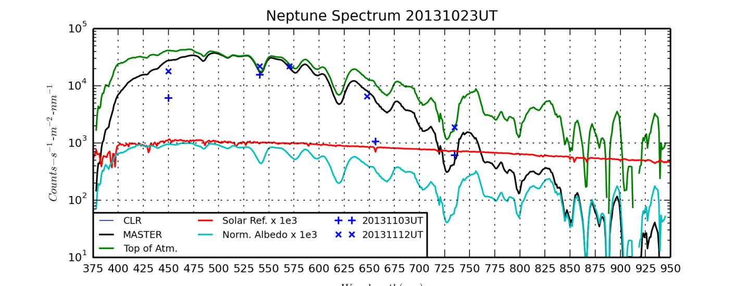

NeptuneSpectrum20131023UT.png (produced by NeptuneSpectrum20131023UT.py)

|  |  |  |  |  |  |
| --- | --- | --- | --- | --- | --- |
| **Band Center (Å)** | **LOI Obs EW** | **Mean Obs EW (Å)** | **Std Err of Mean (Å)** | **Std Err of Mean (%)** | **Ratio (Obs/LOI Obs)** |
| 4410 | 17 | 21.90 | 1.28 | 6% | 1.29\* |
| 4590 | 0 | 13.79 | 1.49 | 11% |  |
| 4860 | 88 | 68.77 | 4.66 | 7% | 0.78 |
| 5090 |  | 42.81 | 3.32 | 8% |  |
| 5430 | 190 | 164.14 | 4.22 | 3% | 0.86 |
| 5760 | 143 | 124.79 | 3.16 | 3% | 0.87 |
| 5970 |  | 44.46 | 0.61 | 1% |  |
| 6190 | 335 | 264.98 | 3.00 | 1% | 0.79 |
| 6680 |  | 241.17 | 3.02 | 1% |  |
| 6825 | 79 | 14.79 | 0.97 | 7% | 0.19\* |
| 7250 | 565 | 302.12 | 5.82 | 2% |  |
| 7250+7050 | 565 | 489.36 | 9.78 | 2% | 0.87 |
| 7593 |  | 63.42 | 8.67 | 14% |  |
| 8990 |  | 450.73 | 450.60 | 100% |  |
| Average EW versus LOI | | | | | 0.84 |
| Standard Error of the Mean | | | | | 0.02 |

\*Outliers not used in computing average EW ratio (Obs/LOI Obs).

* 1. ***Triton***

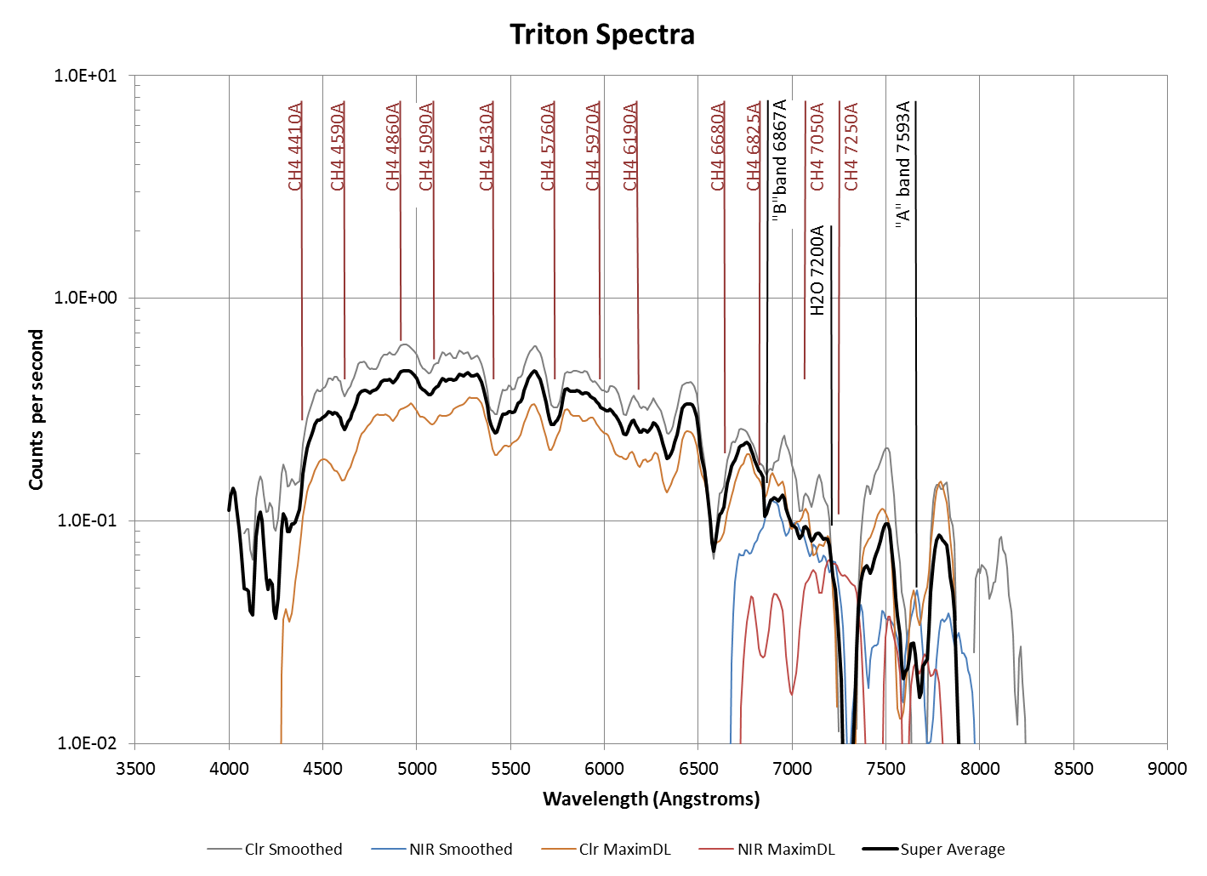

Neptune Spectrum 2013.xlsx

NOTE: I should compute the flux calibrated and albedo spectra for Triton. Triton is very challenging due to contamination from scattered Neptune spectra. After converting to albedo, it may be easier to differentiate and eliminate artifacts of that scattering.

### Analysis: Double Stars

Last Updated 1/22/2014

After six full years of observations, quite a number of stars are showing clear orbital motion. This year I added to the analysis an assessment of the average PA and separation values and their annual rates compared to WD6(?) orbital predictions. In addition, a full table of observations is provided for each star from the my first observation to the present. A summary of observations along with notes is shown in the table below.

|  |  |  |  |
| --- | --- | --- | --- |
| **Star** | **First Obs Date** | **2013 Obs Dates** | **Notes** |
| Castor A-B | 2008-02-19 | 2013-03-06  2013-03-07  2013-04-01 | While a bit noisy, orbital motion is clear. |
| Castor A-C | 2013-03-06  2013-03-07  2013-04-01 | 2013-03-06  2013-03-07  2013-04-01 | Made first measurements this year. |
| Zet Her | 2008.537 | 2013.539 | Has swept through 40 degrees of PA. |
| Eta CrB | 2009.512 | 2013.539 | Has swept through 30 degrees of PA. |
| Eps 1 Lyr | 2007.501 | 2013.816 | Slow mover with good separation, but PA seems to be drifting off WD6 predictions. |
| Eps 1 Lyr | 2007.501 | 2013.816 | Slow mover with good separation and orbital motion is not clear at this time. |
| BU 648 | 2008.637 | 2013.816 | Clear orbital motion, has swept through 15 degrees of PA. |
| Lam Oph | 2009.512 | 2013.816 | Only two measurements – orbital motion not yet evident. |
| 70 Oph | 2008.537 | 2013.816 | Orbital motion exquisitely clear, very tight fit to WD6 prediction. |
| Mu Dra | 2007.714 | 2013.816 | Orbital motion very clear, tight fit to WD6 prediction. |
| Mu Cyg | 2008.706 | 2013.816 | Only two measurements – orbital motion strongly suggested. |
| 61 Cyg | 2008.706 | 2013.816 | Only two measurements – orbital motion weakly suggested. |
| Eta Cas | 1994.961 | 2013.816 | Orbital motion evident, but somewhat noisy. |

Future work could include:

1. Plotting the linear fits in PA and separation on the orbital diagrams. Right now at most it is the end-points of those fits that are plotted.
2. Rigorously reassessing the errors around each measurement for use in weighted fits.
3. Documenting the residuals from the fits.
4. Using weighted fits rather than simple averages for the comparisons to the WD6 predictions.

**Castor**

|  |  |  |
| --- | --- | --- |
|  |  | |
|  | |  |  |  |  | | --- | --- | --- | --- | | **Parameter** | **Value** | **Rate** | **Units** | | PA(O) | 56.48 | -0.94 | deg(/yr) | | PA(P) | 56.50 | -0.63 | deg(/yr) | | PA (O-P) | -0.02 | -0.31 | deg(/yr) | | Sep(O) | 4.696 | 0.067 | asec(/yr) | | Sep(P) | 4.716 | 0.073 | asec(/yr) | | Sep (O-P) | -0.020 | -0.006 | asec(/yr) | |

|  |  |  |  |  |  |  |  |  |  |
| --- | --- | --- | --- | --- | --- | --- | --- | --- | --- |
| **Date** | **PA (O)** | **PA SD** | **Sep (O)** | **Sep SD** | **Notes** | **PA (P)** | **Sep (P)** | **PA (O-P)** | **Sep (O-P)** |
| 2008.137 | 57.94 | 2.31 | 4.740 | 0.193 | Good err. est. | 58.29 | 4.510 | -0.35 | 0.230 |
| 2009.079 | 58.56 | 0.55 | 4.798 | 0.152 | Good err. est. | 57.66 | 4.581 | 0.90 | 0.217 |
| 2009.197 | 58.15 | 0.12 | 4.493 | 0.025 | Good err. est. | 57.58 | 4.589 | 0.57 | -0.096 |
| 2010.027 | 56.51 | 0.26 | 4.803 | 0.056 | Good err. est. | 57.05 | 4.651 | -0.54 | 0.152 |
| 2010.082 | 57.72 | 1.00 | 4.619 | 0.100 | Unknown err. est. | 57.01 | 4.655 | 0.71 | -0.036 |
| 2011.079 | 55.61 | 1.00 | 4.716 | 0.100 | Unknown err. est. | 56.38 | 4.728 | -0.77 | -0.012 |
| 2012.189 | 56.07 | 1.00 | 4.622 | 0.100 | Unknown err. est. | 55.71 | 4.808 | 0.36 | -0.186 |
| 2013.175 | 52.87 | 1.16 | 4.464 | 0.135 | Good err. est. | 55.12 | 4.878 | -2.25 | -0.414 |
| 2013.178 | 56.09 | 1.00 | 5.047 | 0.100 | Unknown err. est. | 55.12 | 4.878 | 0.97 | 0.169 |
| 2013.246 | 55.26 | 0.93 | 4.658 | 0.124 | Good err. est. | 55.08 | 4.883 | 0.17 | -0.225 |

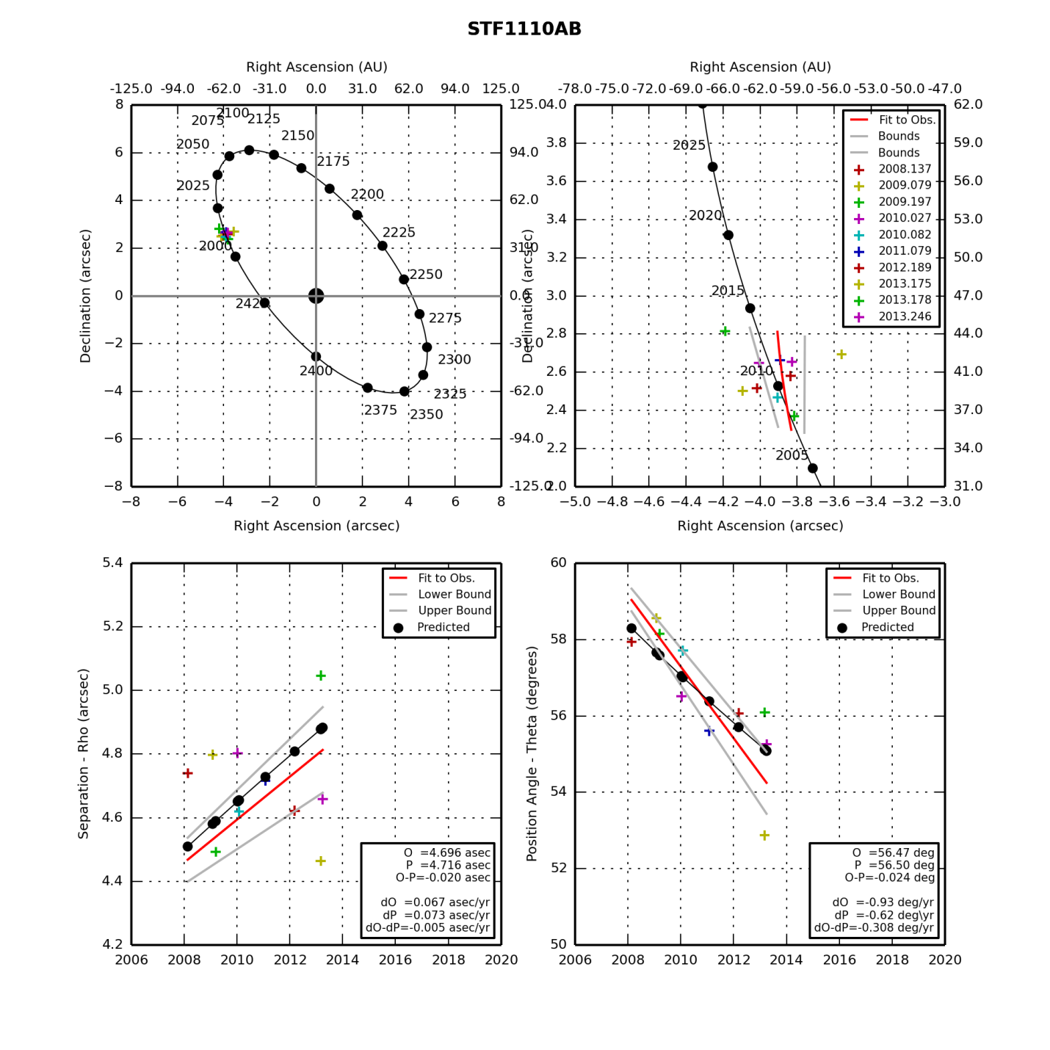

STF1110AB.png (created by StevesBinaryPlotterV05.py on 12/19/2014)

**Zeta Hercules**

|  |  |  |  |  |  |  |  |  |  |  |  |  |  |  |  |  |  |  |  |  |  |  |  |  |  |  |  |  |  |
| --- | --- | --- | --- | --- | --- | --- | --- | --- | --- | --- | --- | --- | --- | --- | --- | --- | --- | --- | --- | --- | --- | --- | --- | --- | --- | --- | --- | --- | --- |
|  | |  |  |  |  | | --- | --- | --- | --- | | **Parameter** | **Value** | **Rate** | **Units** | | PA(O) | 173.54 | -9.09 | deg(/yr) | | PA(P) | 179.20 | -8.37 | deg(/yr) | | PA (O-P) | -5.66 | -0.71 | deg(/yr) | | Sep(O) | 1.089 | 0.019 | asec(/yr) | | Sep(P) | 1.122 | 0.014 | asec(/yr) | | Sep (O-P) | -0.033 | 0.005 | asec(/yr) | |
|  |  |

|  |  |  |  |  |  |  |  |  |  |
| --- | --- | --- | --- | --- | --- | --- | --- | --- | --- |
| **Date** | **PA (O)** | **PA SD** | **Sep (O)** | **Sep SD** | **Notes** | **PA (P)** | **Sep (P)** | **PA (O-P)** | **Sep (O-P)** |
| 2008.537 | 173.53 | 0.99 | 1.050 | 0.200 | Unknown | 190.91 | 1.103 | -17.38 | -0.053 |
| 2008.630 | 187.32 | 0.40 | 1.085 | 0.020 | Unknown | 190.09 | 1.105 | -2.77 | -0.019 |
| 2008.709 | 186.51 | 0.22 | 0.890 | 0.030 | Tentative data reduction 10/17/08 | 189.39 | 1.106 | -2.88 | -0.215 |
| 2009.512 | 175.87 | 0.10 | 1.207 | 0.100 | Tentative data reduction 10/17/08 | 182.38 | 1.116 | -6.51 | 0.091 |
| 2010.564 | 167.54 | 0.10 | 1.248 | 0.100 | Tentative data reduction 10/17/09; Unknown err. Quality | 173.37 | 1.127 | -5.84 | 0.121 |
| 2013.539 | 150.87 | 2.34 | 1.053 | 0.100 | Good err. est.; Tentative reduction 7/18/13 | 149.02 | 1.174 | 1.85 | -0.121 |

**Eta Corona Borealis**

|  |  |  |  |  |  |  |  |  |  |  |  |  |  |  |  |  |  |  |  |  |  |  |  |  |  |  |  |  |  |
| --- | --- | --- | --- | --- | --- | --- | --- | --- | --- | --- | --- | --- | --- | --- | --- | --- | --- | --- | --- | --- | --- | --- | --- | --- | --- | --- | --- | --- | --- |
|  | |  |  |  |  | | --- | --- | --- | --- | | **Parameter** | **Value** | **Rate** | **Units** | | PA(O) | 176.74 | 6.59 | deg(/yr) | | PA(P) | 177.40 | 8.21 | deg(/yr) | | PA (O-P) | -0.66 | -1.62 | deg(/yr) | | Sep(O) | 0.640 | 0.035 | asec(/yr) | | Sep(P) | 0.622 | 0.024 | asec(/yr) | | Sep (O-P) | 0.018 | 0.011 | asec(/yr) | |
|  |  |

|  |  |  |  |  |  |  |  |  |  |
| --- | --- | --- | --- | --- | --- | --- | --- | --- | --- |
| **Date** | **PA (O)** | **PA SD** | **Sep (O)** | **Sep SD** | **Notes** | **PA (P)** | **Sep (P)** | **PA (O-P)** | **Sep (O-P)** |
| 2009.512 | 155.59 | 0.99 | 0.502 | 0.200 | Unknown Error | 163.10 | 0.577 | -7.50 | -0.075 |
| 2010.564 | 179.13 | 0.4 | 0.658 | 0.020 | Unknown Error | 172.95 | 0.615 | 6.18 | 0.042 |
| 2013.539 | 195.50 | 0.22 | 0.760 | 0.030 | Unknown Error | 196.16 | 0.673 | -0.66 | 0.086 |

**Eps 1 Lyr**

|  |  |  |  |  |  |  |  |  |  |  |  |  |  |  |  |  |  |  |  |  |  |  |  |  |  |  |  |  |  |
| --- | --- | --- | --- | --- | --- | --- | --- | --- | --- | --- | --- | --- | --- | --- | --- | --- | --- | --- | --- | --- | --- | --- | --- | --- | --- | --- | --- | --- | --- |
|  | |  |  |  |  | | --- | --- | --- | --- | | **Parameter** | **Value** | **Rate** | **Units** | | PA(O) | 346.39 | -0.93 | deg(/yr) | | PA(P) | 347.47 | -0.31 | deg(/yr) | | PA (O-P) | -1.09 | -0.62 | deg(/yr) | | Sep(O) | 2.355 | -0.011 | asec(/yr) | | Sep(P) | 2.330 | -0.012 | asec(/yr) | | Sep (O-P) | 0.025 | 0.001 | asec(/yr) | |
|  |  |

|  |  |  |  |  |  |  |  |  |  |
| --- | --- | --- | --- | --- | --- | --- | --- | --- | --- |
| **Date** | **PA (O)** | **PA SD** | **Sep (O)** | **Sep SD** | **Notes** | **PA (P)** | **Sep (P)** | **PA (O-P)** | **Sep (O-P)** |
| 2007.501 | 347.29 | 0.99 | 2.531 | 0.200 | Unknown Error | 348.37 | 2.366 | -1.07 | 0.164 |
| 2008.630 | 346.98 | 0.40 | 2.380 | 0.020 | Unknown Error | 348.03 | 2.352 | -1.04 | 0.027 |
| 2008.706 | 347.48 | 0.22 | 2.417 | 0.030 | Unknown Error | 348.00 | 2.351 | -0.52 | 0.065 |
| 2009.512 | 348.03 | 0.09 | 2.238 | 0.090 | Unknown Error | 347.76 | 2.341 | 0.27 | -0.103 |
| 2009.671 | 347.97 | 0.07 | 2.286 | 0.070 | Unknown Error | 347.71 | 2.339 | 0.26 | -0.053 |
| 2011.616 | 345.54 | 0.07 | 2.255 | 0.070 | Unknown Error | 347.11 | 2.315 | -1.56 | -0.060 |
| 2013.808 | 344.31 | 0.07 | 2.348 | 0.070 | Unknown Error | 346.41 | 2.287 | -2.10 | 0.060 |
| 2013.816 | 343.50 | 0.07 | 2.386 | 0.070 | Unknown Error | 346.41 | 2.287 | -2.90 | 0.098 |

**Eps 2 Lyr**

|  |  |  |  |  |  |  |  |  |  |  |  |  |  |  |  |  |  |  |  |  |  |  |  |  |  |  |  |  |  |
| --- | --- | --- | --- | --- | --- | --- | --- | --- | --- | --- | --- | --- | --- | --- | --- | --- | --- | --- | --- | --- | --- | --- | --- | --- | --- | --- | --- | --- | --- |
|  | |  |  |  |  | | --- | --- | --- | --- | | **Parameter** | **Value** | **Rate** | **Units** | | PA(O) | 78.18 | 0.02 | deg(/yr) | | PA(P) | 78.05 | -0.42 | deg(/yr) | | PA (O-P) | 0.13 | 0.44 | deg(/yr) | | Sep(O) | 2.313 | -0.018 | asec(/yr) | | Sep(P) | 2.370 | 0.003 | asec(/yr) | | Sep (O-P) | -0.058 | -0.021 | asec(/yr) | |
|  |  |

|  |  |  |  |  |  |  |  |  |  |
| --- | --- | --- | --- | --- | --- | --- | --- | --- | --- |
| **Date** | **PA (O)** | **PA SD** | **Sep (O)** | **Sep SD** | **Notes** | **PA (P)** | **Sep (P)** | **PA (O-P)** | **Sep (O-P)** |
| 2007.501 | 76.50 | 0.99 | 2.253 | 0.200 | Unknown Error | 79.266 | 2.362 | -2.77 | -0.109 |
| 2008.630 | 78.56 | 0.40 | 2.42 | 0.020 | Unknown Error | 78.793 | 2.365 | -0.23 | 0.055 |
| 2008.706 | 79.26 | 0.22 | 2.402 | 0.030 | Unknown Error | 78.761 | 2.365 | 0.50 | 0.037 |
| 2009.512 | 78.52 | 0.09 | 2.291 | 0.090 | Unknown Error | 78.425 | 2.368 | 0.10 | -0.077 |
| 2009.671 | 77.86 | 0.07 | 2.21 | 0.070 | Unknown Error | 78.358 | 2.368 | -0.50 | -0.158 |
| 2011.616 | 78.16 | 0.07 | 2.177 | 0.070 | Unknown Error | 77.549 | 2.374 | 0.61 | -0.197 |
| 2013.808 | 78.70 | 0.07 | 2.321 | 0.070 | Unknown Error | 76.642 | 2.381 | 2.06 | -0.060 |
| 2013.816 | 77.89 | 0.07 | 2.427 | 0.070 | Unknown Error | 76.639 | 2.381 | 1.25 | 0.046 |

**BU 648**

|  |  |  |  |  |  |  |  |  |  |  |  |  |  |  |  |  |  |  |  |  |  |  |  |  |  |  |  |  |  |
| --- | --- | --- | --- | --- | --- | --- | --- | --- | --- | --- | --- | --- | --- | --- | --- | --- | --- | --- | --- | --- | --- | --- | --- | --- | --- | --- | --- | --- | --- |
|  | |  |  |  |  | | --- | --- | --- | --- | | **Parameter** | **Value** | **Rate** | **Units** | | PA(O) | 256.57 | -2.88 | deg(/yr) | | PA(P) | 257.09 | -3.08 | deg(/yr) | | PA (O-P) | -0.51 | 0.20 | deg(/yr) | | Sep(O) | 1.189 | 0.040 | asec(/yr) | | Sep(P) | 1.051 | 0.042 | asec(/yr) | | Sep (O-P) | 0.138 | -0.002 | asec(/yr) | |
|  |  |

|  |  |  |  |  |  |  |  |  |  |
| --- | --- | --- | --- | --- | --- | --- | --- | --- | --- |
| **Date** | **PA (O)** | **PA SD** | **Sep (O)** | **Sep SD** | **Notes** | **PA (P)** | **Sep (P)** | **PA (O-P)** | **Sep (O-P)** |
| 2008.637 | 260.46 | 0.10 | 1.15 | 0.100 | Unknown Error | 261.73 | 0.99 | -1.27 | 0.161 |
| 2008.706 | 258.65 | 0.09 | 1.14 | 0.090 | Unknown Error | 261.44 | 0.99 | -2.79 | 0.147 |
| 2009.512 | 255.68 | 0.09 | 1.24 | 0.090 | Unknown Error | 258.51 | 1.03 | -2.83 | 0.212 |
| 2009.671 | 263.46 | 0.20 | 1.05 | 0.200 | Unknown Error | 257.96 | 1.04 | 5.50 | 0.014 |
| 2013.816 | 244.60 | 0.09 | 1.36 | 0.090 | Unknown Error | 245.79 | 1.20 | -1.19 | 0.155 |

**Lambda Ophiuchus**

|  |  |  |  |  |  |  |  |  |  |  |  |  |  |  |  |  |  |  |  |  |  |  |  |  |  |  |  |  |  |
| --- | --- | --- | --- | --- | --- | --- | --- | --- | --- | --- | --- | --- | --- | --- | --- | --- | --- | --- | --- | --- | --- | --- | --- | --- | --- | --- | --- | --- | --- |
|  | |  |  |  |  | | --- | --- | --- | --- | | **Parameter** | **Value** | **Rate** | **Units** | | PA(O) |  |  | deg(/yr) | | PA(P) |  |  | deg(/yr) | | PA (O-P) |  |  | deg(/yr) | | Sep(O) |  |  | asec(/yr) | | Sep(P) |  |  | asec(/yr) | | Sep (O-P) |  |  | asec(/yr) | |
|  |  |

|  |  |  |  |  |  |  |  |  |  |
| --- | --- | --- | --- | --- | --- | --- | --- | --- | --- |
| **Date** | **PA (O)** | **PA SD** | **Sep (O)** | **Sep SD** | **Notes** | **PA (P)** | **Sep (P)** | **PA (O-P)** | **Sep (O-P)** |
| 2009.512 |  |  |  |  |  |  |  |  |  |
| 2013.539 |  |  |  |  |  |  |  |  |  |
|  |  |  |  |  |  |  |  |  |  |

**70 Oph**

|  |  |  |  |  |  |  |  |  |  |  |  |  |  |  |  |  |  |  |  |  |  |  |  |  |  |  |  |  |  |
| --- | --- | --- | --- | --- | --- | --- | --- | --- | --- | --- | --- | --- | --- | --- | --- | --- | --- | --- | --- | --- | --- | --- | --- | --- | --- | --- | --- | --- | --- |
|  | |  |  |  |  | | --- | --- | --- | --- | | **Parameter** | **Value** | **Rate** | **Units** | | PA(O) | 130.96 | -1.00 | deg(/yr) | | PA(P) | 131.18 | -1.10 | deg(/yr) | | PA (O-P) | -0.23 | 0.11 | deg(/yr) | | Sep(O) | 5.789 | 0.140 | asec(/yr) | | Sep(P) | 5.770 | 0.131 | asec(/yr) | | Sep (O-P) | 0.019 | 0.010 | asec(/yr) | |
|  |  |

|  |  |  |  |  |  |  |  |  |  |
| --- | --- | --- | --- | --- | --- | --- | --- | --- | --- |
| **Date** | **PA (O)** | **PA SD** | **Sep (O)** | **Sep SD** | **Notes** | **PA (P)** | **Sep (P)** | **PA (O-P)** | **Sep (O-P)** |
| 2008.537 | 132.47 | 0.99 | 5.557 | 0.200 | Unknown Error | 133.379 | 5.503 | -0.91 | 0.054 |
| 2008.709 | 132.23 | 0.40 | 5.549 | 0.020 | Unknown Error | 133.164 | 5.530 | -0.93 | 0.019 |
| 2009.512 | 132.77 | 0.22 | 5.589 | 0.030 | Unknown Error | 132.192 | 5.652 | 0.58 | -0.063 |
| 2010.564 | 130.41 | 0.22 | 5.866 | 0.030 | Unknown Error | 130.977 | 5.803 | -0.57 | 0.063 |
| 2011.616 | 129.99 | 0.22 | 5.913 | 0.030 | Unknown Error | 129.822 | 5.941 | 0.17 | -0.028 |
| 2013.816 | 127.87 | 0.22 | 6.260 | 0.030 |  | 127.560 | 6.192 | 0.31 | 0.068 |

**Mu Dra**

|  |  |  |  |  |  |  |  |  |  |  |  |  |  |  |  |  |  |  |  |  |  |  |  |  |  |  |  |  |  |
| --- | --- | --- | --- | --- | --- | --- | --- | --- | --- | --- | --- | --- | --- | --- | --- | --- | --- | --- | --- | --- | --- | --- | --- | --- | --- | --- | --- | --- | --- |
|  | |  |  |  |  | | --- | --- | --- | --- | | **Parameter** | **Value** | **Rate** | **Units** | | PA(O) | 9.59 | -1.44 | deg(/yr) | | PA(P) | 6.39 | -1.08 | deg(/yr) | | PA (O-P) | 3.20 | -0.36 | deg(/yr) | | Sep(O) | 2.308 | 0.029 | asec(/yr) | | Sep(P) | 2.358 | 0.017 | asec(/yr) | | Sep (O-P) | -0.050 | 0.012 | asec(/yr) | |
|  |  |

|  |  |  |  |  |  |  |  |  |  |
| --- | --- | --- | --- | --- | --- | --- | --- | --- | --- |
| **Date** | **PA (O)** | **PA SD** | **Sep (O)** | **Sep SD** | **Notes** | **PA (P)** | **Sep (P)** | **PA (O-P)** | **Sep (O-P)** |
| 2007.714 | 17.82 | 4.22 | 1.900 | 0.680 | Unknown Error | 8.68 | 2.323 | 9.14 | -0.423 |
| 2008.537 | 10.70 | 0.32 | 2.299 | 0.140 | Unknown Error | 7.76 | 2.337 | 2.94 | -0.038 |
| 2008.709 | 9.13 | 1.84 | 2.380 | 0.070 | Unknown Error | 7.57 | 2.339 | 1.56 | 0.041 |
| 2009.512 | 8.67 | 1.84 | 2.344 | 0.070 | Unknown Error | 6.68 | 2.352 | 1.99 | -0.008 |
| 2010.564 | 7.78 | 1.84 | 2.431 | 0.070 | Unknown Error | 5.54 | 2.370 | 2.24 | 0.061 |
| 2013.816 | 3.43 | 1.84 | 2.496 | 0.070 |  | 2.10 | 2.426 | 1.33 | 0.070 |

**Mu Cyg**

|  |  |  |  |  |  |  |  |  |  |  |  |  |  |  |  |  |  |  |  |  |  |  |  |  |  |  |  |  |  |
| --- | --- | --- | --- | --- | --- | --- | --- | --- | --- | --- | --- | --- | --- | --- | --- | --- | --- | --- | --- | --- | --- | --- | --- | --- | --- | --- | --- | --- | --- |
|  | |  |  |  |  | | --- | --- | --- | --- | | **Parameter** | **Value** | **Rate** | **Units** | | PA(O) |  |  | deg(/yr) | | PA(P) |  |  | deg(/yr) | | PA (O-P) |  |  | deg(/yr) | | Sep(O) |  |  | asec(/yr) | | Sep(P) |  |  | asec(/yr) | | Sep (O-P) |  |  | asec(/yr) | |
|  |  |

|  |  |  |  |  |  |  |  |  |  |
| --- | --- | --- | --- | --- | --- | --- | --- | --- | --- |
| **Date** | **PA (O)** | **PA SD** | **Sep (O)** | **Sep SD** | **Notes** | **PA (P)** | **Sep (P)** | **PA (O-P)** | **Sep (O-P)** |
| 2008.706 |  |  |  |  |  |  |  |  |  |
| 2013.816 |  |  |  |  |  |  |  |  |  |
|  |  |  |  |  |  |  |  |  |  |

**61 Cyg**

|  |  |  |  |  |  |  |  |  |  |  |  |  |  |  |  |  |  |  |  |  |  |  |  |  |  |  |  |  |  |
| --- | --- | --- | --- | --- | --- | --- | --- | --- | --- | --- | --- | --- | --- | --- | --- | --- | --- | --- | --- | --- | --- | --- | --- | --- | --- | --- | --- | --- | --- |
|  | |  |  |  |  | | --- | --- | --- | --- | | **Parameter** | **Value** | **Rate** | **Units** | | PA(O) |  |  | deg(/yr) | | PA(P) |  |  | deg(/yr) | | PA (O-P) |  |  | deg(/yr) | | Sep(O) |  |  | asec(/yr) | | Sep(P) |  |  | asec(/yr) | | Sep (O-P) |  |  | asec(/yr) | |
|  |  |

|  |  |  |  |  |  |  |  |  |  |
| --- | --- | --- | --- | --- | --- | --- | --- | --- | --- |
| **Date** | **PA (O)** | **PA SD** | **Sep (O)** | **Sep SD** | **Notes** | **PA (P)** | **Sep (P)** | **PA (O-P)** | **Sep (O-P)** |
| 2008.706 |  |  |  |  |  |  |  |  |  |
| 2013.816 |  |  |  |  |  |  |  |  |  |
|  |  |  |  |  |  |  |  |  |  |

**Eta Cas**

|  |  |  |  |  |  |  |  |  |  |  |  |  |  |  |  |  |  |  |  |  |  |  |  |  |  |  |  |  |  |
| --- | --- | --- | --- | --- | --- | --- | --- | --- | --- | --- | --- | --- | --- | --- | --- | --- | --- | --- | --- | --- | --- | --- | --- | --- | --- | --- | --- | --- | --- |
|  | |  |  |  |  | | --- | --- | --- | --- | | **Parameter** | **Value** | **Rate** | **Units** | | PA(O) | 320.11 | 0.54 | deg(/yr) | | PA(P) | 320.48 | 0.46 | deg(/yr) | | PA (O-P) | -0.37 | 0.08 | deg(/yr) | | Sep(O) | 12.819 | 0.093 | asec(/yr) | | Sep(P) | 13.109 | 0.035 | asec(/yr) | | Sep (O-P) | -0.290 | 0.058 | asec(/yr) | |
|  |  |

|  |  |  |  |  |  |  |  |  |  |
| --- | --- | --- | --- | --- | --- | --- | --- | --- | --- |
| **Date** | **PA (O)** | **PA SD** | **Sep (O)** | **Sep SD** | **Notes** | **PA (P)** | **Sep (P)** | **PA (O-P)** | **Sep (O-P)** |
| 1994.961 | 311.33 | 0.99 | 11.907 | 0.200 |  | 314.59 | 12.652 | -3.26 | -0.745 |
| 2009.082 | 320.30 | 0.40 | 12.923 | 0.020 |  | 321.10 | 13.162 | -0.80 | -0.239 |
| 2010.082 | 322.30 | 0.22 | 12.950 | 0.030 |  | 321.54 | 13.194 | 0.76 | -0.244 |
| 2011.079 | 323.49 | 0.22 | 12.891 | 0.030 |  | 321.98 | 13.226 | 1.51 | -0.335 |
| 2013.816 | 323.11 | 0.22 | 13.423 | 0.030 |  | 323.18 | 13.311 | -0.07 | 0.112 |

### Analysis: Stellar Spectra

Last Updated 8/29/2015

The spectra taken this year represent my earliest attempts at spectroscopy. As such, they lack some of the consistency of observational procedure and analysis of spectra taken one or two years later. They do however, represent a treasure trove of data in terms of both spectra of a diverse group of main sequence stars as well as filter characterization.

The very first spectra, taken on Jan 9UT, located the 100 l/mm grating in the CFW8 filter wheel and used the 135mm lens at f/2.5. At this focal length the angle of incidence on the grating varied so much that it was impossible to achieve focus along any extended portion of the spectra.

The second set of spectra on Jan 17UT used the disperser as an objective grating with the 135mm lens. This gave a much larger dispersion, but also allowed the light from the sources to be at a uniform incidence angle giving focusable spectra. Nonetheless, I had hesitation about focus and only took spectra through color filters. This was to narrow the spectral range over which I needed to focus. I now certainly realize that this was unnecessary, but in retrospect it provides for excellent characterization of the color filter bandpasses.

**Rigel:**

**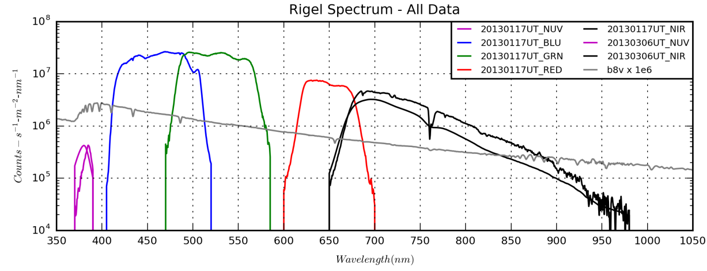**

**Aldebaran:**

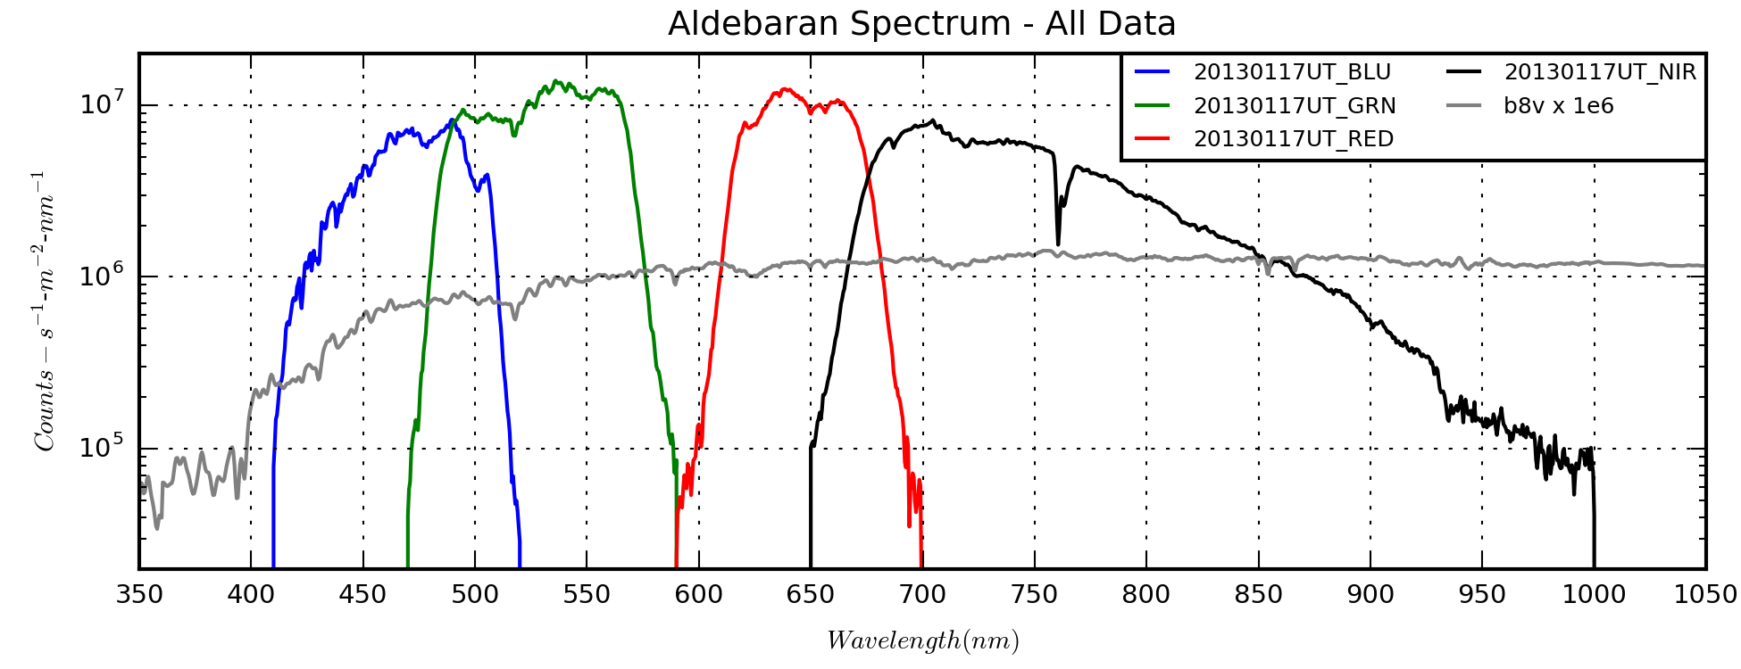

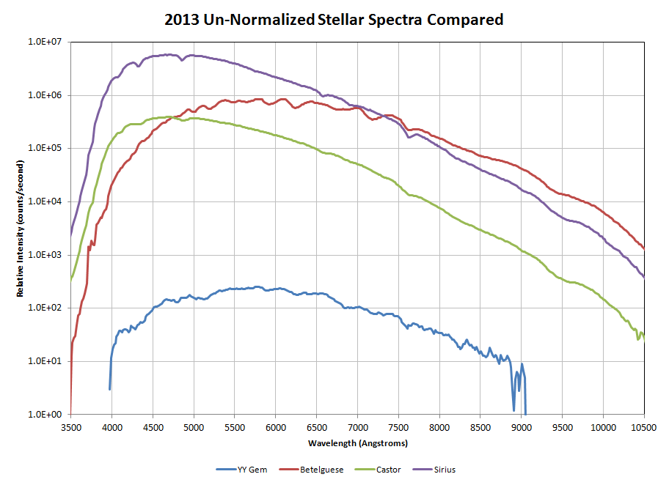

Profiles Stacked Charts.xlsx

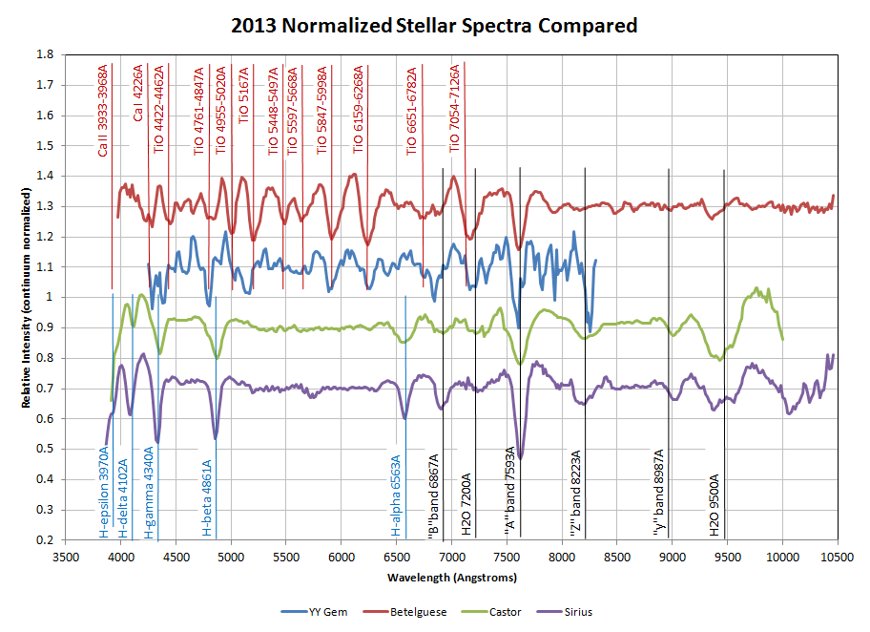

Profiles Stacked Charts.xlsx

### Analysis: Planetary Nebulae Spectra

Last Updated 1/15/2014

**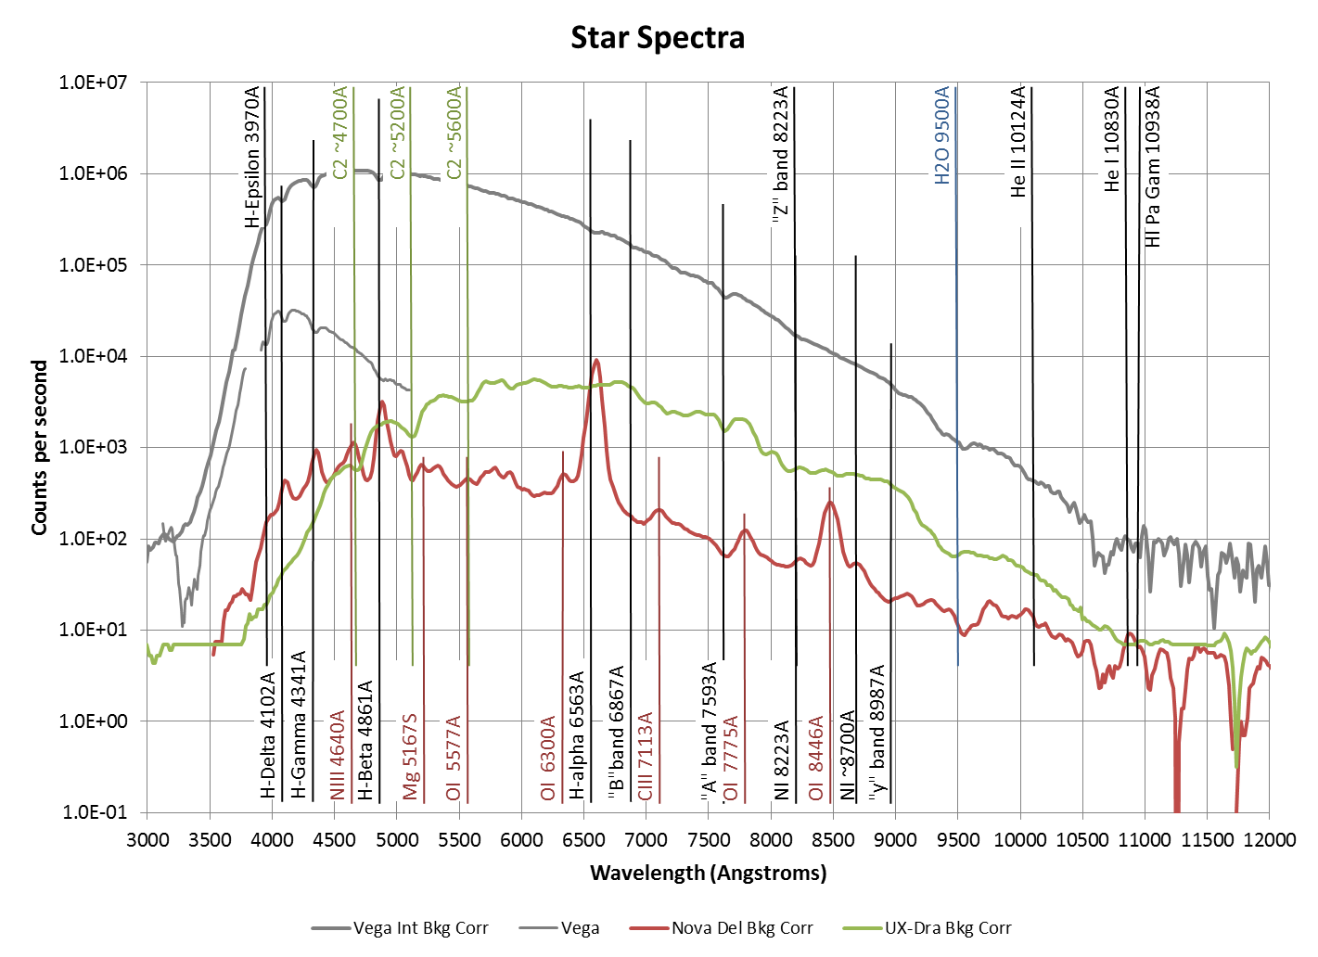**

2013-Stellar+PN-Spectra.xlsx

NOTE: I NEED TO NORMALIZE THESE SPECTRA AND PLOT STACKED!

**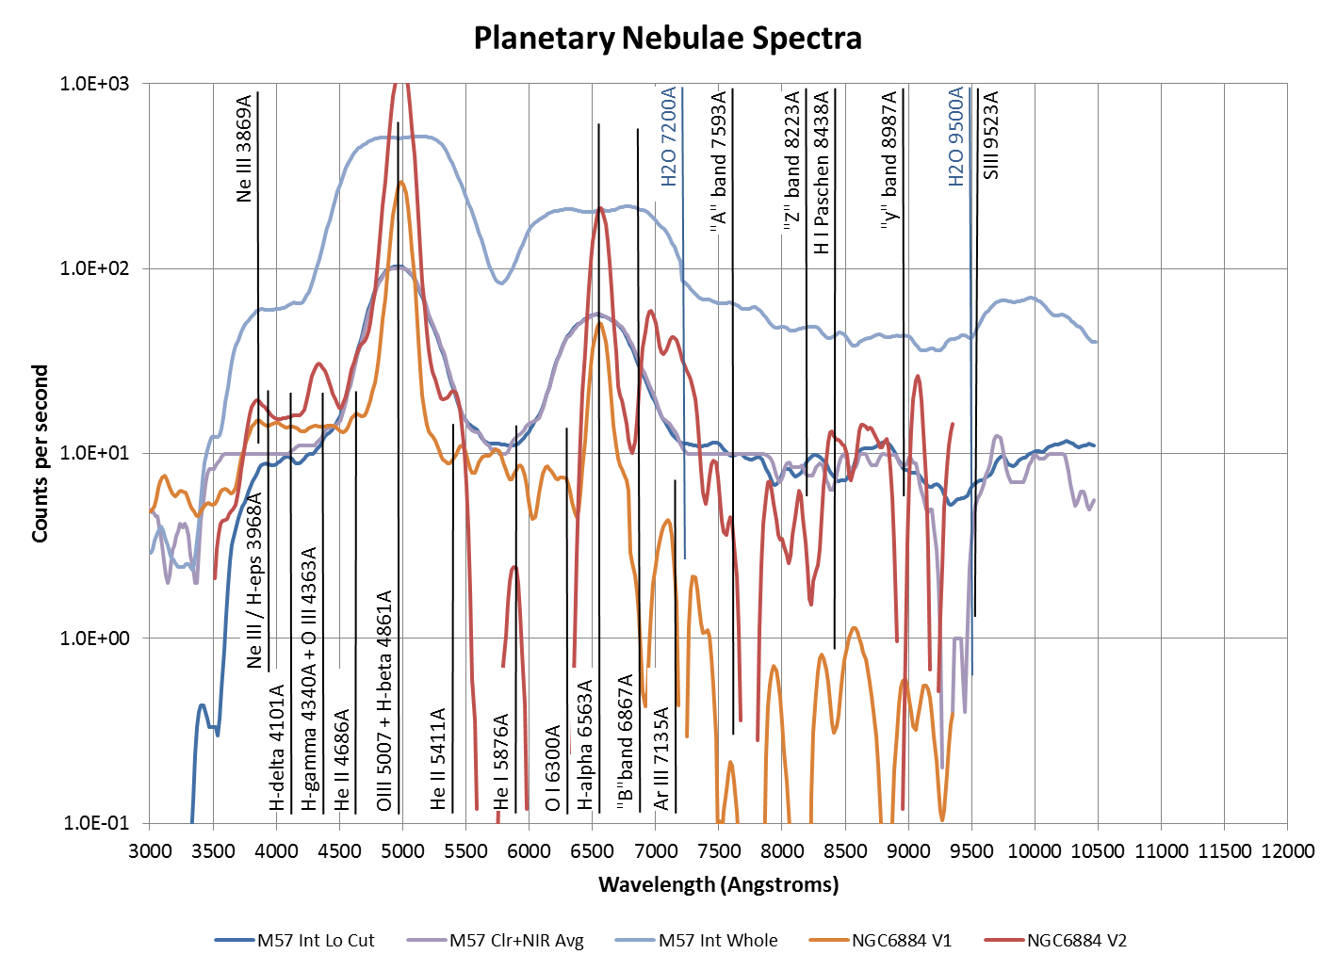**

2013-Stellar+PN-Spectra.xlsx

### Analysis: Nova Delphinus Spectra

Last Updated 1/15/2014

Line identification and subsequent velocity measurement appears to be very challenging.

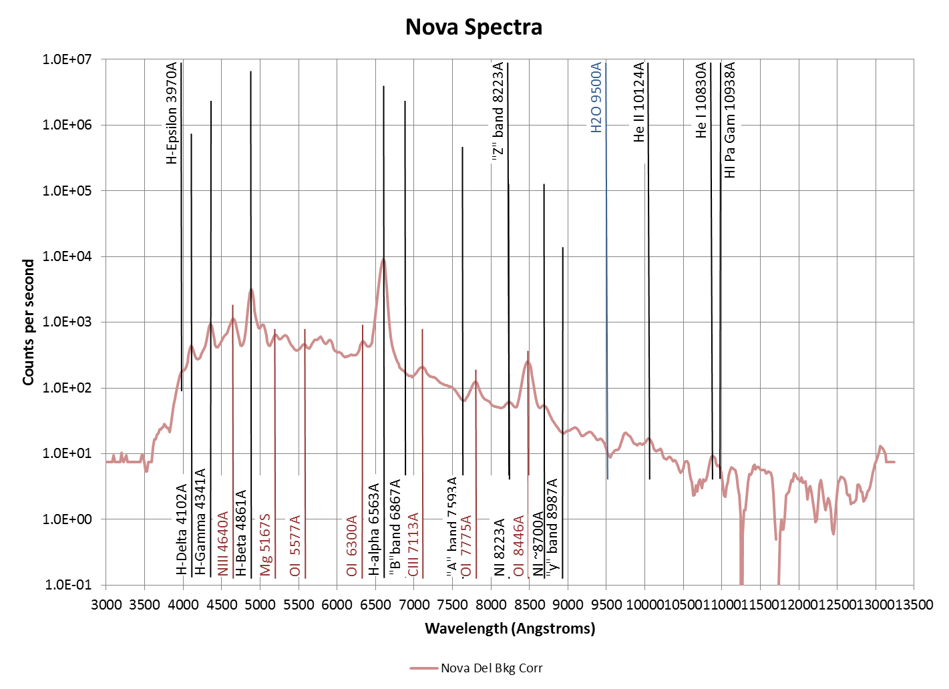

2013-Stellar+PN-Spectra.xlsx

Need to do bibliography here.

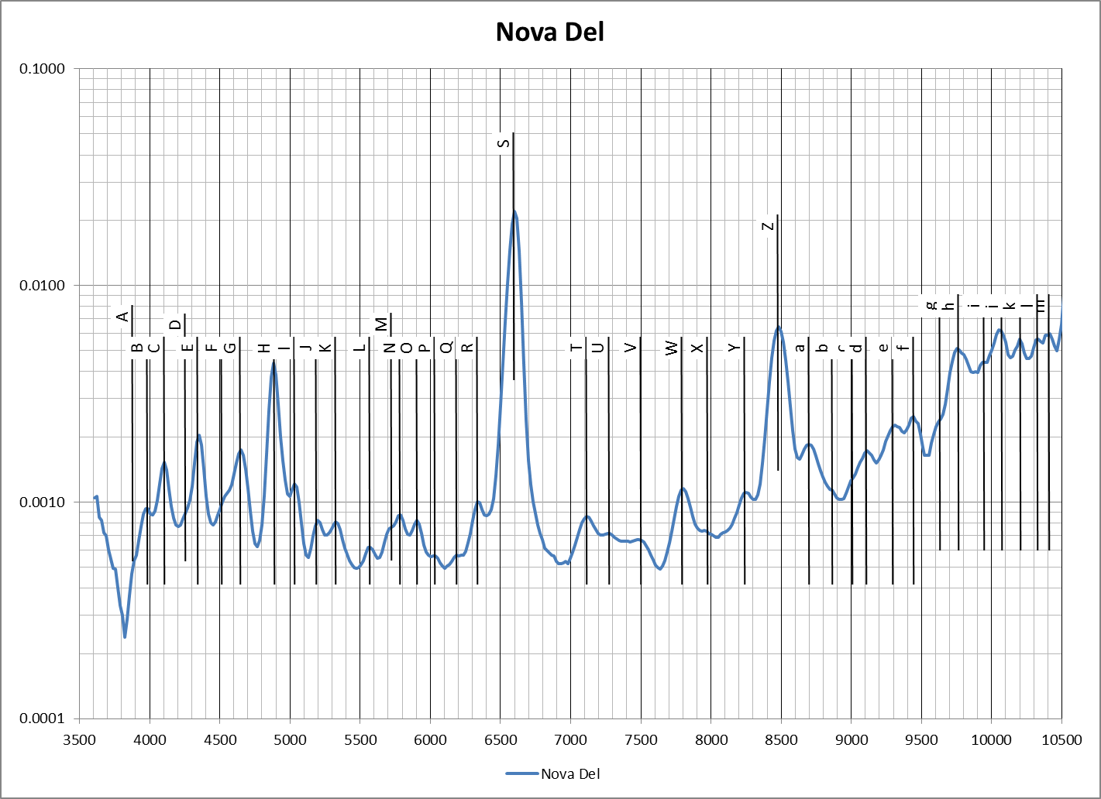

StackedCharts.xlsx

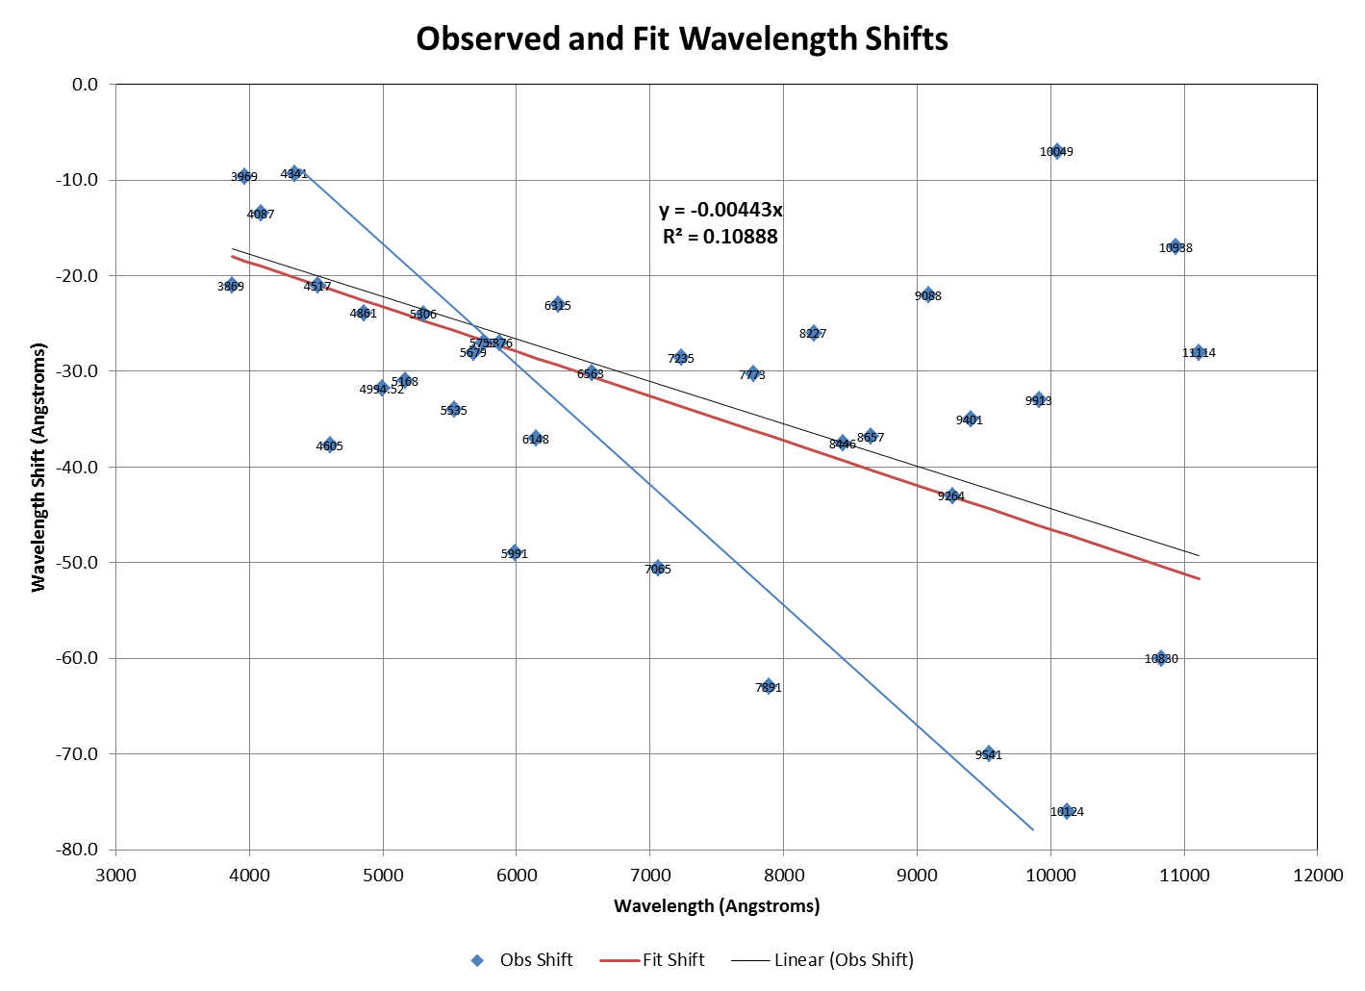

StackedCharts.xlsx

|  |  |  |  |  |  |  |  |  |  |  |  |  |  |  |  |  |  |  |  |
| --- | --- | --- | --- | --- | --- | --- | --- | --- | --- | --- | --- | --- | --- | --- | --- | --- | --- | --- | --- |
| Feature | Appr Raw Net Ht | | Raw Eq Wd | Raw FWHM | Est | R-spec Centroid | Poss Assign | Obs Shift | Fractional Shift | Fit Shift |  | Line | Wave 1 | Line 1 | | Wave 2 | Line 2 | Nova | Ref. |
| A |  | |  |  | 3890 |  | 3869 | -21.0 | -0.0054 | -18.0 | 0.0008 | Ne III |  |  | |  |  |  |  |
| B |  | |  |  | 3980 | 3978.6 | 3969 | -9.6 | -0.0024 | -18.5 | 0.0022 | Combined | 3970 | H-gam | | 3968 | Ca II |  |  |
| C | 200 | |  |  | 4105 | 4100.5 | 4087 | -13.5 | -0.0033 | -19.0 | 0.0013 | Combined | 4102 | H-del | | 4072 | Fe V | V3890 Sgr | Williams et al 1991 |
| D |  | |  |  | 4260 |  |  |  |  |  |  | No line identified | | | | | |  |  |
| E | 600 | |  |  | 4352.8 | 4350.3 | 4341 | -9.3 | -0.0021 | -20.2 | 0.0025 | H-gam |  |  | |  |  |  |  |
| F |  | |  |  | 4515 | 4538 | 4517 | -21.0 | -0.0046 | -21.0 | 0.0000 | N I |  |  | |  |  |  |  |
| G |  | |  |  | 4640 | 4642.7 | 4605 | -37.7 | -0.0082 | -21.4 | 0.0035 | Combined | 4640 | N III | | 4570 | Fe II (37,38) | |  |
| H | 2600 | | -289 | 70.5 | 4881 | 4884.9 | 4861 | -23.9 | -0.0049 | -22.6 | 0.0003 | H-beta |  |  | |  |  |  |  |
| I |  | |  |  | 5030 | 5026.3 | 4994.52 | -31.8 | -0.0064 | -23.2 | 0.0017 | O III Combined | 5007 | O III (0.74) | | 4959 | O III (0.26) | |  |
| J |  | |  |  | 5195 | 5198.5 | 5168 | -31.0 | -0.0060 | -24.0 | 0.0013 | Combined | 5159 | Fe VII | | 5176 | Fe VI | What about Fe II? | |
| K |  | |  |  | 5327 | 5330 | 5306 | -24.0 | -0.0045 | -24.7 | 0.0001 | Combined | 5303 | Fe XIV | | 5309 | Ca V | V3890 Sgr | Williams et al 1991 |
| L |  | |  |  | 5575 | 5569 | 5535 | -34.0 | -0.0061 | -25.8 | 0.0015 | Fe II |  |  | |  |  | Del 2013 | Astrosurf site |
| M |  | |  |  | 5707 |  | 5679 | -28.0 | -0.0049 | -26.4 | 0.0003 | N II |  |  | |  |  |  |  |
| N |  | |  |  | 5790 | 5782 | 5755 | -27.0 | -0.0047 | -26.8 | 0.0000 | N II |  |  | |  |  |  |  |
| O |  | |  |  | 5905 | 5903 | 5876 | -27.0 | -0.0046 | -27.3 | 0.0001 | He I |  |  | |  |  |  |  |
| P |  | |  |  | 6029 | 6040 | 5991 | -49.0 | -0.0082 | -27.9 | 0.0035 | Fe II |  |  | |  |  | Del 2013 | Astrosurf site |
| Q |  | |  |  | 6185 |  | 6148 | -37.0 | -0.0060 | -28.6 | 0.0014 | Fe II |  |  | |  |  | Del 2013 | Astrosurf site |
| R |  | |  |  | 6335 | 6338.4 | 6315 | -23.0 | -0.0036 | -29.4 | 0.0010 | O I Combined | 6300 | O I (0.76) | | 6364 | O I (0.24) |  |
| S | 9200 | | -2893 | 85.5 | 6599 | 6593.2 | 6563 | -30.2 | -0.0046 | -30.5 | 0.0001 | H-alph |  |  | |  |  |  |  |
| T |  | |  |  | 7111 | 7115.6 | 7065 | -50.6 | -0.0072 | -32.9 | 0.0025 | He I |  |  | |  |  |  |  |
| U |  | |  |  | 7265 | 7263.6 | 7235 | -28.6 | -0.0040 | -33.7 | 0.0007 | O II |  |  | |  |  | Oph 1991 |  |
| V |  | |  |  | 7482 |  |  |  |  |  |  |  |  |  | |  |  |  |  |
| W |  | |  |  | 7805 | 7803.3 | 7773 | -30.3 | -0.0039 | -36.2 | 0.0008 | O I |  |  | |  |  |  |  |
| X |  | |  |  | 7954 |  | 7891 | -63.0 | -0.0080 | -36.7 | 0.0033 | Mg II? | Other options | | | | |  |  |
| Y |  | |  |  | 8251 | 8253 | 8227 | -26.0 | -0.0032 | -38.3 | 0.0015 | O I | Several Options Here | | | | |  |  |
| Z | 200 | | -593.71 | 121.8 | 8483 | 8483.5 | 8446 | -37.5 | -0.0044 | -39.3 | 0.0002 | O I |  |  | |  |  |  |  |
| a |  | |  |  | 8697 | 8693.8 | 8657 | -36.8 | -0.0043 | -40.3 | 0.0004 | Combined | 8650 | Na I | | 8664 | Ca II |  |  |
| b |  | |  |  | 8854 | 8856 |  |  |  |  |  | Discarded as too low SNR | | | |  |  |  |  |
| c |  | |  |  | 8995 | 8992 |  |  |  |  |  | Discarded as too low SNR | | | |  |  |  |  |
| d |  | |  |  | 9100 | 9110 | 9088 | -22.0 | -0.0024 | -42.3 | 0.0022 | C I |  |  | |  |  |  |  |
| e |  | |  |  | 9293 | 9307 | 9264 | -43.0 | -0.0046 | -43.1 | 0.0000 | O I |  |  | |  |  | LMC 1991 | Williams etal., 1994 |
| f |  | |  |  | 9440 | 9436 | 9401 | -35.0 | -0.0037 | -43.7 | 0.0009 | Combined | 9396 | N III | | 9406 | C I |  |  |
| g |  | |  |  | 9621 | 9611 | 9541 | -70.0 | -0.0073 | -44.4 | 0.0027 | Combined | 9532 | S III | | 9550 | P 8 /Pa-del | |  |
| h |  | |  |  | 9753 | 9769 |  |  |  |  |  | No line identified | |  | |  |  |  |  |
| i |  | |  |  | 9936 | 9946 | 9913 | -33.0 | -0.0033 | -46.1 | 0.0013 | S VIII |  |  | |  |  | SGR 1998 | Lynch etal., 2001 |
| j |  | |  |  | 10067 | 10056 | 10049 | -7.0 | -0.0007 | -46.8 | 0.0040 | P 7 / Pa-del | |  | |  |  | SGR 1998 | Lynch etal., 2001 |
| k |  | |  |  | 10200 | 10200 | 10124 | -76.0 | -0.0075 | -47.1 | 0.0029 | He II |  |  | |  |  | SGR 1998 | Lynch etal., 2001 |
| l |  | |  |  | 10316 | 10331 |  |  |  |  |  |  |  |  | |  |  |  |  |
| m |  | |  |  | 10390 | 10403 |  |  |  |  |  |  |  |  | |  |  |  |  |
|  |  | |  |  | 10530 | 10536 |  |  |  |  |  |  |  |  | |  |  |  |  |
|  | 7 | |  |  | 10870 | 10890 | 10830 | -60.0 | -0.0055 | -50.4 | 0.0009 | He I |  |  | |  |  | SGR 1998 | Lynch etal., 2001 |
|  |  | |  |  | 10960 | 10955 | 10938 | -17.0 | -0.0016 | -50.9 | 0.0031 | Pa-gam |  |  | |  |  | SGR 1998 | Lynch etal., 2001 |
| 11070 Band Gap | | | |  | 11135 | 11142 | 11114 | -28.0 | -0.0025 | -51.7 | 0.0021 | Unknown but common | | | |  |  | SGR 1998 | Lynch etal., 2001 |
|  | |  |  |  |  |  |  |  |  |  |  |  |  | |  |  |  |  |  |
|  | |  |  |  |  |  |  |  |  |  | Red > 4 sigma | |  | |  |  |  |  |  |
|  | |  |  |  |  |  |  |  |  |  | Yellow 2-4 sigma | |  | |  |  |  |  |  |
|  | |  |  |  |  |  | **All Lines** |  |  |  | Green < 2 sigma | |  | |  |  |  |  |  |
|  | |  |  | Average | | | | -33.0 | -0.00469 |  |  | -1406.69 |  | |  |  |  |  |  |
|  | |  |  | Standard Deviation | | | | 16.2 | 0.00190 |  |  | 570.5 |  | |  |  |  |  |  |
|  | |  |  | Standard Deviation | | | | -49.1% | -40.6% |  |  | -40.6% |  | |  |  |  |  |  |
|  | |  |  | Standard Error of the Mean | | | | 2.7 | 0.00032 |  |  | 96.4 |  | |  |  |  |  |  |
|  | |  |  | Standard Error of the Mean | | | | -8.3% | -6.9% |  |  | -6.9% |  | |  |  |  |  |  |
|  | |  |  | **Three strongest lines** | | | |  |  |  |  |  |  | |  |  |  |  |  |
|  | |  |  | Average | | | | -30.5 | -0.00465 |  |  | -1395.82 | 1.008 | |  |  |  |  |  |
|  | |  |  | Standard Deviation | | | | 6.8 | 0.00024 |  |  | 72.7 |  | |  |  |  |  |  |
|  | |  |  | Standard Deviation | | | | -22% | -5.2% |  |  | -5.2% |  | |  |  |  |  |  |
|  | |  |  | Standard Error of the Mean | | | | 3.9 | 0.00014 |  |  | 42.0 |  | |  |  |  |  |  |
|  | |  |  | Standard Error of the Mean | | | | -12.9% | -3.0% |  |  | -3.0% |  | |  |  |  |  |  |

StackedCharts.xlsx

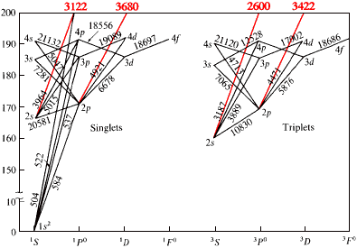

NOTE: I REALLY HAVE A LOT OF LINE ANALYSIS HERE. IT IS VERY DIFFICULT TO PULL OUT THE CONTINUUM FOR THE NOVA. ALSO

**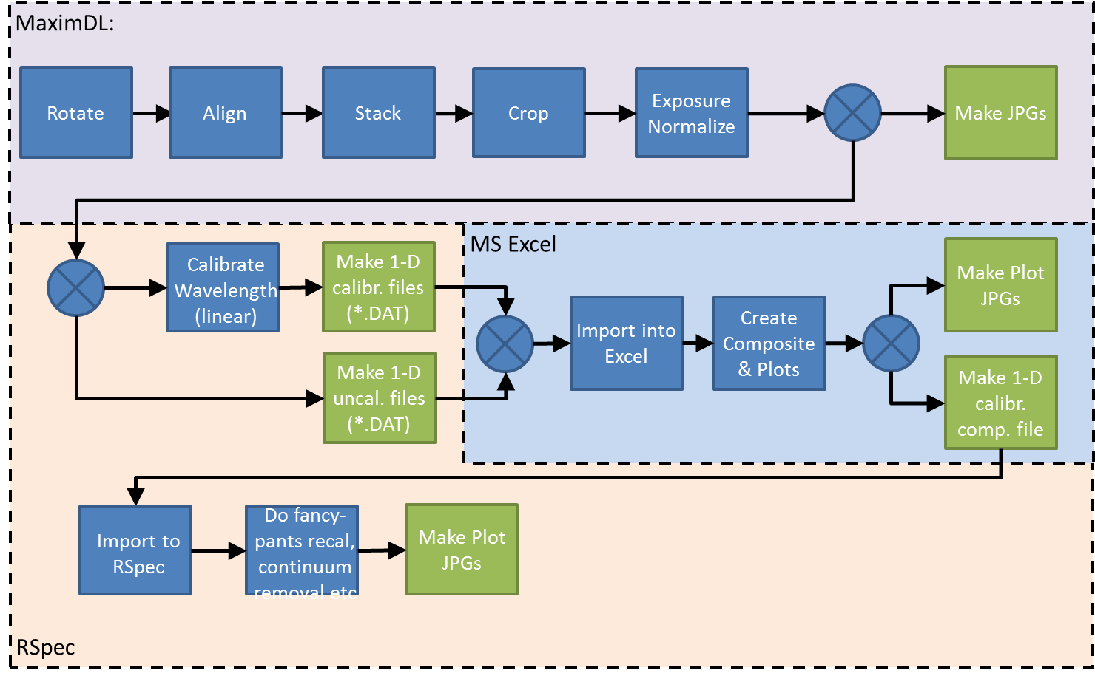**

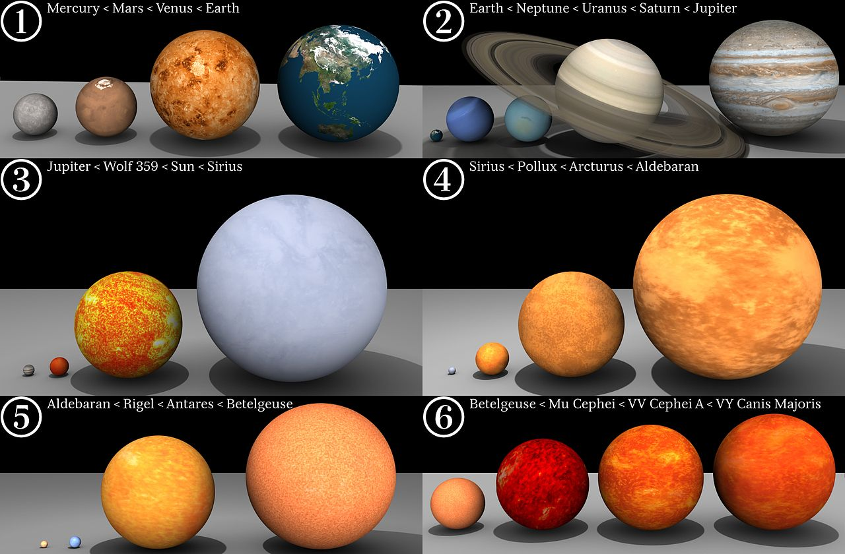

[**http://upload.wikimedia.org/wikipedia/commons/thumb/c/cc/Star-sizes.jpg/1280px-Star-sizes.jpg**](http://upload.wikimedia.org/wikipedia/commons/thumb/c/cc/Star-sizes.jpg/1280px-Star-sizes.jpg)

### Analysis: Castor System (Including YY Gem) as a Place

Last Updated 7/16/2013

**Introduction**

Sextuple star, spectral classes, variability

|  |  |  |
| --- | --- | --- |
| H:\Astronomy\YY Geminorium Project\HDR Files\Castor-RGB-HDR-Smoothed-ColorAdj-Sat150pct-Cropped2-HalfSize.jpg | H:\Astronomy\YY Geminorium Project\HDR Files\Castor-IGB-HDR-Filtered-ColorAdj-Sat150pct-Cropped2-HalfSize.jpg | H:\Astronomy\YY Geminorium Project\HDR Files\Castor-IGU-HDR-Filtered-ColorAdj-Sat130pct-Cropped2-HalfSize.jpg |
| Castor-RGB-HDR-Smoothed-ColorAdj-Cropped2-HalfSize.jpg | Castor-IGB-HDR-Filtered-ColorAdj-Sat150pct-Cropped2-HalfSize.jpg | Castor-IGU-HDR-Filtered-ColorAdj-Sat130pct-Cropped2-HalfSize.jpg |
| H:\Astronomy\YY Geminorium Project\HDR Files\Castor-M(LogLog)HU-HDR-Filtered-ColorAdj-Sat150pct-Cropped2-HalfSize.jpg | H:\Astronomy\YY Geminorium Project\HDR Files\Castor-GBU-HDR-Filtered-ColorAdj-Sat130pct-Cropped2-HalfSize.jpg | H:\Astronomy\YY Geminorium Project\HDR Files\Castor-M(LogLog)IH-HDR-Filtered-ColorAdj-Cropped2-Col-Halfsize.jpg |
| Castor-M(LogLog)HU-HDR-Filtered-ColorAdj-Sat150pct-Cropped2-HalfSize.jpg | Castor-GBU-HDR-Filtered-ColorAdj-Sat130pct-Cropped2-HalfSize.jpg | Castor-M(LogLog)IH-HDR-Filtered-ColorAdj-Cropped2-Col-Halfsize.jpg |

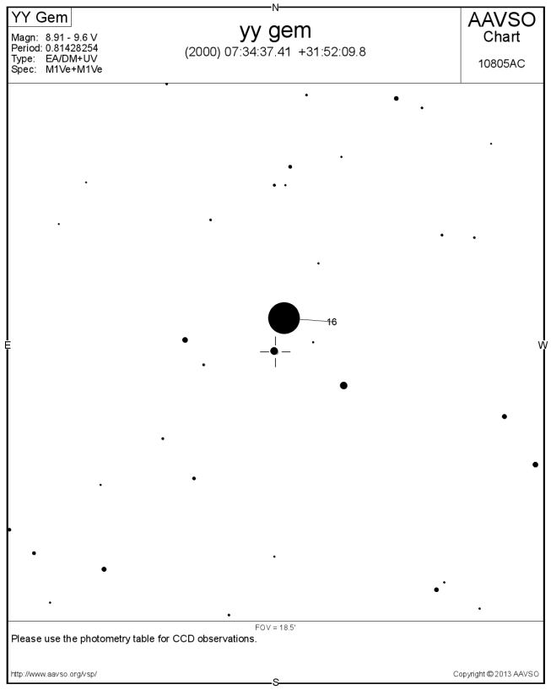

YY Gem light curve

YY Gem spectroscopy

Castor broadband spectroscopy – Need pretty HDR pics here

Castor spectroscopy

**Astrometry**

Astrometric observations for the Castor A-B system have been accumulated for several years and more recently for Castor A-C (YY Gem). The observations presented have been made with the C8 telescope and either the ToUcam 840 or the ST-2000 camera. The observations were made either at focal lengths of 2000mm (f/10) or 5500mm (f/27.5). (Did I ever use the focal reducer?)

Methods of determining plate scale varied, but included a drift exposure or astrometric solution based on reference star locations. Note that this approach is not truly independent because it included the predicted location of the star whose location is being measured (e.g. Castor B). Thus, it is more of an assimilative approach. The predictions are based for Castor B on the TBD ephemeris from the USNO. The Castor C “prediction” is a fixed location based on J2000 coordinates measured from the Tycho II catalog via the Cartes du Ceil program (V3.8). Similarly, an additional reference star location from the Tycho II catalog is used. Figure 5 below shows the predictions and measurements for Castor A-B and Castor A-C. The observations are reduced in the spreadsheet Master\_BinaryAnalysisRev2013b.xlsx and the spreadsheet for further analysis is Gemini\_Binaries.xlsx.

|  |  |
| --- | --- |
|  |  |

Figure 5: Astrometric observations of Castor and YY Gem.

From the observations, one can create a weighted least-squares fit to the trend for both position angle and separation where there is clearly relative motion. The predictions, observations and fits to observations for PA and separation for Castor B relative to Castor A are shown in Figure 6. Data used for the Figure 6 is tabulated in Table 5. Note that for a number of the observations good error estimates are not available at this time. This may be due to the singular nature of an observation or insufficient analysis of multiple observations to determine the error magnitude.

|  |  |
| --- | --- |
|  |  |

Figure 6: PA and separation observations, fits and predictions.

Table 5: Observed and Predicted PA and Separation for Castor B. (Add type of observation, e.g., ST2000 column?)

|  |  |  |  |  |  |  |  |  |  |
| --- | --- | --- | --- | --- | --- | --- | --- | --- | --- |
| **Date** | **PA (O)** | **PA SD** | **Sep (O)** | **Sep SD** | **Notes** | **PA (P)** | **Sep (P)** | **PA (O-P)** | **Sep (O-P)** |
| 2008.137 | 57.94 | 2.31 | 4.740 | 0.193 | Good err. est. | 58.29 | 4.51 | -0.35 | 0.23 |
| 2009.079 | 58.56 | 0.55 | 4.798 | 0.152 | Good err. est. | 57.66 | 4.58 | 0.90 | 0.22 |
| 2009.197 | 58.15 | 0.117 | 4.493 | 0.025 | Good err. est. | 57.58 | 4.59 | 0.57 | -0.10 |
| 2010.027 | 56.51 | 0.262 | 4.803 | 0.056 | Good err. est. | 57.05 | 4.65 | -0.54 | 0.15 |
| 2010.082 | 57.72 | 1.000 | 4.619 | 0.100 | Unknown | 57.01 | 4.66 | 0.71 | -0.04 |
| 2011.079 | 55.61 | 1.000 | 4.716 | 0.100 | Unknown | 56.38 | 4.73 | -0.77 | -0.01 |
| 2012.188 | 56.07 | 1.000 | 4.622 | 0.100 | Unknown | 55.71 | 4.81 | 0.36 | -0.19 |
| 2013.175 | 52.87 | 1.158 | 4.464 | 0.135 | Good err. est. | 55.12 | 4.88 | -2.25 | -0.41 |
| 2013.178 | 56.09 | 1.000 | 5.047 | 0.100 | Unknown | 55.12 | 4.88 | 0.97 | 0.17 |
| 2013.246 | 55.26 | 0.928 | 4.658 | 0.124 | Good err. est. | 55.08 | 4.88 | 0.17 | -0.23 |

|  |  |  |  |  |  |  |
| --- | --- | --- | --- | --- | --- | --- |
|  | **PA(O)**  **deg** | **PA(P)**  **deg** | **PA (O-P)**  **deg** | **Sep(O)**  **asec** | **Sep(P)**  **asec** | **Sep (O-P)**  **asec** |
| **Values** | 56.48 deg | 56.50 deg | -0.023 deg | 4.696 asec | 4.716 asec | -0.020 asec |
|  | **dP/dt(O)**  **deg/yr** | **dP/dt(P)**  **deg/yr** | **dP/dt(O-P)**  **deg/yr** | **dS/dt(O)**  **arcsec/yr** | **dS/dt(P)**  **arcsec/yr** | **dS/dt(O-P)**  **arcsec/yr** |
| **Rates** | -0.937 deg/yr | -0.628 deg/yr | -0.308 deg/yr | 0.0675 arcsec/yr | 0.0732 arcsec /yr | -0.0057 arcsec /yr |

Gemini\_Binaries.xlsx

Castor Astrometry (reference spreadsheet file)

Average positions and errors

Average rates and errors

YY Gem Astrometry (reference spreadsheet file)

Average positions and errors

Average rates and errors

**Spectroscopy**

**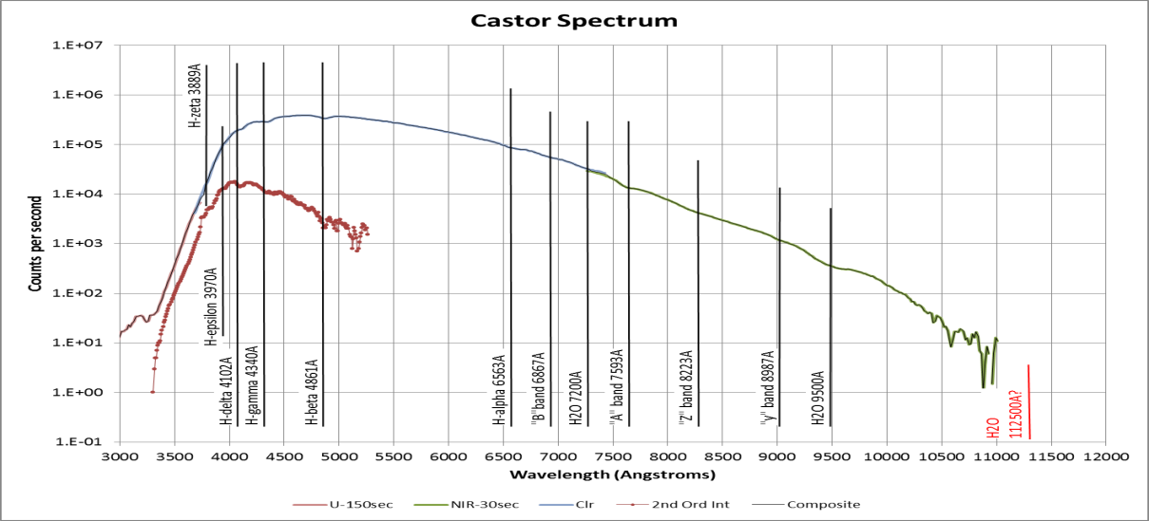**

**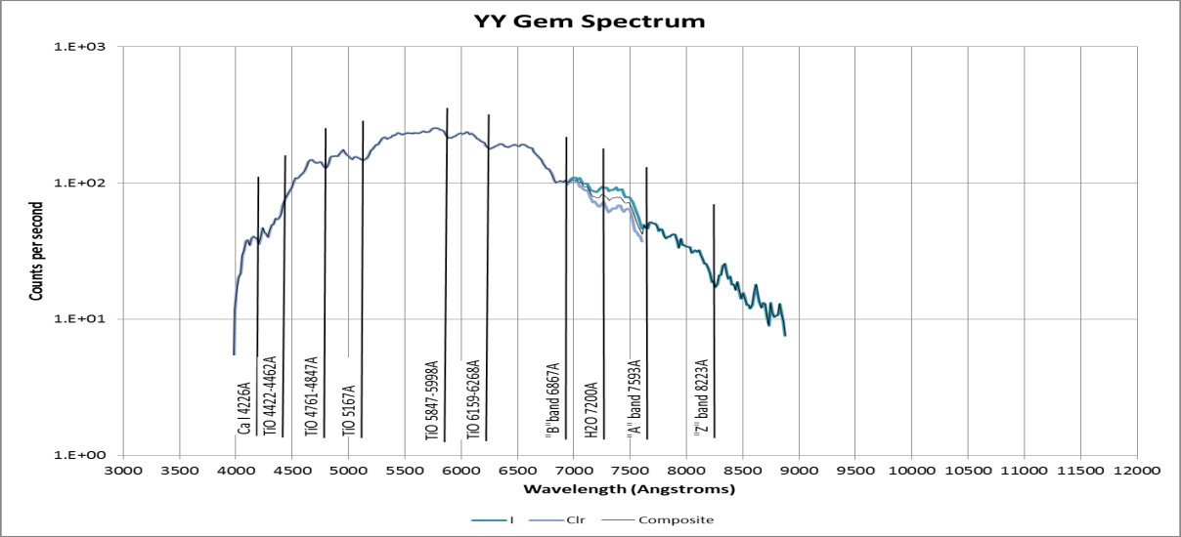**

**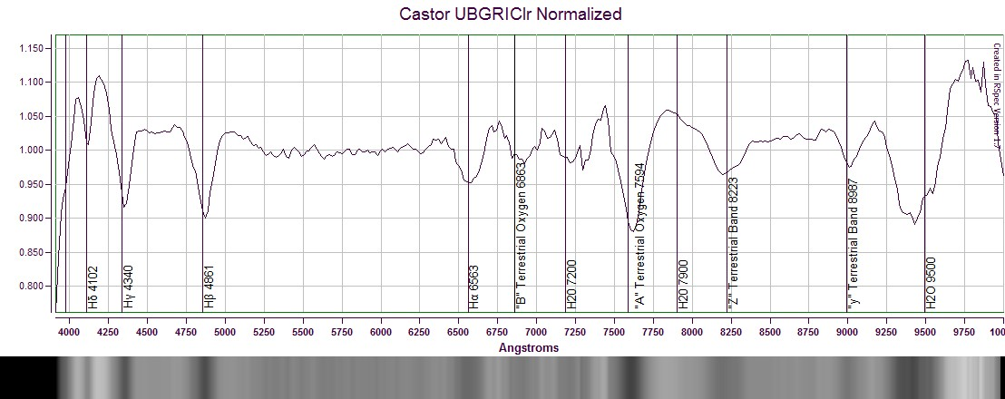**

**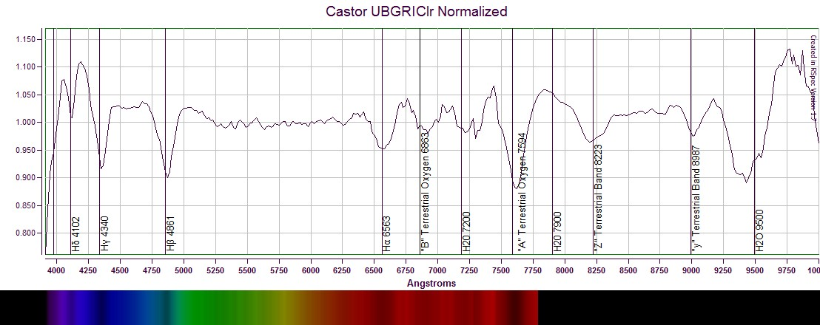**

**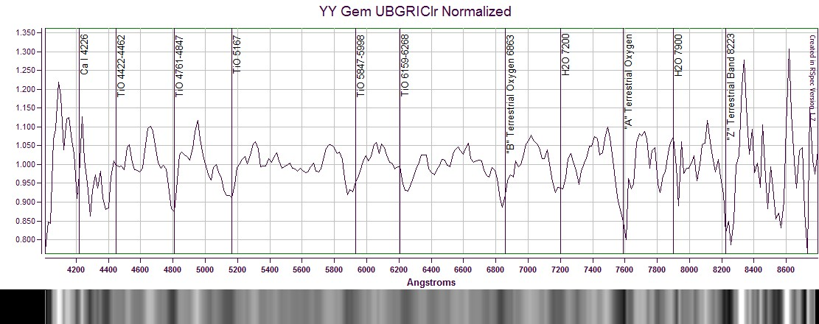**

**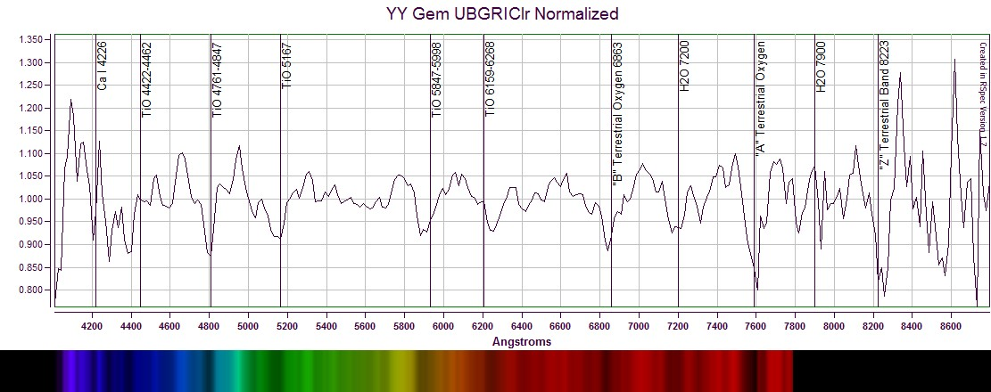**

**YY Gem Variability**

|  |  |
| --- | --- |
| H:\Astronomy\2013\03\05\YY GEM\Castor-20130305-DarkStack130-HalfSize.jpg |  |
| Castor-20130305-DarkStack130-HalfSize.jpg | YY GEM NIR Light Curve 20130306UT.xlsx |

Should compare to data from HDR imaging later in the month!!!

Used Ic band magnitudes for my NIR band for ref stars 1 and 2 (8.988 and 10.104 from B. Garry) and used Gary ephemeris.

Blue from Gary (1: 10.917, 2:12.230) and for NUV

Red (Rc) from Gary (1: 9.419, 2: 10.599) and for Halpha

Green (mislabeled clear) used V from Gary (1: 9.947, 2: 11.158) – used also for Clear (mislabeled Green)

NEED TO MAKE APPROPRIATE CORRECTIONS TO HJD FOR 3/7 AND 4/1

**YY Gem Broadband Photometry**

Green/Clear:

Total in band: 58.606

(954.12 after \* 16.28035 Ang/pix)

Start: 4757.687

End: 6060.114

Average: 5408.9000

Width: 1302.427

Equiv. Width: 954.12

Green in Band:

O order: 349.8

1st order: 11361

2nd order: ~100? How much is noise?

If we normalize to the peak rather than to 1.0 then since Green exceeds Clear, we would actually get a narrower equivalent width.

Red/Clear:

Total in band: 38.557

(627.72 after \* 16.28035 Ang/Pix)

Start: 6011.272

End: 6955.533

Avg.: 6483.403

Width: 944.261

Equiv. Width: 627.72

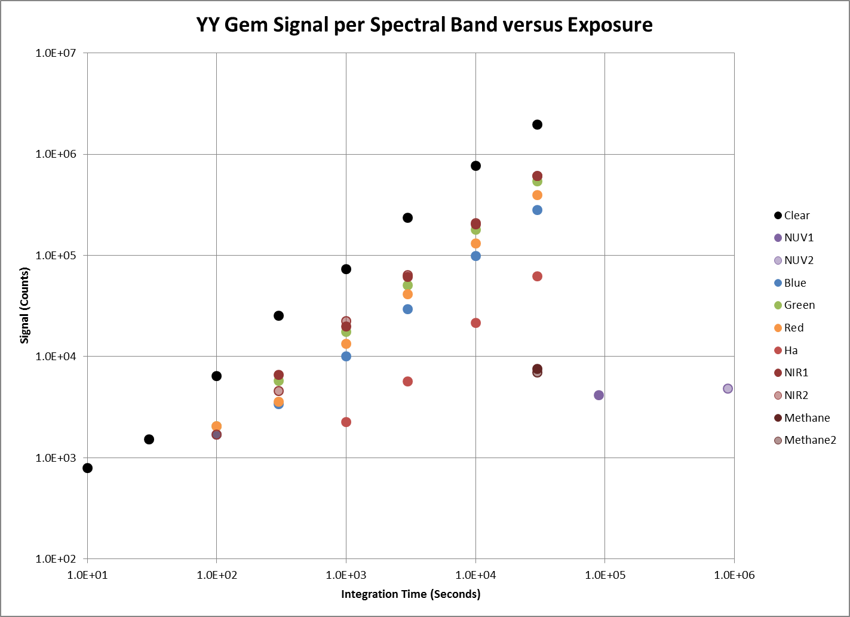

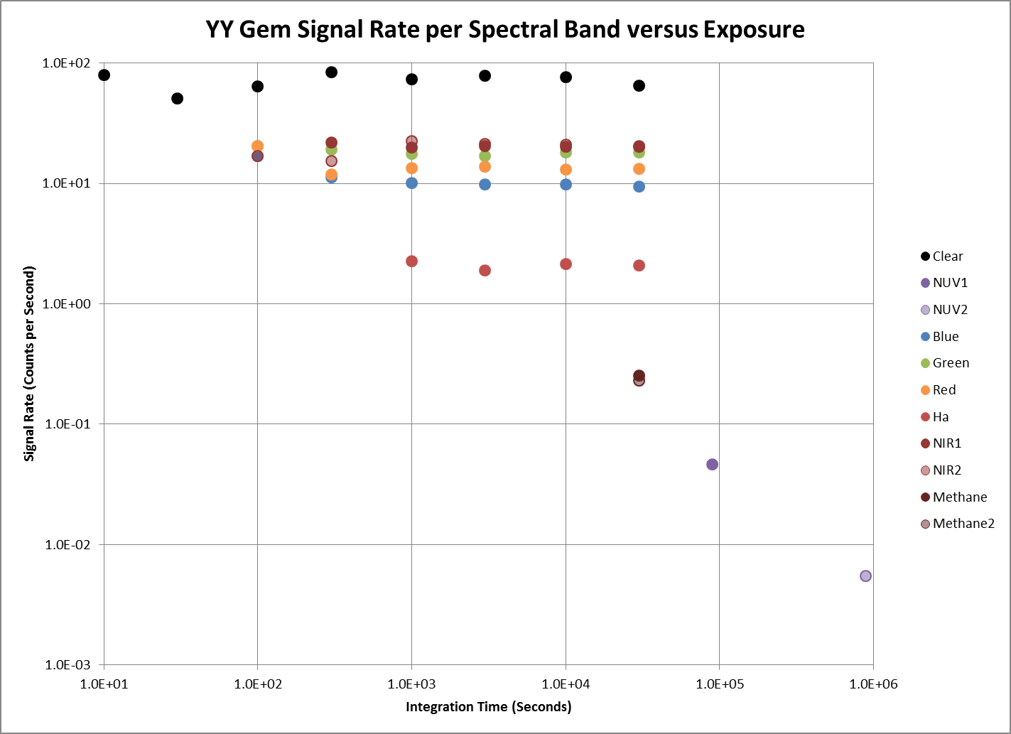

HDR ***Color*** Imagery

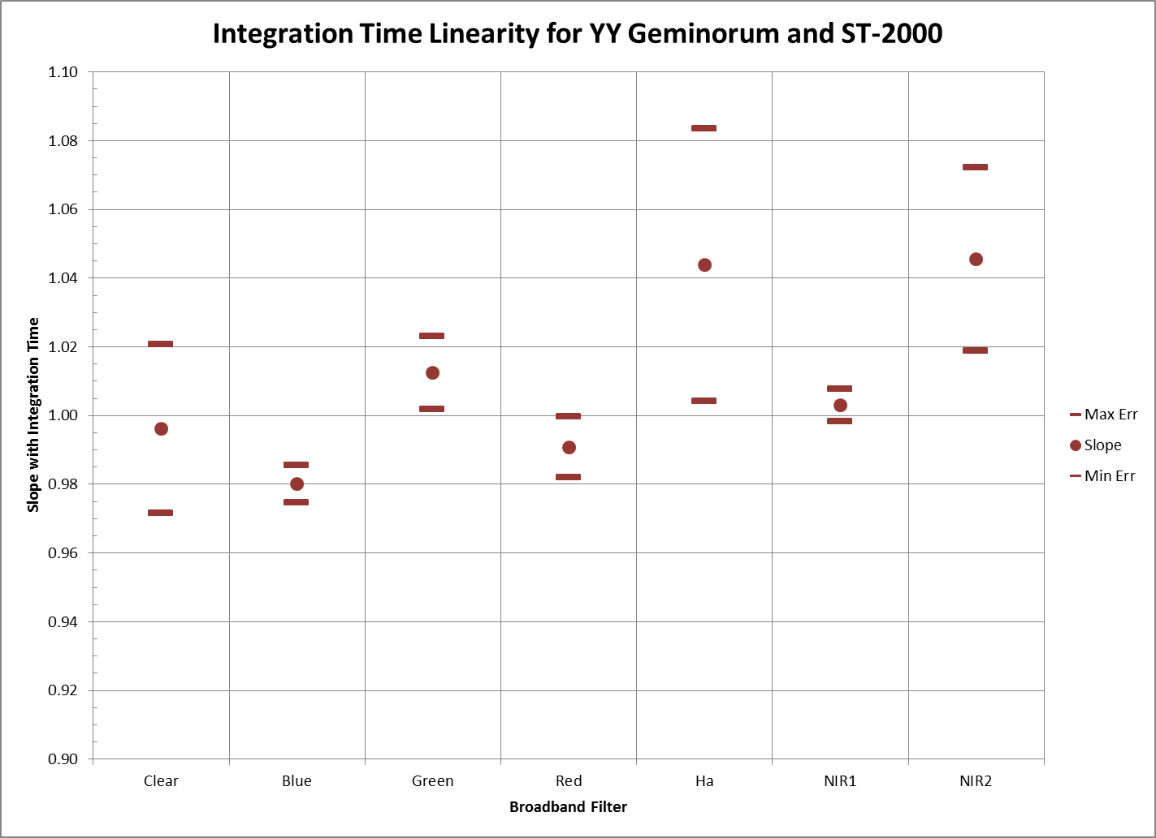

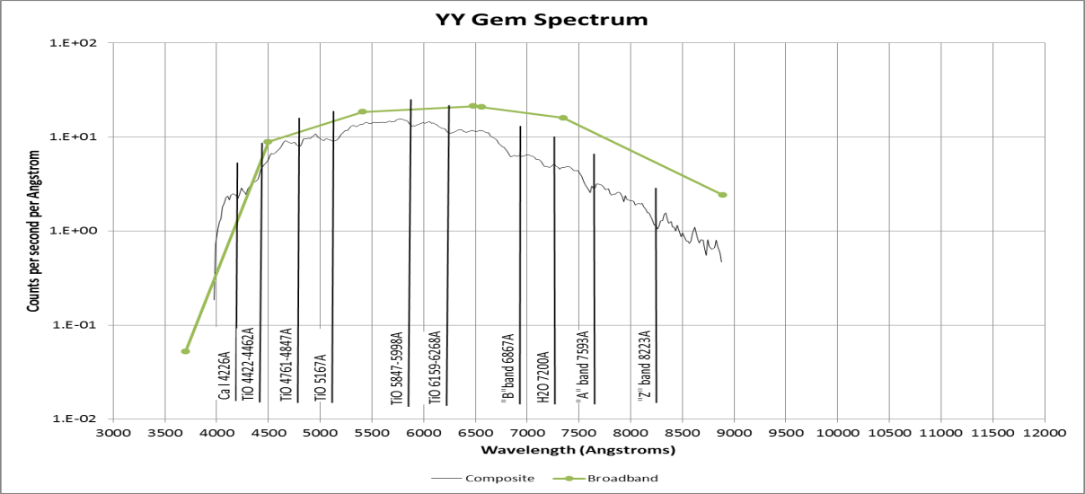

Is disparity due to photons versus ergs? I think not because both are in units of counts! With better band definition, I should be able to sum the area under the spectrum per band and see how the result compares to the broadband signature. It could very well be that I am seeing the additional attenuation as a function of wavelength due to the grating being added to the optical train.

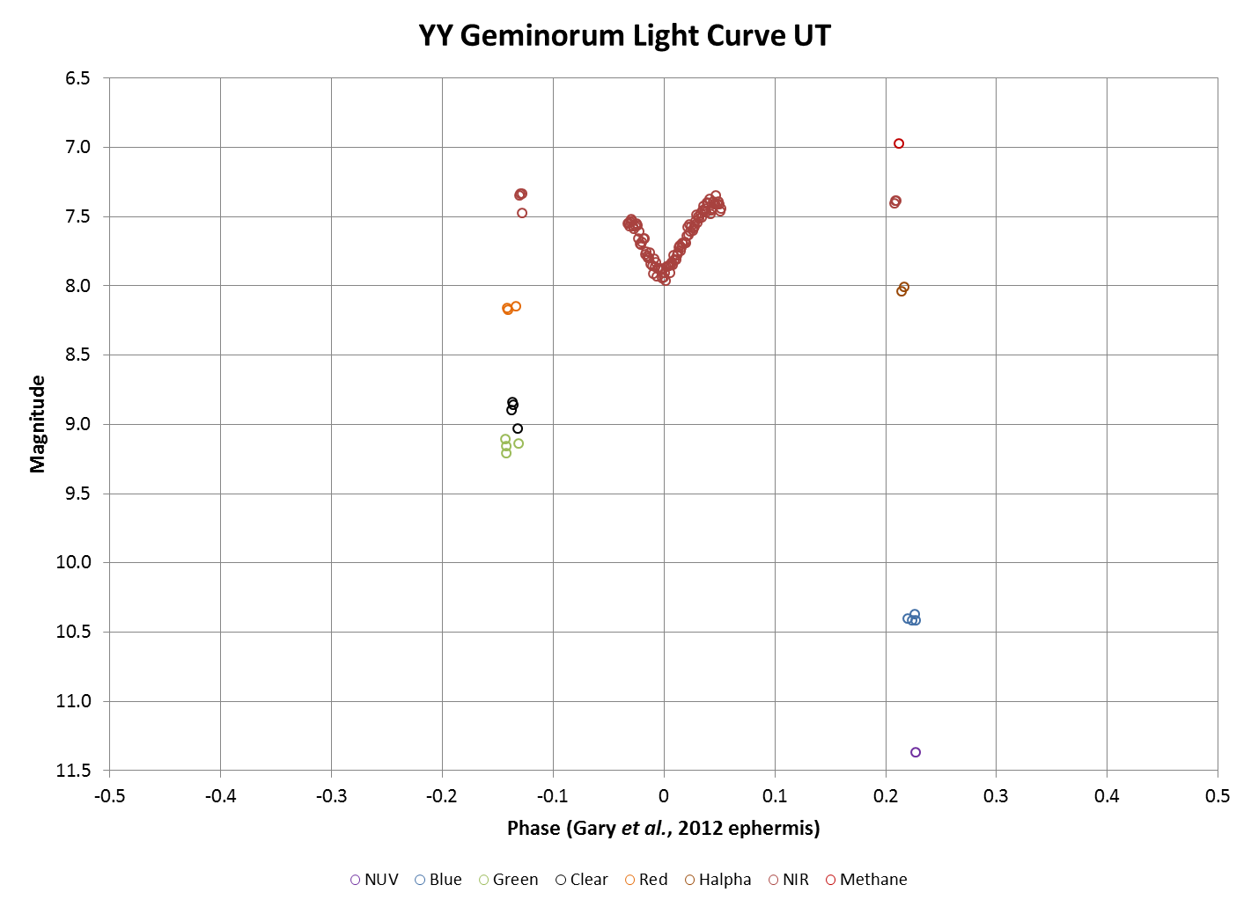

|  |  |  |  |  |  |  |  |  |
| --- | --- | --- | --- | --- | --- | --- | --- | --- |
| Band | Observed Magnitude | | Computed TOA Flux (ergs/cm^2/s/Ang) | | Observed Counts (Cts/s/Ang) | | System Sensitivity | |
|  |  |  |  |  |  |  |  |  |
| Clear | 8.909 | ±0.084 | 7.85E-11 | ±8.66E-11 | 18.42 | ±0.79 | 2.35E+11 |  |
| NUV | 11.371 |  | 1.18E-11 |  | 0.05 |  | 4.39E+09 |  |
| Blue | 10.402 | ±0.021 | 4.55E-11 | ±4.79E-11 | 8.92 | ±0.14 | 1.96E+11 |  |
| Green | 9.155 | ±0.043 | 9.85E-11 | ±1.20E-10 | 18.53 | ±0.26 | 1.88E+11 |  |
| Red | 8.162 | ±0.013 | 1.23E-10 | ±1.26E-10 | 21.30 | ±0.25 | 1.74E+11 |  |
| H-alpha | 8.028 | ±0.030 | 1.39E-10 | ±1.49E-10 | 20.86 | ±0.81 | 1.50E+11 |  |
| NIR | 7.406 | ±0.018 | 1.34E-10 | ±1.39E-10 | 15.97 | ±0.09 | 1.20E+11 |  |
| Methane | 6.971 |  | 1.99E-10 |  | 2.42 | ±0.11 | 1.21E+10 |  |

Errors, where available, indicate 95% confidence interval.

Need to convolve errors to come up with error bars/confidence interval on sensitivity. Also, need to note that the observed counts errors are standard error without the 1.96 factor to indicate the 95% confidence level. I need to fix this.

Could also compare to model spectrum in RSPEC program to estimate fluxes and calibrations.

### Analysis: M42 – Multispectral Imaging

Last Updated 2/27/2013

Need exposure summary table here.

If my Ha filter is FWHM=7nm, then it definitely includes Ha (6563) along with the two N II lines (6548, 6583), but not He (6678) nor the S II lines (6717, 6731).

5876 He I is mostly missed in the gap between green and red filters (forgetting the ‘clear’ leaks).

|  |  |  |  |  |  |  |
| --- | --- | --- | --- | --- | --- | --- |
|  | **U** | **B** | **G** | **R** | **Ha** | **I** |
| **Stars** | Early | Early | Early-Late | Late | Late | Late |
| **Dust** | Reflection | Reflection | Reflection | Reflection | Minimal | Penetration? |
| **Emission** | **3726 O II: 10**  <3835 H I: 10+  3868 Ne III: 4  3888 H I(8) & He I: 4  3967 N III: 7 | **4101 H del: 8**  **4340 H gam: 10**  4472 He I: 5  **4861 H bet: 20**  4957 O III: 20  5007 O III: 20 | 4861 H bet: 20  **4957 O III: 20**  **5007 O III: 20**  5876 He I: 10\* | 6300 O III: 3  6312 S III: 4  6363 O III: 1.5  **6548 N II: 15**  **6563 H alp: 20**  **6583 N II: 20**  6678 He I: 8  6717 S II: 4  6731 S II: 6 | 6548 N II: 15\*  **6563 H alp: 20**  6583 N II: 20\* | **7065 He I: 12**  **7135 Ar III: 15**  **7320 O II: 10**  **7330 O II: 10**  7751 Ar III: ? |
| **RGB** |  | X | X | X |  |  |
| **IGU** | X |  | X |  |  | X |
| **IHU** | X |  |  |  | X | X |
| **IRU** | X |  |  | X |  | X |
| **IHG** |  |  | X |  | X | X |
| **IRG** |  |  | X | X |  | X |

|  |  |
| --- | --- |
| H:\Astronomy\M42 Project 2013\M42-20130XXX-RGB-Wavelets-Sat150pct-Greened-HalfSize.jpg | H:\Astronomy\M42 Project 2013\M42-2013020X-IGU-Wavelets-Sat150pct-HalfSize.jpg |
| M42-20130XXX-RGB-Wavelets-Sat150pct-Greened-HalfSize.jpg | M42-2013020X-IGU-Wavelets-Sat150pct-HalfSize.jpg |
| H:\Astronomy\M42 Project 2013\M42-2013020X-IHU-Wavelets-HalfSize.jpg | H:\Astronomy\M42 Project 2013\M42-20130XXX-IRU-Wavelets-Sat150pct-HalfSize.jpg |
| M42-2013020X-IHU-Wavelets-HalfSize.jpg | M42-20130XXX-IRU-Wavelets-Sat150pct-HalfSize.jpg |
| H:\Astronomy\M42 Project 2013\M42-2013020X-IHG-Wavelets-HalfSize.jpg | H:\Astronomy\M42 Project 2013\M42-20130XXX-IRG-Wavelets-Sat150pct-Redened-HalfSize.jpg |
| M42-2013020X-IHG-Wavelets-HalfSize.jpg | M42-20130XXX-IRG-Wavelets-Sat150pct-Redened-HalfSize.jpg |

Note that there are some stellar objects that appear brighter in Ha than in Red. That is *very* interesting.

|  |  |
| --- | --- |
| H:\Astronomy\M42 Project 2013\M42-HaOverRed-BkgSub-16bit-HalfSize.jpg | H:\Astronomy\M42 Project 2013\M42-BlueOverNIR-BkgSub-16bit-HalfSize.jpg |
| M42-HaOverRed-BkgSub-16bit-HalfSize.jpg | M42-BlueOverNIR-BkgSub-16bit-HalfSize.jpg |
| H:\Astronomy\M42 Project 2013\M42-BlueOverGreen-BkgSub-16bit-HalfSize.jpg | H:\Astronomy\M42 Project 2013\M42-BlueOverNUV-BkgSub-16bit-HalfSize.jpg |
| M42-BlueOverGreen-BkgSub-16bit-HalfSize.jpg | M42-BlueOverNUV-BkgSub-16bit-HalfSize.jpg |
| H:\Astronomy\M42 Project 2013\M42-HaOverBlue-BkgSub-16bit-HalfSize.jpg | H:\Astronomy\M42 Project 2013\M42-NIROverNUV-BkgSub-16bit-HalfSize.jpg |
| M42-HaOverBlue-BkgSub-16bit-HalfSize.jpg | M42-NIROverNUV-BkgSub-16bit-HalfSize.jpg |
| H:\Astronomy\M42 Project 2013\M42-HaOverNUV-BkgSub-16bit-HalfSize.jpg |  |
| M42-HaOverNUV-BkgSub-16bit-HalfSize.jpg | M42-NIROverNUV-BkgSub-16bit-HalfSize.jpg |

### Analysis: M31 Wide Angle, Multispectral

Last Updated 1/28/2013

After creating (linear IEEE) masters, slaved to alignment and sizing with Green, I created a RGB image allowing resize, but not auto-background. The weights were 1.5,0.6,1.0. Then I did an color balance with ‘mouse’ setting the background. Doing a Log-Log processing and then lots of playing with saturation and color balance, I got an aesthetically pleasing image.

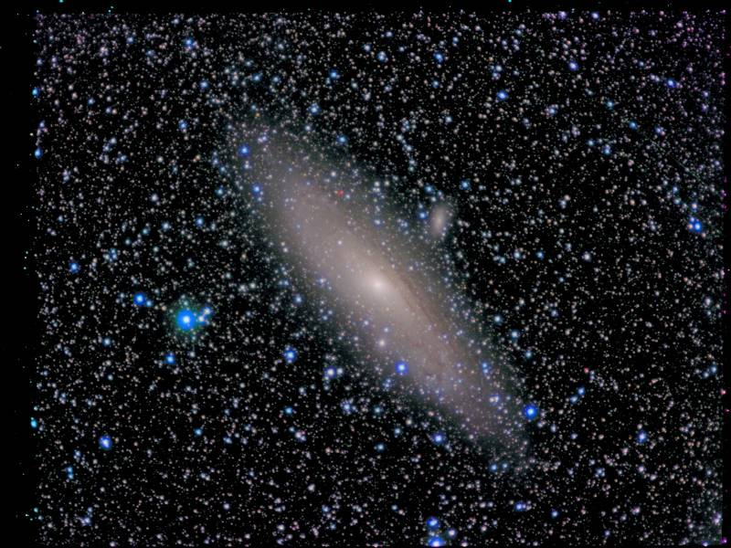 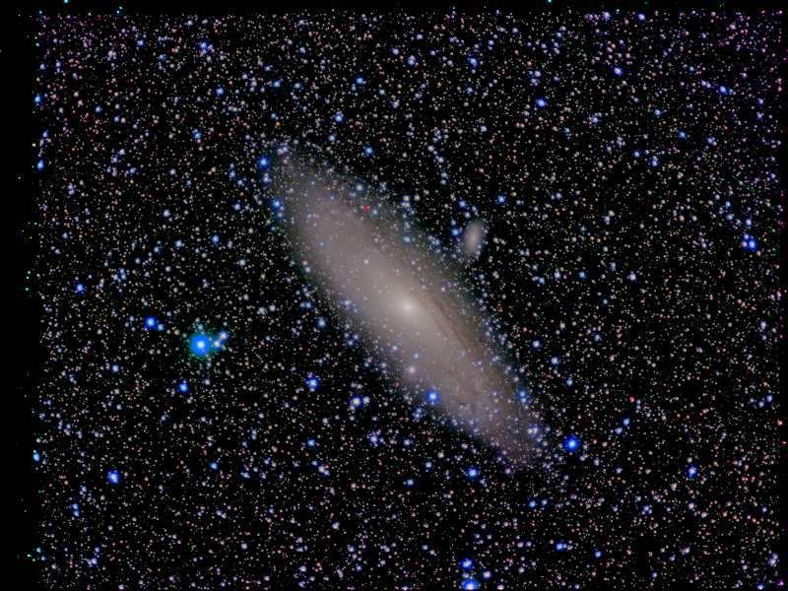

M31-2011-2013-RGB-RGB-Master-Log-BkgClr-Log-Rev2-HalfSize.jpg

M31-2011-2013-RGB-RGB-Master-Log-BkgClr-Log-Rev2-Wavelets2.0-1.5-HalfSize.jpg

1. NeptunePhotometry.xlsx [↑](#footnote-ref-1)
2. NeptunePhotometry.xlsx [↑](#footnote-ref-2)
3. NeptunePhotometry.xlsx [↑](#footnote-ref-3)
4. NeptunePhotometery.xlsx [↑](#footnote-ref-4)
5. NeptunePhotometery.xlsx [↑](#footnote-ref-5)